Intersex Genital Mutilations
Human Rights Violations Of Persons
With Variations Of Sex Anatomy

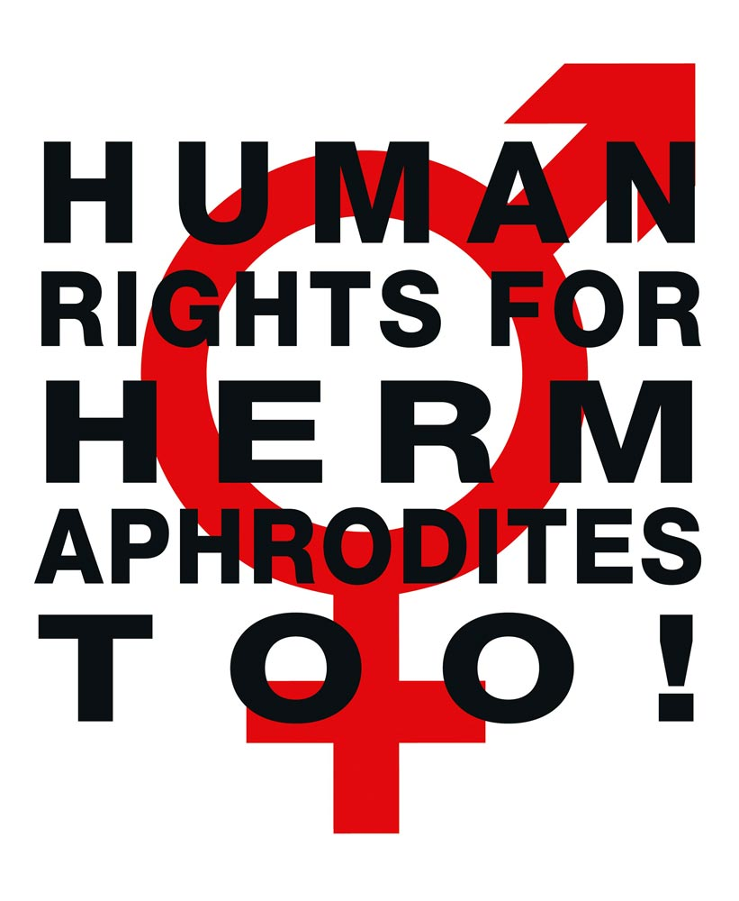

NGO Report
to the 7th and 8th Report of France
on the Convention on the Elimination of All Forms
of Discrimination against Women (CEDAW)

+ Supplement “Intersex, IGM and Human Rights”.
Compiled by:

StopIGM.org / Zwischengeschlecht.org (International Intersex Human Rights NGO)
Markus Bauer
Daniela Truffer
Zwischengeschlecht.org
P.O.Box 2122
CH-8031 Zurich
info_at_zwischengeschlecht.org
http://Zwischengeschlecht.org/
http://StopIGM.org/

In collaboration with:

Nadine Coquet (Intersex Person and Advocate, France)

Vincent Guillot (Intersex Person and Advocate, France)
vincentguillot608_at_gmail.com

June 2016

This NGO Report online:
http://intersex.shadowreport.org/public/2016-CEDAW-France-NGO-Zwischengeschlecht-Intersex-IGM.pdf

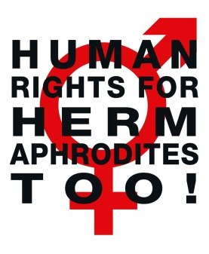
Executive Summary
France is in breach of its obligations under the Convention on the Elimination of All Forms of Discrimination against Women to (a) take effective legislative, administrative, judicial or other measures to prevent involuntary, non-urgent surgery and other medical treatment of intersex persons based on prejudice, and (b) to ensure access to redress, and the right to fair and adequate compensation and rehabilitation for victims (Arts. 1, 5 and 12, General Recommendations No. 19 and 31).
This Committee has already recognised intersex issues as relevant to the Convention in its 2009 Concluding Observations to Germany. In addition, CRC has consistently considered IGM as a harmful practice and violence, and CAT and CRPD as at least ill-treatment, issuing so far 14 Concluding Observations typically obliging State parties to enact legislation to (a) end the practice and (b) ensure redress and compensation, plus (c) access to free counselling. Also the UN Special Rapporteur on Torture (SRT), the UN Special Rapporteur on Health (SRH), the UN High Commissioner for Human Rights (UNHCHR), the World Health Organisation (WHO) and the Council of Europe (COE) recognise IGM practices as a serious human rights violation (S1).
Intersex people are born with Variations of Sex Anatomy, including atypical genitals, atypical sex hormone producing organs, atypical response to sex hormones, atypical genetic make-up, atypical secondary sex markers. While intersex people may face several problems, in the “developed world” the most pressing are the ongoing Intersex Genital Mutilations, which present a distinct and unique issue constituting significant human rights violations (S2).
IGM Practices include non-consensual, medically unnecessary, irreversible, cosmetic genital surgeries, and/or other harmful medical treatments that would not be considered for “normal” children, without evidence of benefit for the children concerned, but justified by societal and cultural norms and beliefs. Typical forms of IGM include “masculinising” and “feminising”, “corrective” genital surgery, sterilising procedures, imposition of hormones, forced genital exams, vaginal dilations, medical display, human experimentation and denial of needed health care
(A2, S3).
IGM Practices cause known lifelong severe physical and mental pain and suffering, including loss or impairment of sexual sensation, painful scarring, painful intercourse, incontinence, urethral strictures, impairment or loss of reproductive capabilities, lifelong dependency of artificial hormones, significantly elevated rates of self-harming behaviour and suicidal tendencies, lifelong mental suffering and trauma, increased sexual anxieties, less sexual activity, dissatisfaction with functional and aesthetic results. (A1, S3)
Since 1950, IGM has been practised systematically and on an industrial scale all over the “developed world”, and all typical IGM forms are still practised in France today. Parents and children are misinformed, kept in the dark, sworn to secrecy, kept isolated and denied appropriate support. (A, A1, A2, S2, S3, S4, S5).
This Thematic NGO Report has been compiled by the international intersex NGO Zwischengeschlecht.org / StopIGM.org in collaboration with French intersex advocates Nadine Coquet and Vincent Guillot. It contains Concluding Recommendations (B).

NGO Report to the 7th and 8th Report of France on the Convention on the Elimination of All Forms of Discrimination against Women (CEDAW)

Table of Contents

Executive Summary 3
Introduction 5
A. Intersex Genital Mutilations in France as a violation of CEDAW 6
1. IGM Practices: Involuntary, unnecessary medical interventions based on prejudice 6
2. IGM practices in France: Pervasive and unchallenged 6
3. IGM in France as a harmful practice and gender based violence 8
a) Article 5 in conjunction with General recommendation No. 31 8
b) Article 1 in conjunction with General recommendation No. 19 9
c) Article 12 in conjunction with General recommendation No. 19 9
4. French IGM doctors consciously dismissing human rights concerns 9
5. Lack of legislative provisions, impunity of the perpetrators 10
B. Recommendations 13
Annexe 1 – “Case Studies” 14
Annexe 2 – IGM Practices in France: Facts and Figures 20
1. Lack of Protection for Intersex Persons, IGM Practices Remain Pervasive 20
2. Most Common IGM Forms advocated by Officially Appointed Bodies and Doctors 20
a) IGM 3: Sterilising Procedures plus arbitrary imposition of hormones 20
b) IGM 2: Feminising Genital Surgeries 20
c) IGM 1: Masculinising Genital Surgeries 21
3. Examples of French University Children’s Clinics advocating & perpetrating IGM 21
a) Centre Hospitalier Universitaire de Lyon 21
b) Hôpitaux universitaires Paris-Sud (Hôpital Kremlin-Bicêtre) 22
c) Hôpital Universitaire mère-enfant Robert-Debré, Paris 23
d) Lille University Clinic (Hôpital Jeanne de Flandre) 23
e) Amiens University Clinic 23
Supplement 1 – Bibliography: Intersex & Human Rights Mechanisms 24
1. International Bodies Recognising Human Rights Violations of Intersex Children 24
2. State Bodies Recognising Human Rights Violations of Intersex Children 35
3. National Ethics Bodies Recognising Human Rights Violations of Intersex Children 35
4. NGO, NHRI Reports on Human Rights Violations of Intersex Children 36
Supplement 2 – What is Intersex? 39
1. Variations of Sex Anatomy 39
2. How common is Intersex? 41
3. Intersex is NOT THE SAME as LGBT 41
4. Terminology 43
Supplement 3 – IGM Practices: Non-Consensual, Unnecessary Medical Interventions 45
1. What are Intersex Genital Mutilations (IGM)? 45
2. Most Frequent Surgical and Other Harmful Medical Interventions 46
3. How Common are Intersex Genital Mutilations? 50
4. Lack of Legislative Prevention of IGM Practices 51
5. Lack of Disinterested Review, Analysis, Outcome Studies and Research 55
6. Lack of Independent Data Collection and Monitoring 56
Supplement 4 – “IGM in Medical Textbooks, Part 1: Current Practice” 57
Supplement 5 – “IGM in Medical Textbooks, Part 2: Historical Examples” 64
Introduction
Background and State Report
IGM practices are known to cause severe, lifelong physical and psychological pain and suffering, and have been repeatedly recognised by multiple UN treaty bodies as constituting a harmful practice, violence and torture or ill-treatment, however weren’t mentioned in the combined 7th and 8th French State Report. This NGO Report demonstrates that the current medical abuse of intersex persons – advocated, facilitated and paid for by the State party – constitutes a serious breach of France’s obligations under the Convention on the Elimination of All Forms of Discrimination against Women.
About the Rapporteurs
This NGO report has been prepared by the French intersex persons and advocates Nadine Coquet and Vincent Guillot in collaboration with the international intersex NGO Zwischengeschlecht.org / StopIGM.org.
Nadine Coquet is a French intersex person, survivor of IGM practices, intersex human rights defender and a member of OII Francophonie. Nadine has testified to IGM practices at a hearing of the French Senate.
Vincent Guillot is a French intersex person, survivor of IGM practices and an intersex human rights defender for more than a decade. Vincent is a co-founder of Organisation Intersex International (OII).
StopIGM.org / Zwischengeschlecht.org is an international intersex human hights NGO based in Switzerland, working to end IGM Practices and other human rights violations perpetrated on intersex people, according to its motto, “Human Rights for Hermaphrodites, too!” According to its charter, Zwischengeschlecht.org works to support persons concerned seeking redress and justice and regularly reports to UN treaty bodies.
Methodology
This thematic NGO report is a localised and updated version of the thematic NGO Reports for Switzerland (CRC 2014) and France (CAT 2016) by partly the same rapporteurs.
It includes 2 anonymised personal testimonies of French survivors of IGM practices compiled by the Rapporteurs, based on written submissions solicited for the 2015 French CRC NGO report, illustrating in an exemplary manner how typical forms IGM are practiced in France causing severe physical and mental pain and suffering.
A. Intersex Genital Mutilations in France as a violation of CEDAW
1. IGM Practices:
Involuntary, unnecessary medical interventions based on prejudice
IGM practices include non-consensual, medically unnecessary, irreversible, cosmetic genital surgeries, and/or other similar medical treatments, including imposition of hormones, performed on children with variations of sex anatomy (see p. 39), without evidence of benefit for the children concerned, but justified by “psychosocial indications [...] shaped by the clinician’s own values”, the latter informed by societal and cultural norms and beliefs, enabling clinicians to withhold crucial information from both patients and parents, and to submit healthy intersex children to risky and harmful invasive procedures that would not be considered for “normal” children, “simply because their bodies did not fit social norms” (for references, see p. 45).
Typical forms of IGM include “feminising” or “masculinising”, “corrective” genital surgery, sterilising procedures, imposition of hormones (including prenatal “therapy”), forced genital exams, vaginal dilations, medical display, human experimentation, selective (late term) abortions and denial of needed health care, causing lifelong severe physical and mental pain and suffering (see p. 47-50).
In a response to French and international IGM doctors advocating involuntary non-urgent surgeries on intersex children in a 2016 medical publication, two bioethicists underlined the prejudice informing the current medical practice (see also opposite p. 7):
“The implicit logic of [the doctors’] paper reflects what bioethicist George Annas has called a ‘monster ethics’ [6], which can be summed up this way: babies with atypical sex are not yet fully human, and so not entitled to human rights. Surgeons make them human by making them recognizably male or female, and only then may they be regarded as entitled to the sexual and medical rights and protections guaranteed to everyone else by current ethical guidelines and laws.”
2. IGM practices in France: Pervasive and unchallenged
In France (see CRC/C/FRA/CO/5, paras 47-48; CAT/C/FRA/CO/7, paras 32–33), same as in the neighbouring states of Switzerland (see CRC/C/CHE/CO/2-4, paras 42-43; CAT/C/CHE/CO/7, para 20), Germany (see CAT/C/DEU/CO/5; para 20; CRPD/C/DEU/CO/1, paras 37-38) and the United Kingdom (see CRC/C/GBR/CO/5, paras 45–46), there are no legal or other protections in place to ensure the rights of intersex children to physical and mental integrity, autonomy and self-determination, and to prevent non-consensual, medically unnecessary, irreversible surgery and other harmful treatments a.k.a. IGM practices.
To this day, the French government, despite now acknowledging the “extremely recent issue”, undeviatingly refuses to “take effective legislative, administrative, judicial or other measures” to protect intersex children, but instead claims the “expertise” of the perpetrators themselves would be best suited to “prevent” practices “that later may be experienced as intolerable mutilations” (see p. 11).
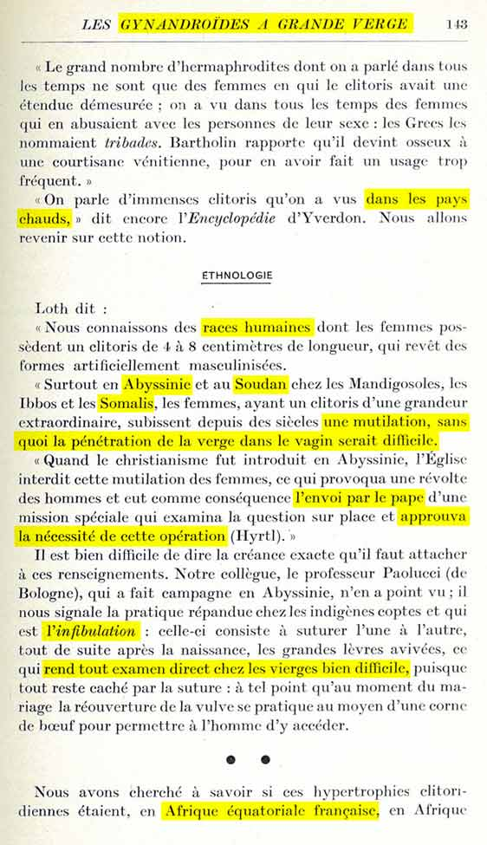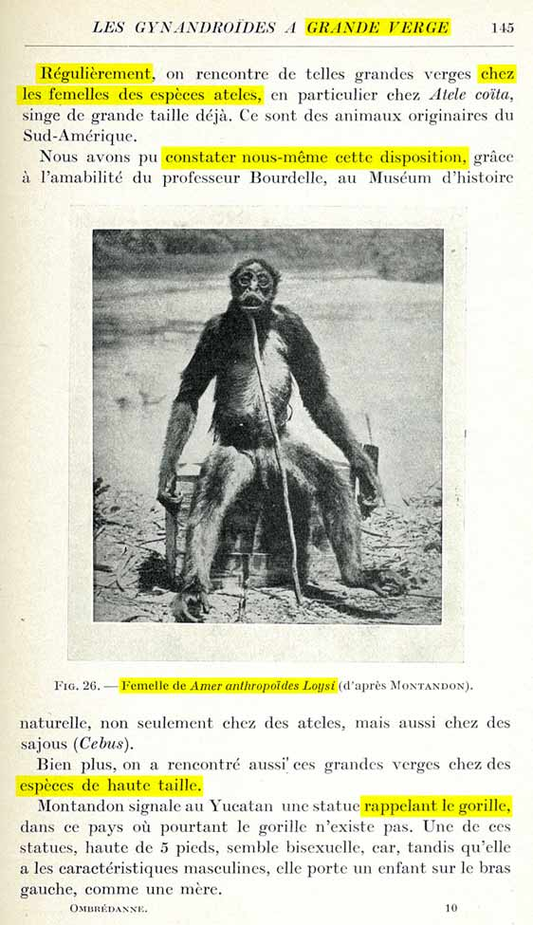
Paris 1939: “Les Hermaphrodites et la Chirurgie”
– Five Centuries of Dehumanising ‘Scientific’ Prejudice and Practice in a Nutshell
Ombrédanne’s textbook “Hermaphrodites and Surgery” offers a thorough collection of harmful ‘scientific notions’ originally established in France during the ‘age of enlightenment’, and still informing the western medical practice today, namely that
- intersex is a subhuman species, and therefore most frequent in less developed and more primitive sections of the human race, traditionally located in the hotter climates, as well as amongst primates, and
- for such less evolved specimens, practices that couldn’t be tolerated on fully-fledged humans, like for example clitoris amputations or FGM, are not just tolerable, but downright necessary, and even approved by a papal envoy.
While Ombrédanne’s own justifications are more secular and rationalised, the bottom line remains the same: In such specimens, amputation or cutting of the clitoris is surely justified.
Source: Louis Ombrédanne: Les Hermaphrodites et la Chirurgie. Paris, 1939, p. 143, 145
Dana Aliza Levy: “Conceptions and Perceptions of Human Difference: Albinos and Hermaphrodites in the Enlightenment”, Bachelor Thesis, 2012, see http://stop.genitalmutilation.org/post/Racist-Roots-of-Intersex-Genital-Mutilations-IGM
At the same time, all forms of IGM practices remain widespread and ongoing, persistently advocated by the official public medical body “Haute Autorité de Santé (HAS)”, including in “National Guidelines”, and paid for by the public health insurance, e.g. “feminising surgery” including partial clitoris amputation (for more examples, see p. 20-21; for photo of “feminising labioplasty” by Pierre Mouriquand, see 60):
“4.4.5 Surgical Procedure
“The surgical procedure during the first months of life includes three principal stages:
opening of the vaginal cavity at the pelvic floor (vaginoplasty), which represents the most difficult part, in particular in cases of high confluence
if necessary, the reduction in size of the clitoris while preserving the vascularisation and the nerves
the perineoplasty which, if possible, consists of the reconstruction of the small labia, the margins of the vaginal introitus, and the reduction of the labia majora which are often enlarged.”
Currently, all major French public University or Regional Children’s Clinics, including, but not limited to the government-appointed “Reference centres for rare diseases of sex development”, employ doctors advocating, prescribing and perpetrating IGM practices (for examples, see p. 21-23).
In addition, both the French state and French doctors and university clinics are deeply involved in the international perpertrators’ “research” projects “DSDnet” and “I-DSD”, which both advocate and perpertrate IGM practices (see p. 55-56).
3. IGM in France as a harmful practice and gender based violence
a) Article 5 in conjunction with General recommendation No. 31
Article 5 (a) of the Convention stipulates “To modify the social and cultural patterns of conduct of men and women, with a view to achieving the elimination of prejudices and customary and all other practices which are based on the idea of the inferiority or the superiority of either of the sexes or on stereotyped roles for men and women”.
This Committee has already recognised intersex issues to be relevant to the Convention in CEDAW/C/DEU/CO/6, paras. 4, 61, 62, 64 – as the first ever Committee to include intersex in Concluding Observations in 2009.
Since 2015, the Committee on the Rights of the Child (CRC) has repeatedly examined IGM practices, including in France, and consistently considered IGM to constitute a harmful practice and violence against children according to art. 24.3 CRC, typically referring to the Joint general recommendation No. 31 CEDAW / Joint general comment No. 18 CRC “on harmful practices” (JGR 31/18).

Clearly, due to their nature, IGM practices also fall within the scope of article 5 (a) CEDAW and JGR No. 31/18.
JGR No. 31/18 clearly stipulates the right of victims of IGM practices to “equal access to legal remedies and appropriate reparations” (para 55 (q)), and specifically to ensure that “children subjected to harmful practices have equal access to justice, including by addressing legal and practical barriers to initiating legal proceedings, such as the limitation period” (para 55 (o)).
b) Article 1 in conjunction with General recommendation No. 19
In addition, due to their nature, IGM practices clearly also constitute a form of gender-based violence, and thus also article 1 of the convention in conjunction with the Committee’s General recommendation No. 19 applies, which further underline the right to life (para 7 (a)) and the right to protection from ill-treatment (CIDT) (para 7 (b)).
As selective abortions of intersex fetuses is also practiced in France, also GR 19 para 7 (a) applies.
Regarding ill-treatment (GR 19 para 7 (b)), since 2011 the Committee against Torture (CAT) has repeatedly examined IGM practices, including in France, and consistently considered them as constituting at least ill-treatment.
Thus, also art. 1 CEDAW in conjunction with GR 19 apply.
c) Article 12 in conjunction with General recommendation No. 19
States parties are required by article 12 to take measures to ensure equal access to health care, and GR 19 particularly underlines the right to the highest standard attainable of physical and mental health (para 7 (g)).
IGM practices per se are detrimental to the health of survivors. Additionally, one specific form of IGM practices is denial of needed health care (see p. 50).
In addition, the Special Rapporteur on Health has identified intersex children as a “vulnerable group” and IGM practices as a “painful and high-risk procedure with no proven medical benefits”, and IGM 2 “clitoral reduction” as constituting “a form of female genital mutilation”.
Thus, also art. 12 CEDAW in conjunction with GR 19 applies.
4. French IGM doctors consciously dismissing human rights concerns
It must be duly noted that French paediatric surgeons and endocrinologists are particularly adamant advocates of IGM practices, consciously dismissing to consider any human rights concerns, despite openly acknowledging knowledge of relevant criticisms by human rights and ethics bodies.
For example Prof. Alaa El-Ghoneimi (Hôpital Universitaire Robert-Debré, Paris, see p. 23) simply dismissed the 2013 Report by the Special Rapporteur on Torture as “unjust”.
In the same vein, Prof. Pierre Mouriquand (Centre Hospitalier Universitaire de Lyon, see p. 21-22) dismissed both the 2013 Report by the Special Rapporteur on Torture and the 2012 Recommendations by the Swiss National Advisory Commission on Biomedical Ethics blanketly as “inappropriate and biased statements” and “biased and counterproductive reports”, while insisting on continuing with IGM practices.
And in a 2016 article (in press), Prof. Pierre Mouriquand (Centre Hospitalier Universitaire de Lyon, see p. 21-22, corresponding author), Dr. Claire Bouvattier (Hôpitaux universitaires Paris-Sud – Hôpital Kremlin-Bicêtre, see p. 22-23), Prof. Alaa El-Ghoneimi (Hôpital Universitaire mère-enfant Robert-Debré, Paris, see p. 23), Dr. Claire-Lise Gay, Dr. Daniela Gorduza and Dr. Pierre-Yves Mure (all Centre Hospitalier Universitaire de Lyon, see p. 21-22), all working in or collaborating with government-appointed “Reference centre for rare diseases of sex development” join up with two dozen mostly well-known international IGM advocates (including Mouriquand’s co-authors of the 2013 “ESPU standpoint”, see above) to continue to advocate early involuntary IGM surgeries on intersex children, justified e.g. to “Restore functional genital anatomy to allow future penetrative intercourse (as a male or a female)”, “Avoid stigmatization related to atypical anatomy” and “To respond to the parents’ desire to bring up a child in the best possible conditions” – while at the same time not once even mentioning the human rights of the children concerned.
This blatant omission led to a response by two bioethicists, reiterating:
“The lack of evidence appears not to have had much impact on physicians’ confidence in a standard of care that has remained largely unchanged. More damningly, nowhere in this paper is there a discussion of respect for DSD patients’ right to decide for themselves whether to have healthy sexual tissue removed. The authors simply ignored the violations of human rights entailed by the prevailing standard of care that have been identified in statements by Swiss and German ethics councils[2] and [3], the United Nations [4], and the Council of Europe [5]. Nowhere is there discussion of psychosocial (including peer) support for the child or family, despite the whole approach being predicated on concerns about ‘stigma risk’ and despite the claim that a main goal is ‘to respond to the parents’ desire to bring up a child in the best possible conditions.’”
5. Lack of legislative provisions, impunity of the perpetrators
Article 5 (a) of the Convention in conjunction with the Joint general recommendation No. 31 CEDAW / Joint general comment No. 18 CRC “on harmful practices” (2014) underline state parties’ obligations to “explicitly prohibit by law and adequately sanction or criminalize harmful practices” (JGR 31/18, para 13), as well as to “adopt or amend legislation with a view to effectively addressing and eliminating harmful practices” JGR 31/18, para 55), and specifically to ensure “that the perpetrators and those who aid or condone such practices are held accountable” (JGR 31/18, para 55 (o)).
Also the Committee’s General recommendation No. 19 obliges State parties, inter alia, to “take appropriate and effective measures to overcome all forms of gender-based violence”(para 24 (a)), to “encourage the compilation of statistics and research on the extent, causes and effects of violence, and on the effectiveness of measures to prevent and deal with violence” (para 24 (c)), to provide “Effective complaints procedures and remedies, including compensation” (para 24 (I)), “take all legal and other measures that are necessary to provide effective protection of women against gender-based violence” (para 24 (t)).
Accordingly, with regards to IGM practices, the Committee on the Rights of the Child (CRC), referring to Article 24 para 3 CRC and the Joint general recommendation No. 31 CEDAW / Joint general comment No. 18 CRC, already explicitly recognised the obligation for State parties to “ensure that no-one is subjected to unnecessary medical or surgical treatment during infancy or childhood, guarantee bodily integrity, autonomy and self-determination to children concerned”, as well as to “[u]ndertake investigation of incidents of surgical and other medical treatment of intersex children without informed consent and adopt legal provisions in order to provide redress to the victims of such treatment, including adequate compensation”.
However, the French state party, despite now admitting to being made aware of the “extremely recent issue”, and having tasked the National Consultative Ethics Committee for health and life sciences (Comité consultatif national d’éthique pour les sciences de la vie et de la santé) to report on the matter, so far still refuses to “take effective legislative, administrative, judicial or other measures” to protect intersex children, but instead claims the “expertise” of the perpetrators themselves would be “best suited” to ensure prevention of further serious human rights violations of intersex children:
“With such complex medical questions, which entail multiple lifelong consequences, the quality of the medical expertise and care, and of a continuous dialogue is best suited to guarantee compliance with the rights of the child. It must ensure to prevent any premature decisions and any action, which later may be experienced as intolerable mutilation.”
What’s worse, after already having been reprimanded by CRC for IGM practices, when thereafter questioned by CAT, the French state party simply repeated verbatim the same statement regarding IGM as a purely “medical question” and “therapeutic decision”, and the “medical expertise” of IGM doctors as “best suited” to prevent IGM practices.
6. Obstacles to redress, fair and adequate compensation
The statutes of limitation prevent survivors of early childhood IGM Practices to call a court because persons concerned often do not find out about their medical history until much later in life, which in combination with severe trauma caused by IGM Practices often proves to amount to a severe obstacle. Even though in France the statutes of limitations compare favourably to neighbouring countries, they still effectively prohibit survivors of early childhood IGM practices to call a court, as persons concerned often do not find out about their medical history until much later in life, and severe trauma caused by IGM Practices often prohibits them to act in time once they do. So far there was no case of a victim of IGM practices succeeding in going to court (see also Case No. 1).
The French government so far refuses to ensure that non-consensual unnecessary IGM surgeries on minors are recognised as a form of genital mutilation or harmful practice, or as a form of torture or ill-treatment respectively, which would case formally prohibit parents from giving “consent”. In addition, the State party refuses to initiate impartial investigations, as well as data collection, monitoring, and disinterested research (see below 55-56). In addition, despite legal obligations to do so, also French hospitals are often unwilling to provide full access to patient’s files (see also Cases No. 1-2).
This situation is not in line with France’s obligations under the Convention.

B. Recommendations

The Rapporteurs respectfully suggest that, with respect to the treatment of intersex persons, the Committee includes the following measures in their recommendations to the French Government (in line with CRC’s previous recommendations to France, Switzerland, the United Kingdom and Ireland):

Harmful practices: Intersex persons
The Committee remains seriously concerned about cases of medically unnecessary and irreversible surgery and other treatment of intersex children and adults without their informed consent, which can cause severe suffering, and the lack of redress and compensation in such cases.
In the light of its joint general comment No. 31 (2014) and No. 18 of the Committee on the Rights of the Child on harmful practices, the Committee recommends that the State party:
(a) Ensure that no-one is subjected to unnecessary medical or surgical treatment during infancy or childhood, adopt legislation with a view to guarantee bodily integrity, autonomy and self-determination to persons concerned, and provide families with intersex children with adequate counselling and support;
(b) Undertake investigation of incidents of surgical and other medical treatment of intersex persons without informed consent and adopt legal provisions in order to provide redress to the victims of such treatment, including adequate compensation; and,
(c) Educate and train medical and psychological professionals on the consequences of unnecessary surgical and other medical interventions for intersex children, including of “blind” prenatal hormonal interventions on pregnant women and their children.

Annexe 1 – “Case Studies”

The first-person narratives have been collected for the 2015 France CRC NGO report. The abstracts were composed by the Rapporteurs. The identity of all persons concerned is known to the Rapporteurs.
Case Study No. 1
The person concerned was born 1971 in Nantes and raised as a girl. When turning 17, she consulted different doctors due to absent puberty, without letting her parents know. It was found that she had XY chromosomes and mixed gonads, but the doctors withheld the truth from her. She submitted to gonadectomy without informed consent, but was given conflicting justifications for the surgery by different doctors. 17 years later, after years of denial and breakdown, the person concerned returned to her former surgeon and finally gets to know the truth, but statutes of limitations have expired.
The person concerned tells their story:
In 1988, at the age of 17, after waiting to hit puberty in vain for years, I decided to consult a gynaecologist. I chose a specialist in Nantes, about 50 kilometres far from where I lived, instead of going to the family doctor, the subject being tabu at home. I left home hitchhiking, pretending to go to an appointment with the nephrologist who for years has been seeing me regularly for a renal insufficiency. I was welcomed by the gynaecologist Dr Françoise Dano who assured me that everything was normal. She prescribed me a blood test. When I met her again, her tone had changed. She was less confident and sent me to an endocrinologist. Therefore, I found myself as a sick person for something that I didn’t link with health.
The endocrinologist, Dr Hubert du Rostu, prescribed me a karyotype test. This examination reminded me of biology course at school, where we studied the human karyotype, showing but one anomaly, trisomy 21. I therefore asked myself what had brought them to suspect me in such a way. I went to see Dr Dano, the gynaecologist, to know about the result of this examination. She put down the document in front of me and explained that there was no anomaly. I couldn’t stop looking at the paper where I read that my sex chromosomes were XY, which seemed to contradict my biology course. My knowledge vanished in front of the confidence with which Dr Dano assured me that everything was OK.
I returned to high school the next day and couldn’t help myself to brag about having had a chromosomal analysis which turned out to be perfect, thus XY. I was so happy that they hadn’t found trisomy. The entire class burst out laughing, and I was told that this was impossible, since XY are male sex chromosomes. I was confused and told myself that I might have read it wrong. I still was waiting for an injection or a treatment which would induce my puberty, the only reason why I had turned to a doctor. Instead of that, the endocrinologist and the gynaecologist decided to send me to the Brétésché clinic in Nantes to see the urologist and surgeon Dr Éric Hermouët to have my ovaries examined with a camera and under general anaesthetic. I left the clinic without knowing more about it.
I saw Dr Dano again with the idea that everything was finally settled. She told me again that they had to observe the ovaries with the naked eye via exploratory surgery before the treatment could start. I was hospitalised for two and a half days for this intervention. I was asked to enter the clinic on a Sunday evening, Dr Hermouët received me in the deserted outpatients department, and made me sign a consent form allowing him to remove everything which had to be. I was underage then. I didn’t meet Dr Hermouët after the surgery and couldn’t get any information before leaving the clinic. I went to see the family doctor a week later to remove the stitches like the nurse at the clinic had asked me.
I encountered his substitute who took note of the letter from the surgeon in front of me. He seemed stunned. When he realised I hadn’t been informed at all, his jaw dropped, and he eventually told me that they had removed my ovaries. This was the first blow. I realized that I would never have children. The substitute recommended to return to see the family doctor after he’d be back from his holiday. I went to see Dr André Le Cardiec the next week. However, I didn’t encounter the warm person who had cared for all my family, but an outraged man who was shouting at me. As I showed no reaction to his words which I couldn’t comprehend, he completely lost his temper and told me that my kidney failure was something rare, but what they had just discovered inside of me was extremely rare and monstrous. I was shocked by his agitation and his offending words.
They had discovered that I was a monster, my life left me and endless emptiness took its place. I walked out of the doctor’s office watching the sky hoping that someone over there come and tell me that I had landed on the wrong planet. I didn’t know where to go. Then I decided to go back to my mother’s place and I entered into a period of self-destruction which lasted two years. Two weeks after this horrifying news, I saw Dr Dano who softened the subject talking about a removal of ovaries that had been necessary to avoid cancer. She assured me that I was a complete woman and that it would be possible for me to bear children with hormonal therapy and an egg cell donation. I clung to this hope and entered into adulthood with the hormonal treatment. Then I cut off with all these doctors except Dr Dano, the gynaecologist. Two years later, in 1990, I couldn’t remember what had happened.
17 years later, after years of denial and breakdowns, I decided to meet Dr Hermouët again to understand the nature of the surgery I was submitted to in 1988. First he denied and explained that it was his father, which had retired, who had operated me. Then he excused himself and asked me to leave his office because he had to take care of a child birth. I realized that he tried to hide something and I waited for him to return in front of his door. He returned half an hour later, holding my medical records in his hands. He then invited me to enter his study and warned me that what was inside of this file was unspeakable. I insisted to know and he explained that my karyotype turned out to be male, and that they had removed one gonad on the occasion of the first surgical examination, which turned out to be a testicle. The second had been removed during the second surgery.
Anyway, that was different from what I was told earlier. I was both proud and shaky when I visited Dr Dano, the gynaecologist who meanwhile had refused to let me try assisted reproduction with egg cell donation. I told her what I had learned. She categorically denied everything, called me delirious and suggested to call a psychiatrist for an appointment. Also when I tried to talk to her about this subject later, she always insisted she wasn’t aware of this and that she wasn’t my doctor at that time. When I asked her why she prescribed me hormones, she answered that I suffered from early menopause or from ovarian cancer, insisting that this was the only information given to her. Then I found some support in a community center, before meeting other intersex persons via OII Francophonie.
In 2015, I tried to get my medical records back from Dr du Rostu’s office. As soon as he received my letter he called me back claiming that he had no file with my name in his office. I then threatened to come with a lawyer which gave him a scare. He promised to look for it. A few hours later he called me back to say he couldn’t find anything with my name in his records. A week later, I received a one page document that was difficult to read. It was the result of the analysis of the first testicle removed, describing ovarian tissue without egg cells and showing no risk of malignancy. A week later I received three more pages of my records among which there was the analysis of the second gonad describing a mixture of ovarian and testicular tissues, but still with no risk of malignancy. Therefore, Dr Hermouët had lied to me when he claimed that he had found testicles instead of ovaries, to avoid me to contest these operations. Between 2007 and 2015, the statutes of limitations which are twenty years in France had expired and it was to late to register a complaint.

Case Study No. 2
The person concerned was born 1965 in the Clinique des Sablons in Neuilly sur Seine, with a micro penis, without scrotum and testes, and a vaginal cavity. The diagnosis was “déficit gonadique primitif” / „anorchia“ (absence of testes, gonadal dysgenesis, streak gonads). The child was raised as a boy. The gonads were removed, and a scar on the penis suggests a hypospadias surgery. A test at age 10 showed male chromosomes XY. Later a gynaecologist confirmed the probable removal of an uterus. The person suffers to this day from the treatment and lies, and is unable to work.
The person concerned tells their story:
I was born 1965 in the Clinique des Sablons in Neuilly sur Seine, with a micropenis, without scrotum and testes, and with a hidden vaginal cavity, as the third of six children, to a professor of history and a nurse. I was hospitalised immediately at the Hôpital Saint-Vincent-de-Paul in Paris for fifteen days. Neither me nor my parents know what happened during these days. When I was returned to my parents, they were only informed that I had suffered an allergic reaction to antibiotics. I was eventually diagnosed with „déficit gonadique primitif“ (gonadal dysgenesis) and „anorchia“ (absence of testes). When my mother picked me up, the doctors told her that I was a monster and that I would die soon.
Until the age of six I lived a normal life with my parents and siblings, and went to school regularly. Nobody told me anything and I never asked questions.
At six years, I underwent a first exploratory surgery without results, performed by doctor Ficheux at the Clinique Villa Medicis in Courbevoie, which was declared as appendectomy. I have no idea if they already removed my gonads or if they did it later.
After this surgery my parents bought a house in the Bretagne, twelve hours from our home, where I would live most of the time during the year, together with my grandmother and a schizophrenic uncle, because my parents were ashamed of me, especially after the surgeries.
After having raised thirteen children herself, my grandmother didn’t want me. She was always very severe and ordered me around. Even when I was week after surgery, I had to make my bed alone. I had to help a lot on my grandmother’s farm, went to school rarely and didn’t have much contact with peers. When my grandmother had to attend a family celebration, my uncle was put in a hospital and I was sent to stay with another family. At the funeral of my mother a year ago, a lot of my relatives were surprised to see me, they thought I had died as a child.
Although at the age of seven my life was normal, and I didn’t have any pain or difficulties urinating, until the age of majority I was treated quarterly at the Hôpital Trousseau in Paris by urologist Jacques Brueziere, head of department Béatrice Mougenot, and endocrinologist M.C. Raux-Eurin.
I only stayed with my parents when I had to go to the hospital in Paris for my quarterly examinations or for surgeries. During that time I also attended school near Paris. My siblings and classmates never understood why I was absent so often. When I was well I would stay at my parent’s house for a month or so. When I had surgery they would send me back to my grandmother in the Bretagne.
During the quarterly appointments at the hospital, where I had to stay for some days or even a week, the doctors performed X-rays to determine the bone maturity, they took blood samples, urinary probes, they examined my naked body, looked at my genitals, checked the growth of my armpit hair, and took photographs. Afterwards, they first talked with my parents alone, then with me and my parents together. I also had to see a doctor who performed psychological tests, but didn’t even know he was a psychologist.
I was intimidated and afraid. The doctors never told me or my parents anything but, “Everything is OK”, or “don’t cry, you are big”. They told me that there is nobody else like me, that I am the only one on this planet.
I suffered very early of anxiety, and our family doctor prescribed me tranquilisers.
The doctors told my parents that I was a failed boy, but they would fix me, and that everything was alright. They regularly gave me testosterone injections.
Since my mother couldn’t get any answers out of the doctors, she asked a personal friend who happened to be a clinician herself. I know from correspondence in my medical records that both, my mother’s doctor friend and our family doctor, were instructed to tell us exactly the same: that everything is OK, I just had to take the testosterone and attend the quarterly examinations. My mother was very disappointed when she found out.
In the following years I underwent another three large surgeries at the Hôpital Trousseau in Paris, which also are referred to as functional explorations in my medical records without further specifications. My parents weren’t informed about the results, or what was done exactly.
A total of ten scars on my abdomen suggest even more surgeries which aren’t mentioned in the medical records I was eventually able to obtain.
After surgery the doctors would always apply an urethral catheter, although I was able to go to the toilet myself – unlike other children in the same room, which for example had a broken leg, but used a urine bottle.
My urethral catheter was often removed roughly, although I told the nurse I felt it was sticking, which was very painful. I regularly ended up with having infections, blood and pus in my urine, which required a treatment with antibiotics.
During the morning visits, often 10–15 medical personnel and students came into the room, the Professor lifted my blanket, and everybody stared at my genitals.
My father used to bring me to hospital, and my mother came to take me home afterwards. But they both never visited me in the hospital. My father said he was too busy, and my mother couldn’t bear it. Once she had encountered me lying in bed, hands and feet bound, and was shocked. Only two young aunts came to see me once a week. Sometimes it was a friend of my parents, who brought me to the hospital. When my mother came to the hospital to take me home, we didn’t take a taxi, but went with the bus to the train station, although I couldn’t barely stand straight because I was weak and in pain. My mother was ashamed, because people looked at me, and told me to pull myself together.
My mother told me more than once it would have been better, if I was born dead. „If I had known, I would have aborted you.“
At thirteen, the doctors prescribed me regular shots of testosterone. Nonetheless, I developed breasts during puberty which I hid under baggy clothes. I hated the testosterone shots, they gave me headaches and tremendous pain in my legs, I was aggressive and couldn’t sleep, nor concentrate at school. However, the doctors always blamed something else, preferably growing pains or my attitude, and insisted on continuing with the shots. Eventually, at sixteen I simply refused to see them anymore, and until the age of 22 I had no hormones at all.
I found out myself that I had a vaginal cavity which was closed by a membrane. When I was 22 a gynaecologist confirmed that I have a small vaginal cavity. Some years ago another gynaecologist told me that based on the informations in the medical records, I must have had at least the rudiment of an uterus, which obviously had been removed.
I was able to obtain some of my medical records in 2003 with the help of my former family doctor, who told me that, because of a new law in France from 2002, every patient would have the right to have his medical records. So he ordered my medical records and we studied them together. They weren’t complete, the years until I turned six were missing, and there were some sheets which obviously belonged to another boy’s records.
This was the first time I learned that I am intersex. I was happy, because it proved I wasn’t crazy after all.
Nonetheless, in my adult years my bad experiences with doctors and hospitals continued. Several times I was forced to or blackmailed into „consenting“ to hormonal treatments or surgeries, for example when my parents admitted me to a clinic after a suicide attempt.
I have been taking anxiolytics, antidepressants and mood stabilisers from the age of eighteen. When I stopped with the anxiolytics for a few months, my genital and my legs started to hurt. My doctor told me that the anxiolytics were also painkillers and had suppressed the pain.
To this day I can’t sleep except when I am dead tired or with the aid of barbiturates, because I have nightmares either of surgeries or medical exams, or training courses for assistant doctors, where they displayed me naked.
I still suffer from an intense pain when I urinate, recurring urinary tract infections, and incontinence.
Today I refuse any follow-up treatments, and any hormone replacement therapy with testosterone, but I take estrogen without prescription instead. My body didn’t change. However, I no longer suffer from hot flashes, and I could quit the mood-stabilisers which I was prescribed for many years.
Since 2006, I am unable to work due to anxiety and incontinence. At 50, I never made any contribution to a retirement pension, I am without home, and on welfare.
Annexe 2 – IGM Practices in France: Facts and Figures
1. Lack of Protection for Intersex Persons, IGM Practices Remain Pervasive
a) Summary
In France (see CRC/C/FRA/CO/5, paras 47-48; CAT/C/FRA/CO/7, paras 32–33) there are no legal or other protections in place to ensure the rights of intersex children to physical and mental integrity, autonomy and self-determination, with the French government framing IGM practices as mere “complex medical questions” and “therapeutic decisions” (see p. 11-12).
All forms of IGM practices remain widespread and ongoing, persistently advocated by the official public medical body “Haute Autorité de Santé (HAS)”, including in “National Guidelines”, and paid for by the public health insurance.
Currently, all major French public University or Regional Children’s Clinics, including, but not limited to the government-appointed “Reference centres for rare diseases of sex development”, employ doctors advocating, prescribing and perpetrating IGM practices.
2. Most Common IGM Forms advocated by Officially Appointed Bodies and Doctors
a) IGM 3: Sterilising Procedures plus arbitrary imposition of hormones
(see also Cases No. 1–2), as advocated by Prof. Pierre Mouriquand, chief surgeon of one of the government-appointed “Reference centres for rare diseases of sex development”:
“Surgery on the gonads
• Removal of the gonads in CAIS and PAIS because of risk of tumours in adults.
• Early surgery or surgery during puberty, according to the choice of the parents:
• Associated inguinal hernia
• Psychological problems according to age”
See also photos of gonadectomies by Pierre Mouriquand on 2016 CRC France NGO Report p. 55
b) IGM 2: Feminising Genital Surgeries,
as advocated by the official public medical body “Haute Autorité de Santé (HAS)” in their “National CAH Guidelines”:
“4.4 Surgical Therapy
“4.4.1 Environment
“[...] The surgical treatment is prescribed by the paediatric surgeon according to surgery for anomalies of sex development.
“4.4.2 Surgical Schedule
“French surgeons operate on the little girls when the metabolical and endocrine situation is stable, earliest in the first months of life. The essential reasons for choosing this age is the responsiveness of genital tissues when the repair is done early, and the minimisation of psychological consequences for the child and the parents.”
“4.4.5 Surgical Procedure
“The surgical procedure during the first months of life includes three principal stages:
opening of the vaginal cavity at the pelvic floor (vaginoplasty), which represents the most difficult part, in particular in cases of high confluence
if necessary, the reduction in size of the clitoris while preserving the vascularisation and the nerves
the perineoplasty which, if possible, consists of the reconstruction of the small labia, the margins of the vaginal introitus, and the reduction of the labia majora which are often enlarged.”
See also photo of “feminising labioplasty” by Pierre Mouriquand on p. 60

c) IGM 1: Masculinising Genital Surgeries
(see also Case No. 2), as advocated by the official public medical body “Haute Autorité de Santé (HAS)”:
“1.2.3. Position of the working group
“[...] According to the working group, [penile] curvatures associated with a hypospadias [...] are ideally operated in early infancy [...].”
According to a publication by a public medical body under the auspices of the French Ministry of Health and based on statistics obtained from the official hospital activity and expenditure data (“Programme de médicalisation des systèmes d’information (PMSI)”), in France over 3000 children under 7 years are submitted to “hypospadias repair surgery” every year, with the majority of children under 2 years at the time of surgery, and with total numbers increasing yearly, and the age at surgery becoming lower and lower.
See also photos of “masculinising hypospadias repair” by Pierre Mouriquand on p. 59
Repeated Forced Genital Exams and Photography (see also Case No. 2) are also common place in France, see e.g. the pictorial examples published by the “French Urology Association”.
3. Examples of French University Children’s Clinics advocating & perpetrating IGM
a) Centre Hospitalier Universitaire de Lyon,
government-appointed “Reference centre for rare diseases of sex development”, see various pictorial and text examples in publications and presentations. Chief surgeon Prof. Pierre Mouriquand and fellow surgeon Dr. Daniela Gorduza are also part of the surgeon’s working group responsible for the “National CAH Guidelines” advocating “feminising” IGM practices (see above). CHU de Lyon is also part of the international perpetrator’s study “DSDnet”, where surgeon Pierre Mouriquand is listed as participant, as well as part of the international perpetrator’s study “DSD-Life”, where surgeon Daniela Gorduza is listed in the project staff (for background information on both “DSDnet” and “DSD-Life” see also below p. 55–56).
Prof. Mouriquand is also known as a particularly adamant advocate of IGM practices consciously dismissing human rights concerns (see below p. A.1.d).
See also pictorial examples of IGM practices by Pierre Mouriquand on p. 57-60
b) Hôpitaux universitaires Paris-Sud (Hôpital Kremlin-Bicêtre),
government-appointed “Reference centre for rare diseases of sex development”, is also part of the international perpetrator’s study “DSD-Life” (see also below p. 55-56), where endocrinologist Dr. Claire Bouvattier is listed as the scientific lead, and the centre (self-)described as follows:
“The Department of Pediatric Endocrinology, Hôpital Kremlin Bicêtre, has a longstanding experience in clinical care of patients with DSD. Dr. Claire Bouvattier sees 250-300 patients/year with DSD in their clinics and have access to all DSD patients of associated hospitals through the French National DSD Reference centre. The French National DSD Reference Paris centre comprises a multidisciplinary specific DSD team including: Pediatric Endocrinology, Pediatric Radiology, Hormonal and Molecular Biologiy [sic], Pediatric Surgery, Gynecology and Psychologiy [sic]. [...] As our DSD center is a partner for all the French pediatric endocrinologists, we will coordinate the study DSD-Life in France.”
A 2014 “DSD-Life”-presentation co-authored by Dr. Claire Bouvattier lists for “Individuals with DSD” the following common surgical procedures:
“[S]urgery
Vaginoplasty (CAH, XY DSD)
Hypospadias repair (XY DSD, hypospadias)
Orchidopexy (XY DSD, hypospadias)
Gonadectomy (XY DSD)”
And an online fact sheet “Doctor, is it a boy or a girl?” co-authored by Dr. Claire Bouvattier and paediatric surgeon Dr. Daniela Gorduza (CHU Lyon, see above) claims:
“(12) The goal of the surgical intervention is to give back [sic] an anatomy and functionality of the genital apparatus by carrying out feminising or masulinising surgery.”
c) Hôpital Universitaire mère-enfant Robert-Debré, Paris
lists as “Specialty: surgery on anomalies of the genitourinary system” Prof. Alaa El-Ghoneimi, consulting surgeon for paediatric urology, is also part of the surgeon’s working group of the French National CAH guidelines (see above A.1.b “feminising surgeries”), and a particularly adamant advocate of IGM practices consciously dismissing human rights concerns (see below A.1.d).
d) Lille University Clinic (Hôpital Jeanne de Flandre),
in a 2015 presentation by paediatric surgeons of the clinic, counts “1003 cases of hypospadias were identified in our reference center” from 1992–2012.
e) Amiens University Clinic,
in a 2015 presentation by paediatric surgeons of the clinic, counts 57 cases of hypospadias including 10.5% cases of undescended testes enrolled in a 2011–2014 study.
Supplement 1 – Bibliography: Intersex & Human Rights Mechanisms
1. International Bodies Recognising Human Rights Violations of Intersex Children
2006: UN WHO, Genomic resource centre, Gender and Genetics: Genetic Components of Sex and Gender (online)
http://www.who.int/genomics/gender/en/index1.html
Gender Assignment of Intersex Infants and Children
Intersex is defined as a congenital anomaly of the reproductive and sexual system. An estimate about the birth prevalence of intersex is difficult to make because there are no concrete parameters to the definition of intersex. The Intersex Initiative, a North-American based organization, estimates that one in 2,000 children, or five children per day in the United States, are born visibly intersex. (36) This estimate sits within range; from genital anomalies, such as hypospadias, with a birth prevalence of around 1:300 to complex genital anomalies in which sex assignment is difficult, with a birth prevalence of about 1:4500. (37) Many intersex children have undergone medical intervention for health reasons as well as for sociological and ideological reasons. An important consideration with respect to sex assignment is the ethics of surgically altering the genitalia of intersex children to “normalize” them.
Clitoral surgery for intersex conditions was promoted by Hugh Hampton Young in the United States in the late 1930s. Subsequently, a standardized intersex management strategy was developed by psychologists at Johns Hopkins University (USA) based on the idea that infants are gender neutral at birth. (38) Minto et al. note that “the theory of psychosexual neutrality at birth has now been replaced by a model of complex interaction between prenatal and postnatal factors that lead to the development of gender and, later, sexual identity”. (39) However, currently in the United States and many Western European countries, the most likely clinical recommendation to the parents of intersex infants is to raise them as females, often involving surgery to feminize the appearance of the genitalia. (40)
Minto et al. conducted a study aiming to assess the effects of feminizing intersex surgery on adult sexual function in individuals with ambiguous genitalia. As part of this study, they noted a number of ethical issues in relation to this surgery, including that:
- there is no evidence that feminizing genital surgery leads to improved psychosocial outcomes;
- feminizing genital surgery cannot guarantee that adult gender identity will develop as female; and that
- adult sexual function might be altered by removal of clitoral or phallic tissue. (41)

2009: UN CEDAW, CEDAW/C/DEU/CO/6, 10 February 2009, para 61–62:
http://www2.ohchr.org/english/bodies/cedaw/docs/co/CEDAW-C-DEU-CO6.pdf
Cooperation with non-governmental organizations
61. [...] The Committee regrets, however, that the call for dialogue by non-governmental organizations of intersexual [...] people has not been favourably entertained by the State party.
62. The Committee request the State party to enter into dialogue with non-governmental organizations of intersexual [...] people in order to better understand their claims and to take effective action to protect their human rights.
Follow-up to concluding observations
67. The Committee requests the State party to provide, within two years, written information on the steps undertaken to implement the recommendations contained in paragraphs 40 and 62.

2009: UN SR Health, A/64/472, 10 August 2009, para 49:
http://www.refworld.org/pdfid/4aa762e30.pdf
IV. Vulnerable groups and informed consent
A. Children
49. Health-care providers should strive to postpone non-emergency invasive and irreversible interventions until the child is sufficiently mature to provide informed consent. [67] [Fn. 67: This is particularly problematic in the case of intersex genital surgery, which is a painful and high-risk procedure with no proven medical benefits; see, e.g., Colombian Constitutional Court, Sentencia SU-337/99 and Sentencia T-551/99.] Safeguards should be in place to protect children from parents withholding consent for a necessary emergency procedure.

2011: UNHCHR, A/HRC/19/41, 17 November 2011, para 57:
http://www.ohchr.org/Documents/Issues/Discrimination/A.HRC.19.41_English.pdf
“In addition, intersex children, who are born with atypical sex characteristics, are often subjected to discrimination and medically unnecessary surgery, performed without their informed consent, or that of their parents, in an attempt to fix their sex.”

2011: UN CAT, CAT/C/DEU/CO/5, 12 December 2011, para 20:
http://www2.ohchr.org/english/bodies/cat/docs/co/CAT.C.DEU.CO.5_en.pdf
Intersex people
20. The Committee takes note of the information received during the dialogue that the Ethical Council has undertaken to review the reported practices of routine surgical alterations in children born with sexual organs that are not readily categorized as male or female, also called intersex persons, with a view to evaluating and possibly changing current practice. However, the Committee remains concerned at cases where gonads have been removed and cosmetic surgeries on reproductive organs have been performed that entail lifelong hormonal medication, without effective, informed consent of the concerned individuals or their legal guardians, where neither investigation, nor measures of redress have been introduced. The Committee remains further concerned at the lack of legal provisions providing redress and compensation in such cases (arts. 2, 10, 12, 14 and 16).
The Committee recommends that the State party:
(a) Ensure the effective application of legal and medical standards following the best practices of granting informed consent to medical and surgical treatment of intersex people, including full information, orally and in writing, on the suggested treatment, its justification and alternatives;
(b) Undertake investigation of incidents of surgical and other medical treatment of intersex people without effective consent and adopt legal provisions in order to provide redress to the victims of such treatment, including adequate compensation;
(c) Educate and train medical and psychological professionals on the range of sexual, and related biological and physical, diversity; and
(d) Properly inform patients and their parents of the consequences of unnecessary surgical and other medical interventions for intersex people.

2013: UN SR Torture, A/HRC/22/53, 1 February 2013, paras 77, 76, 88:
http://www.ohchr.org/Documents/HRBodies/HRCouncil/RegularSession/Session22/A.HRC.22.53_English.pdf
77. Children who are born with atypical sex characteristics are often subject to irreversible sex assignment, involuntary sterilization, involuntary genital normalizing surgery, performed without their informed consent, or that of their parents, “in an attempt to fix their sex”, [107] leaving them with permanent, irreversible infertility and causing severe mental suffering.
76. [...] These procedures [genital-normalizing surgeries] are rarely medically necessary,[106] can cause scarring, loss of sexual sensation, pain, incontinence and lifelong depression and have also been criticized as being unscientific, potentially harmful and contributing to stigma (A/HRC/14/20, para. 23). [...]
88. The Special Rapporteur calls upon all States to repeal any law allowing intrusive and irreversible treatments, including forced genital-normalizing surgery, involuntary sterilization, unethical experimentation, medical display, “reparative therapies” or “conversion therapies”, when enforced or administered without the free and informed consent of the person concerned. He also calls upon them to outlaw forced or coerced sterilization in all circumstances and provide special protection to individuals belonging to marginalized groups.

2013: Council of Europe (COE), Resolution 1952 (2013) “Children’s right to physical integrity”, 1 October 2013, paras 2, 6, 7:
http://www.assembly.coe.int/nw/xml/XRef/X2H-Xref-ViewPDF.asp?FileID=20174&lang=en
2. The Parliamentary Assembly is particularly worried about a category of violation of the physical integrity of children, which supporters of the procedures tend to present as beneficial to the children themselves despite clear evidence to the contrary. This includes, amongst others, female genital mutilation, the circumcision of young boys for religious reasons, early childhood medical interventions in the case of intersex children and the submission to or coercion of children into piercings, tattoos or plastic surgery.
6. The Assembly strongly recommends that member States promote further awareness in their societies of the potential risks that some of the above mentioned procedures may have on children’s physical and mental health, and take legislative and policy measures that help reinforce child protection in this context.
7. The Assembly therefore calls on member States to:
7.1. examine the prevalence of different categories of non-medically justified operations and interventions impacting on the physical integrity of children in their respective countries, as well as the specific practices related to them, and to carefully consider them in light of the best interests of the child in order to define specific lines of action for each of them;
7.2. initiate focused awareness-raising measures for each of these categories of violation of the physical integrity of children, to be carried out in the specific contexts where information may best be conveyed to families, such as the medical sector (hospitals and individual practitioners), schools, religious communities or service providers; [...]
7.4. initiate a public debate, including intercultural and interreligious dialogue, aimed at reaching a large consensus on the rights of children to protection against violations of their physical integrity according to human rights standards;
7.5. take the following measures with regard to specific categories of violation of children’s physical integrity: [...]
7.5.3. undertake further research to increase knowledge about the specific situation of intersex people, ensure that no-one is subjected to unnecessary medical or surgical treatment that is cosmetic rather than vital for health during infancy or childhood, guarantee bodily integrity, autonomy and self-determination to persons concerned, and provide families with intersex children with adequate counselling and support; [...]
7.7. raise awareness about the need to ensure the participation of children in decisions concerning their physical integrity wherever appropriate and possible, and to adopt specific legal provisions to ensure that certain operations and practices will not be carried out before a child is old enough to be consulted.

2014: UN CRPD, CRPD/C/DEU/Q/1, 17 April 2014, paras 12–13:
http://tbinternet.ohchr.org/Treaties/CRPD/Shared%20Documents/DEU/CRPD_C_DEU_Q_1_17084_E.doc
Freedom from exploitation, violence and abuse (art. 16)
12. How many irreversible surgical procedures have been undertaken on intersexual children before an age at which they are able to provide informed consent? Does the State party plan to stop this practice?
13. Please provide up to date statistics on forced sterilizations of persons, i.e. without their free and informed consent.

2014: OHCHR, UN Women, UNAIDS, UNDP, UNFPA, UNICEF and WHO, Eliminating forced, coercive and otherwise involuntary sterilization. An interagency statement, May 2014, paras 2, 6, 7:
http://www.who.int/iris/bitstream/10665/112848/1/9789241507325_eng.pdf?ua=1
Background
Some groups, such as […] intersex persons, also have a long history of discrimination and abuse related to sterilization, which continues to this day. […] Intersex persons, in particular, have been subjected to cosmetic and other nonmedically necessary surgery in infancy, leading to sterility, without informed consent of either the person in question or their parents or guardians. Such practices have also been recognized as human rights violations by international human rights bodies and national courts (15, 64).
[…] [I]ntersex persons
Intersex persons may be involuntarily subjected to so-called sex-normalizing or other procedures as infants or during childhood, which, in some cases, may result in the termination of all or some of their reproductive capacity. Children who are born with atypical sex characteristics are often subjected to cosmetic and other non-medically indicated surgeries performed on their reproductive organs, without their informed consent or that of their parents, and without taking into consideration the views of the children involved (64; 147, para 57; 148; 149). As a result, such children are being subjected to irreversible interventions that have lifelong consequence for their physical and mental health (64; 150, para 20; 151).
Medical procedures that might result in sterility may sometimes be justified because of benefits to health, including the reduction of cancer risk (152). Such treatments may be recommended for […] intersex persons; however, they may be proposed on the basis of weak evidence, without discussing alternative solutions that would retain the ability to procreate (151, 153–157). Parents often consent to surgery on behalf of their intersex children, including in circumstances where full information is lacking (151, 158, 159).
It has been recommended by human rights bodies, professional organizations and ethical bodies that full, free and informed consent should be ensured in connection with medical and surgical treatments for intersex persons (64, 150) and, if possible, irreversible invasive medical interventions should be postponed until a child is sufficiently mature to make an informed decision, so that they can participate in decision-making and give full, free and informed consent (15, 149). It has also been recommended that health-care professionals should be educated and trained about bodily diversity as well as sexual and related biological and physical diversity, and that professionals should properly inform patients and their parents of the consequences of surgical and other medical interventions (149; 150, para 20; 160–162).
Remedies and redress
- Recognize past or present policies, patterns or practices of coercive sterilization, and issue statements of regret or apology to victims, as components of the right to remedy for these practices.
- Provide notification, through appropriate and humane means, to people who have been subjected to coercive sterilization, and who may be unaware of their situation, and provide information on the possibility of seeking administrative and judicial redress.
- Promptly, independently and impartially investigate all incidents of forced sterilization with due process guarantees for the alleged suspect, and ensure appropriate sanctions where responsibility has been established.
- Provide access, including through legal aid, to administrative and judicial redress mechanisms, remedies and reparations for all people who were subjected to forced, coercive or involuntary sterilization procedures, including compensation for the consequences and acknowledgement by governments and other responsible authorities of wrongs committed. Enable adults to seek redress for interventions to which they were subjected as children or infants.
- Guarantee access to reversal procedures, where possible, or assisted reproductive technologies for individuals who were subjected to forced, coercive or otherwise involuntary sterilization.
Monitoring and compliance
- Establish monitoring mechanisms for the prevention and documentation of forced, coercive and otherwise involuntary sterilization, and for the adoption of corrective policy and practice measures.
- Collect data regarding forced, coercive and otherwise involuntary sterilization, in order to assess the magnitude of the problem, identify which groups of people may be affected, and conduct a comprehensive situation and legal analysis.
- Providers of sterilization services should implement quality improvement programmes to ensure that recommendations aimed at preventing forced, coercive and otherwise involuntary sterilization are followed and procedures are properly documented.
- Establish mechanisms for obtaining patient feedback on the quality of services received, including from marginalized populations.

2015: UN CRC, CRC/C/CHE/CO/2-4, 4 February 2015, paras 42–43:
http://tbinternet.ohchr.org/Treaties/CRC/Shared%20Documents/CHE/CRC_C_CHE_CO_2-4%20ADVANCE%20UNEDITED%20VERSION_19492_E.doc
E. Violence against children (arts. 19, 24, para. 3, 28, para. 2, 34, 37 (a) and 39) […]
Harmful practices
42. While welcoming the adoption of a new provision of criminal law prohibiting genital mutilation, the Committee is deeply concerned at: […]
(b) Cases of medically unnecessary surgical and other procedures on intersex children, which often entail irreversible consequences and can cause severe physical and psychological suffering, without their informed consent, and the lack of redress and compensation in such cases.
43. The Committee draws the attention of the State party to the Joint General Comment No. 18 on harmful practices (2014), together with the Committee on the Elimination of Discrimination against Women, and urges the State party to: […]
(b) In line with the recommendations on ethical issues relating to intersexuality by the National Advisory Commission on Biomedical Ethics, ensure that no-one is subjected to unnecessary medical or surgical treatment during infancy or childhood, guarantee bodily integrity, autonomy and self-determination to children concerned, and provide families with intersex children with adequate counselling and support.

2015: UN CRPD, CRPD/C/DEU/CO/1, 13 May 2015, p. 6–7, paras 37-38:
http://tbinternet.ohchr.org/_layouts/treatybodyexternal/Download.aspx?symbolno=CRPD/C/DEU/CO/1
Protecting the integrity of the person (art. 17)
37. The Committee is concerned about: [...] c) the lack of implementation of the 2011 recommendations CAT/C/DEU/CO/5, para. 20, regarding upholding bodily integrity of intersex children.
38. The Committee recommends that the State party take the necessary measures, including of a legislative nature to:
[...]
(d) Implement all the recommendations of CAT/C/DEU/CO/5, para. 20 relevant to intersex children.

2015: Commissioner on Human Rights of the Council of Europe (COE), Issue Paper “Human rights and intersex people”, 12 May 2015, p. 1–62:
https://wcd.coe.int/ViewDoc.jsp?Ref=CommDH/IssuePaper%282015%291&Language=lanEnglish&Ver=original&BackColorInternet=C3C3C3&BackColorIntranet=EDB021&BackColorLogged=F5D383

2015: WHO, Report “Sexual health, human rights and the law”, June 2015, p. 27-28:
http://apps.who.int/iris/bitstream/10665/175556/1/9789241564984_eng.pdf?ua=1
“A major concern for intersex people is that so-called sex normalizing procedures are often undertaken during their infancy and childhood, to alter their bodies, particularly the sexual organs, to make them conform to gendered physical norms, including through repeated surgeries, hormonal interventions and other measures. As a result, such children may be subjected to medically unnecessary, often irreversible, interventions that may have lifelong consequences for their physical and mental health, including irreversible termination of all or some of their reproductive and sexual capacity.”
“Increasingly, concerns are being raised by intersex people, their caregivers, medical professionals and human rights bodies that these interventions often take place without the informed consent of the children involved and/or without even seeking the informed consent of their parents (178, 262, 264, 270–273).”
“It has also been recommended [by human rights bodies and ethical and health professional organizations] that investigation should be undertaken into incidents of surgical and other medical treatment of intersex people without informed consent and that legal provisions should be adopted in order to provide remedies and redress to the victims of such treatment, including adequate compensation (91, 264).”

2015: UN CAT, CAT/C/CHE/CO/7, 14 August 2015, para 20:
http://intersex.shadowreport.org/public/CAT_C_CHE_CO_7-Concl-Obs-Switzerland-2015_G1520151.pdf
Intersex persons
20. The Committee welcomes the Federal Council decision to give an opinion by the end of 2015 on the recommendations of the National Advisory Commission on Biomedical Ethics with regard to the unnecessary and in some cases irreversible surgical procedures that have been carried out on intersex persons (i.e. persons with variations in sexual anatomy) without the effective, informed consent of those concerned. However, the Committee notes with concern that these procedures, which reportedly caused physical and psychological suffering, have not as yet given rise to any inquiry, sanction or reparation (arts. 2, 12, 14 and 16).
The Committee recommends that, in light of the forthcoming decision by the Federal Council, the State party:
a) Take the necessary legislative, administrative and other measures to guarantee respect for the physical integrity and autonomy of intersex persons and to ensure that no one is subjected during infancy or childhood to non-urgent medical or surgical procedures intended to decide the sex of the child, as recommended by the National Advisory Commission on Biomedical Ethics and the Committee on the Rights of the Child (see CRC/C/CHE/CO/2-4, para. 43 (b));
b) Guarantee counselling services and free psychosocial support for all persons concerned and their parents, and inform them that any decision on unnecessary treatment can be put off until the person concerned are able to decide for themselves;
c) Undertake investigation of reports of surgical and other medical treatment of intersex people without effective consent and adopt legal provisions in order to provide redress to the victims of such treatment, including adequate compensation.

2015: UN CRC, CRC/C/CHL/CO/4-5, 2 October 2015, paras 48–49:
http://tbinternet.ohchr.org/_layouts/treatybodyexternal/Download.aspx?symbolno=CRC%2fC%2fCHL%2fCO%2f4-5&Lang=en
Harmful practices
48. While noting the proposed development of a protocol for the health care of intersex babies and children, the Committee is seriously concerned about cases of medically unnecessary and irreversible surgery and other treatment on intersex children, without their informed consent, which can cause severe suffering, and the lack of redress and compensation in such cases.
49. In the light of its joint general comment No. 18 (2014) and No. 31 of the Committee on the Elimination of Discrimination against Women on harmful practices, the Committee recommends that the State party expedite the development and implementation of a rights-based health care protocol for intersex children, setting the procedures and steps to be followed by health teams, ensuring that no one is subjected to unnecessary surgery or treatment during infancy or childhood, protecting the rights of the children concerned to physical and mental integrity, autonomy and self-determination, providing intersex children and their families with adequate counselling and support, including from peers, and ensuring effective remedy for victims, including redress and compensation.

2015: UN CAT, CAT/C/AUT/CO/6, 9 December 2015, paras 44–45:
http://tbinternet.ohchr.org/_layouts/treatybodyexternal/Download.aspx?symbolno=CAT%2fC%2fAUT%2fCO%2f6&Lang=en
Intersex Persons
44. The Committee appreciates the assurances provided by the delegation that surgical interventions on intersex children are carried out only when necessary, following medical and psychological opinions. It remains concerned however about reports on cases of unnecessary surgery and other medical treatment with life-long consequences to which intersex children would have been subjected without their informed consent. The Committee is further concerned at the lack of legal provisions providing redress and rehabilitation in such cases (arts. 14 and 16).
45. The State party should:
(a) Take the necessary legislative, administrative and other measures to guarantee the respect for the physical integrity and autonomy of intersex persons and to ensure that no one is subjected during infancy or childhood to non-urgent medical or surgical procedures intended to decide the sex of the child;
(b) Guarantee impartial counselling services for all intersex children and their parents, so as to inform them of the consequences of unnecessary and non-urgent surgery and other medical treatment to decide on the sex of the child and the possibility of postponing any decision on such treatment or surgery until the persons concerned can decide by themselves;
(c) Guarantee that full, free and informed consent is ensured in connection with medical and surgical treatments for intersex persons and that non-urgent, irreversible medical interventions are postponed until a child is sufficiently mature to participate in decision-making and give effective consent;
(d) Undertake investigation of instances of surgical interventions or other medical procedures performed on intersex people without effective consent, and ensure that the persons concerned are adequately compensated.

2015: UN CAT, CAT/C/DNK/CO/6-7, 9 December, paras 42–43:
http://tbinternet.ohchr.org/_layouts/treatybodyexternal/Download.aspx?symbolno=CAT%2fC%2fDNK%2fCO%2f6-7&Lang=en
Intersex Persons
42. While taking note of the information provided by the delegation on the decision-making process related to treatment of intersex children, the Committee remains concerned at reports of unnecessary and irreversible surgery and other medical treatment with life-long consequences to which intersex children have been subjected before the age of 15 when their informed consent is required. The Committee is further concerned at hurdles faced by these persons when seeking redress and compensation in such cases (arts. 14 and 16).
43. The State party should:
(a) Take the necessary legislative, administrative and other measures to guarantee the respect for the physical integrity and autonomy of intersex persons and ensure that no one is subjected during infancy or childhood to unnecessary medical or surgical procedures;
(b) Guarantee counselling services for all intersex children and their parents, so as to inform them of the consequences of unnecessary surgery and other medical treatment;
(c) ensure that full, free and informed consent is respected in connection with medical and surgical treatments for intersex persons and that non-urgent, irreversible medical interventions are postponed until a child is sufficiently mature to participate in decision-making and give full, free and informed consent;
(d) Provide adequate redress for the physical and psychological suffering caused by such practices to intersex persons.

2015: UN CAT, CAT/C/CHN-HKG/CO/4-5, 9 December 2015, paras 28–29:
http://tbinternet.ohchr.org/_layouts/treatybodyexternal/Download.aspx?symbolno=CAT%2fC%2fCHN-HKG%2fCO%2f5&Lang=en
[...] [I]ntersex Persons
28. [...] The Committee is also concerned that intersex children are subjected to unnecessary and irreversible surgery to determine their sex at an early stage. Furthermore, the Committee is concerned at the long term physical and psychological suffering caused by such practices (arts. 10, 12, 14 and 16).
29. HKSAR should:
[...]
(b) Guarantee impartial counselling services for all intersex children and their parents, so as to inform them of the consequences of unnecessary and non-urgent surgery and other medical treatment to decide on the sex of the child and the possibility of postponing any decision on such treatment or surgery until the persons concerned can decide by themselves;
(c) Guarantee that full, free and informed consent is ensured in connection with medical and surgical treatments for intersex persons and that non-urgent, irreversible medical interventions are postponed until a child is sufficiently mature to participate in decision-making and give full, free and informed consent;
(d) Provide adequate redress for the physical and psychological suffering caused by such practices to some intersex persons.

2016: UN CRC, CRC/C/IRL/CO/3-4, 4 February 2016, paras 39-40:
http://stop.genitalmutilation.org/public/Ireland_Concl-Obs_CRC_C_IRL_CO_3-4_22988_E.doc
E. Violence against children (arts. 19, 24, para.3, 28, para. 2, 34, 37 (a) and 39)
Harmful practices [CRC art. 24(3)]
39. The Committee notes as positive the adoption of the Gender Recognition Act of 2015 by the State party. However, the Committee remains concerned about cases of medically unnecessary surgeries and other procedures on intersex children before they are able to provide their informed consent, which often entail irreversible consequences and can cause severe physical and psychological suffering, and the lack of redress and compensation in such cases
40. The Committee recommends that the State party:
(a) Ensure that no-one is subjected to unnecessary medical or surgical treatment during infancy or childhood, guarantee bodily integrity, autonomy and self-determination to children concerned, and provide families with intersex children with adequate counselling and support;
(b) Undertake investigation of incidents of surgical and other medical treatment of intersex children without informed consent and adopt legal provisions in order to provide redress to the victims of such treatment, including adequate compensation; and,
(c) Educate and train medical and psychological professionals on the range of sexual, and related biological and physical, diversity and on the consequences of unnecessary surgical and other medical interventions for intersex children.

2016: UN CRC, CRC/C/FRA/CO/5, 4 February 2016, paras 47-48:
http://stop.genitalmutilation.org/public/France_Concl-Obs_CRC_C_FRA_CO_5_22995_E.doc
D. Violence against children (arts. 19, 24, para.3, 28, para. 2, 34, 37 (a) and 39)
Harmful practices [CRC art. 24(3)]
47. While noting with appreciation the progress made by the State party to eradicate female genital mutilation the Committee is, however, concerned by many young girls still at risk and the possible resurgence of the phenomenon. The Committee is also concerned that medically unnecessary and irreversible surgery and other treatment is routinely performed on intersex children.
48. Recalling the Committee’s joint general comment No. 18 (2014) and No. 31 of the Committee on the Elimination of Discrimination against Women on harmful practices, the Committee recommends that the State party gather data with a view to understanding the extent of these harmful practices with a view to better identify children at risk and prevent them. It recommends that the State party:
(a) Increase awareness of female genital mutilation in the State party among girls at risk, medical professionals, social workers, the police and gendarme officers, and magistrates;
(b) Develop and implement a rights-based health care protocol for intersex children, ensuring that children and their parents are appropriately informed of all options, that children are involved, to the largest extent, in decision-making about their treatment and care, and no child is subjected to unnecessary surgery or treatment.

2016: UN CAT, CAT/C/FRA/CO/7, 13 May 2016, paras 32–33:
http://intersex.shadowreport.org/public/cat-57-france-concl-obs_INT_CAT_COC_FRA_23916_F.pdf
Personnes intersexuées
32. Le Comité est préoccupé par les informations faisant état d’i nterventions chirurgicales non nécessaires et parfois irréversibles pratiquées sur des enfants intersexués sans le consentement éclairé de ces personnes ou de leurs proches et sans que toutes les options possibles leur aient toujours été exposées. Il est aussi préoccupé par le fait que ces interventions, qui entraîneraient des souffrances physiques et psychologiques, n’ont encore donné lieu à aucune enquête, sanction ou réparation. 11 regrette l’absence d’ informations sur les mesures législati ves et administratives spéci fiques permettant d’encadrer la situation des personnes intersexuées. (art. 2, 12, 14, 16).
33. Le Comité recommande à l’Etat partie de:
a) prendre des mesures législatives, administratives ou autres nécessaires pour garantir le respect de l’ intégrité physique des personnes intersexuées afin que nul ne soit soumis durant l’enfance à des traitements médicaux ou chirurgicaux visant à déterminer le sexe d’un enfant qui ne présentent aucun caractère d’ urgence médicale;
b) s’assurer des services d’un conseil impartial et un accompagnement psychosocial gratuit pour les personnes concernées et leurs parents ou leurs proches;
c) veiller à ce qu‘aucune intervention chirurgicale ou traitement médical ne soit effectué sans qu’un consentement plein, libre et éclairé n’ait été obtenu et que ces personnes, leurs parents ou leurs proches n’aient été informées sur les différentes options, y compris celle de reporter toute décision sur des traitements non nécessaire jusqu’à que la personne concernée puisse se prononcer par elle-même;
d) envisager des enquêtes sur les cas de traitements médicaux ou chirurgicaux que des personnes intersexuées auraient subis sans avoir donné leur consentement effectif et éclairé, et d’adopter des mesures afin d’accorder réparation à toutes les victimes, y compris une indemnisation adéquate;
e) conduire des études sur cette question afin de mieux la comprendre et la traiter.

2016: UN CRC, CRC/C/NPL/CO/3-5, 9 June 2016, paras 41–42:
http://intersex.shadowreport.org/public/CRC-Nepal-2016-Concl-Obs_INT_CRC_RLI_NPL_24199_E.docx
E. Violence against children (arts. 19, 24, para.3, 28, para. 2, 34, 37 (a) and 39)
Harmful practices [CRC art. 24(3)]
41. The Committee welcomes the positive steps taken by the State party towards the recognition of lesbian, gay, bisexual, transgender and intersex (LGBTI) rights, including the reference to of “gender and sexual minority” in the discrimination grounds prohibited under article 18 of the new Constitution (right to equality) and the recent addition to identity documents of a third gender category recognizing genders other than “male” and “female.” However, the Committee remains concerned about:
(a) The lack of awareness of issues related to intersex children in Nepal and the high levels of stigma and discrimination faced by intersex children;
(b) The challenges faced by intersex children to access identity documents that correspond with the sex/gender identity of their choosing; and,
(c) Cases of medically unnecessary surgeries and other procedures on intersex children before they are able to provide their informed consent, which often entail irreversible consequences and can cause severe physical and psychological suffering, and the lack of redress and compensation in such cases.
42. The Committee recommends that the State party:
(a) Conduct awareness-raising campaigns to combat stigma and discrimination against intersex children;
(b) Ensure that intersex children have access to identity documents that correspond with the sex/gender identity of their choosing;
(c) Ensure that no child is subjected to unnecessary medical or surgical treatment, guarantee bodily integrity, autonomy and self-determination to children concerned, and provide families with intersex children with adequate counselling and support;
(d) Undertake investigation of incidents of surgical and other medical treatment of intersex children without informed consent and adopt legal provisions in order to provide redress to the victims of such treatment, including reparation and/or adequate compensation; and,
(e) Educate and train medical and psychological professionals on the range of sexual, and related biological and physical, diversity and on the consequences of unnecessary surgical and other medical interventions for intersex children.

2016: UN CRC, CRC/C/GBR/CO/5, 9 June 2016, paras 45–46:
http://intersex.shadowreport.org/public/CRC-UK-2016-Concl-Obs_CRC_C_GBR_CO_5_24195_E.docx
E. Violence against children (arts. 19, 24, para.3, 28, para. 2, 34, 37 (a) and 39)
Harmful practices [CRC art. 24(3)]
45. The Committee welcomes the enactment of the Serious Crime Act (2015) in England and Wales which enabled the courts to issue protection orders to protect potential or actual child victims of female genital mutilation. However the Committee is concerned at:
(a) The significant number of children who are affected by harmful practices, including female genital mutilation and forced marriage of girls and boys aged 16-17 years in some parts of the State party;
(b) Cases of medically unnecessary surgeries and other procedures on intersex children before they are able to provide their informed consent, which often entail irreversible consequences and can cause severe physical and psychological suffering, and the lack of redress and compensation in such cases.
46. With reference to its general comment No. 18 on harmful practices (2014), the Committee recommends that the State party:
(a) Take effective measures to ensure that marriage of children of 16-17 years of age takes place only in exceptional circumstances and is based on the full, free and informed consent of the concerned children;
(b) Continue and strengthen preventive and protection measures to address the issue of harmful practices, including collecting data, training of relevant professionals, awareness-raising programmes, provision of protection and care to the child victims and the prosecution of perpetrators of these acts;
(c) Ensure that no one is subjected to unnecessary medical or surgical treatment during infancy or childhood, guarantee bodily integrity, autonomy and self-determination to children concerned, and provide families with intersex children with adequate counselling and support;
(d) Provide redress to the victims of such treatment;
(e) Educate medical and psychological professionals on the range of sexual, and related biological and physical, diversity and on the consequences of unnecessary interventions for intersex children.

2. State Bodies Recognising Human Rights Violations of Intersex Children
2005: San Francisco Human Rights Commission (SFHRC), A Human Rights Investigation into the “Normalization” of Intersex People, 28 April 2005
http://sf-hrc.org/modules/showdocument.aspx?documentid=1798
2013: Australian Senate, Community Affairs References Committee, Involuntary or coerced sterilisation of intersex people in Australia, October 2013
http://www.aph.gov.au/Parliamentary_Business/Committees/Senate/Community_Affairs/Involuntary_Sterilisation/Sec_Report/~/media/Committees/Senate/committee/clac_ctte/involuntary_sterilisation/second_report/report.ashx
2014: German Conference of Women’s and Equality Ministers (GFMK), Resolution of the 24th GFMK Conference, 1–2 October 2013
https://www.gleichstellungsministerkonferenz.de/documents/2014_10_13_Beschluesse_GESAMT_Extern.pdf
2015: Maltese Parliament, Gender Identity Gender Expression and Sex Characteristics Act (GIGESC), 14 April 2015, Article 14(1–5) “Right to bodily integrity and physical autonomy”
http://justiceservices.gov.mt/DownloadDocument.aspx?app=lp&itemid=26805&l=1
2015: Austrian Children’s and Youth Attorneys (KiJAÖ) [NHRI], Position Paper on Intersex, [7 October 2015]
http://kija.at/images/KiJAOE-Positionspapier_zur_Intersexualitt_2015.pdf

3. National Ethics Bodies Recognising Human Rights Violations of Intersex Children
2011: German Ethics Council, Opinion Intersexuality, 23 February 2012
http://www.ethikrat.org/files/opinion-intersexuality.pdf
2012: Swiss National Advisory Commission on Biomedical Ethics (NEK-CNE), On the management of differences of sex development. Ethical issues relating to “intersexuality”, Opinion No. 20/2012, 9 November 2012
http://www.nek-cne.ch/fileadmin/nek-cne-dateien/Themen/Stellungnahmen/en/NEK_Intersexualitaet_En.pdf

4. NGO, NHRI Reports on Human Rights Violations of Intersex Children
2004: CESCR Argentina, Mauro Cabral
http://ilga.org/ilga/en/article/61
2008: CEDAW Germany, Intersexuelle Menschen e.V./XY-Frauen
http://intersex.shadowreport.org/public/Association_of_Intersexed_People-Shadow_Report_CEDAW_2008.pdf
2010: CESCR Germany, Intersexuelle Menschen e.V./XY-Frauen
http://intersex.shadowreport.org/public/Association_of_Intersexed_People-Shadow_Report_CESCR_2010.pdf
2011: CEDAW Costa Rica, IGLHRC / MULABI, p. 8–11
http://intersex.shadowreport.org/public/IGLHRC_Shadow-Report_Costa-Rica_CEDAW_2011.pdf
2011: CAT Germany, Intersexuelle Menschen e.V./XY-Frauen, Humboldt Law Clinic
http://intersex.shadowreport.org/public/Association_of_Intersexed_People-Shadow_Report_CAT_2011.pdf
2012: UPR Switzerland, Swiss NGO Coalition for the UPR, para 18
http://lib.ohchr.org/HRBodies/UPR/Documents/Session14/CH/JS3_UPR_CHE_S14_2012_JointSubmission3_E.pdf
2012: UN SRT, Advocates for Informed Choice (AIC), unpublished submission
2012: CRC Luxemburg, Radelux
http://www.ances.lu/attachments/article/162/RADELUX_sppl%20report%202012%20English%20Version.pdf
2012: WHO, Advocates for Informed Choice (AIC), Zwischengeschlecht.org,
2 unpublished submissions for forthcoming WHO Statement on Involuntary Sterilization
2013: CRPD Germany, BRK-Allianz, Germany, p. 36–37
http://www.brk-allianz.de/attachments/article/93/Alternative_Report_German_CRPD_Alliance_final.pdf
2013: UPR Germany, German Institute for Human Rights (GIHR), para 23
http://lib.ohchr.org/HRBodies/UPR/Documents/Session16/DE/GIHR_UPR_DEU_S16_2013_GermanInstituteforHumanRightsE.pdf
- German CRPD ALLIANCE, para 15
http://lib.ohchr.org/HRBodies/UPR/Documents/Session16/DE/js4_upr16_deu_s16_2013_jointsubmission4_e.pdf
- National Coalition for the Implementation of the UN Convention on the Rights of the Child in Germany (NC), para 4
http://lib.ohchr.org/HRBodies/UPR/Documents/Session16/DE/js5_upr_deu_s16_2013_jointsubmission5_e.pdf
- Forum Menschenrechte, paras 38, 39, 58
http://lib.ohchr.org/HRBodies/UPR/Documents/Session16/DE/js6_upr_deu_s16_2013_jointsubmission6_e.pdf
2013: CRC Germany, German Institute for Human Rights (GIHR), para 2.b.
http://www.institut-fuer-menschenrechte.de/uploads/tx_commerce/GIHR_Suggested_topics_to_be_taken_into_account_for_the_preparation_of_a_list_of_issues_by_the_CRC_on_the_implementation_of_the_Convention_on_the_Rights_of_the_Child_in_Germany.pdf
- National Coalition for the Implementation of the UN Convention on the Rights of the Child in Germany (NC), lines 789–791, 826–828
http://www2.ohchr.org/english/bodies/crc/docs/ngos/Germany_National%20Coalition%20for%20the%20Implementation%20of%20the%20UNCRC%20in%20Germany_CRC%20ReportCRCWG65.pdf
2013: Inter-American Commission on Human Rights, Advocates for Informed Choice (AIC)
http://www.aph.gov.au/DocumentStore.ashx?id=432c5135-4336-472e-bb24-59c89eb4a643
+ Hearing
2014: UNHRC, Canadian HIV/AIDS Legal Network, joined by International Lesbian and Gay Association
http://oii.org.au/24756/intersex-human-rights-panel-meeting-un-human-rights-council/
2014: CRC Switzerland, Child Rights Network Switzerland, p. 25–26
http://www.netzwerk-kinderrechte.ch/fileadmin/nks/aktuelles/ngo-bericht-UN-ausschuss/NGO_Report_CRC_CRNetworkSwitzerland_English.pdf
2014: CRC Switzerland, Zwischengeschlecht.org, Intersex.ch, SI Selbsthilfe Intersexualität
http://intersex.shadowreport.org/public/2014-CRC-Swiss-NGO-Zwischengeschlecht-Intersex-IGM_v2.pdf
2014: CAT Australia, OII Australia, AISSGA, People with Disabilities, National LGBTI Health Alliance
https://oii.org.au/wp-content/uploads/2014/10/OII-Australia-CAT-submission.pdf
2014: CAT USA, Advocates for informed Choice (AIC)
http://intersex.shadowreport.org/public/USA-AIC-CAT-2014-2014_INT_CAT_CSS_USA_18525_E.pdf
2015: CAT New Zealand, ITANZ
https://www.hrc.co.nz/files/3914/2950/4674/ITANZ_Submission_on_CAT__13_Jan_2015.pdf
2015: CRPD Germany, Zwischengeschlecht.org
http://intersex.shadowreport.org/public/2015-CRPD-LoI-Germany_NGO-Report_Zwischengeschlecht_Intersex-IGM.pdf
2015: CAT Switzerland, Zwischengeschlecht.org
http://intersex.shadowreport.org/public/2015-CAT-Swiss-NGO-Zwischengeschlecht-Intersex-IGM.pdf
2015: CRC Chile, Observatorio de Derechos Humanos – Chile (Andrés Rivera Duarte), International Gay and Lesbian Human Rights Commission (IGLHR
http://tbinternet.ohchr.org/Treaties/CRC/Shared%20Documents/CHL/INT_CRC_NGO_CHL_19433_E.pdf
2015: CAT Hong Kong, Beyond the Boundary - Knowing and Concerns Intersex (BBKCI)
http://intersex.shadowreport.org/public/2015-CAT-Hong-Kong-China-NGO-BBKCI-Intersex.pdf
2015: CAT Austria, Verein Intersexueller Menschen Österreich VIMÖ, Zwischengeschlecht.org
http://intersex.shadowreport.org/public/2015-CAT-Austria-VIMOE-Zwischengeschlecht-Intersex-IGM.pdf
2015: CAT Denmark, Ditte Dyreborg, Zwischengeschlecht.org
http://intersex.shadowreport.org/public/2015-CAT-Denmark-NGO-Zwischengeschlecht-Intersex-IGM.pdf
2016: CRC Ireland, Gavan Coleman, Zwischengeschlecht.org
http://intersex.shadowreport.org/public/2015-CRC-Ireland-NGO-Zwischengeschlecht-Intersex-IGM.pdf
2016: CRC France, Vincent Guillot, Zwischengeschlecht.org
http://intersex.shadowreport.org/public/2015-CRC-France-NGO-Zwischengeschlecht-Intersex-IGM.pdf
2016: CAT France, Vincent Guillot, Zwischengeschlecht.org
http://intersex.shadowreport.org/public/2016-CAT-France-NGO-Zwischengeschlecht-Intersex-IGM.pdf
2016: CRC Nepal, Esan Regmi, Parsu Ram Rai, Blue Diamond Society
http://intersex.shadowreport.org/public/2016-CRC-Nepal-Blue-Diamond-Intersex.docx
2016: CRC Nepal, Zwischengeschlecht.org
http://intersex.shadowreport.org/public/Endorsement-Letter-CRC-72-Nepal.pdf
2016: CRC UK, StopIGM.org/Zwischengeschlecht.org, ISUK, OII-UK, UKIA
http://intersex.shadowreport.org/public/2016-CRC-UK-NGO-Zwischengeschlecht-Intersex-IGM_v2.pdf
Supplement 2 – What is Intersex?
1. Variations of Sex Anatomy
Intersex persons, in the vernacular also known as hermaphrodites, or medically as persons with “Differences of Sex Development (DSD),” are people born with “atypical” sex anatomies and reproductive organs, including
a) “ambiguous genitalia”, e.g. “enlarged” clitoris, urethral opening not on the tip of the penis, but somewhere below on the underside of the penis (Hypospadias), fused labia, absence of vagina (vaginal agenesis, or Mayer-Rokitansky-Küster-Hauser syndrome MRKH), unusually small penis or micropenis, breast development in “males”; and/or
b) atypical hormone producing organs, or atypical hormonal response, e.g. a mix of ovarian and testicular tissue in gonads (ovotestes, “True Hermaphroditism”), the adrenal gland of the kidneys (partly) producing androgens (e.g. testosterone) instead of cortisol (Congenital Adrenal Hyperplasia CAH), low response to testosterone (Androgen Insensitivity Syndrome AIS), undescended testes (e.g. in Complete Androgen Insensitivity Syndrome CAIS), little active testosterone producing Leydig cells in testes (Leydig Cell Hypoplasia), undifferentiated streak gonads (Gonadal Dysgenesis GD if both gonads are affected, or Mixed Gonadal Dysgenesis MGD with only one streak gonad); and/or
c) atypical genetic make-up, e.g. XXY (Klinefelter Syndrome), X0 (Ullrich Turner Syndrome), different karyotypes in different cells of the same body (mosaicism and chimera).
Variations of sex anatomy include
- “atypical characteristics” either on one or on more of the above three planes a)–c),
- or, while individual planes appear “perfectly normal”, together they “don’t match”, e.g. a newborn with male exterior genitals but an uterus, ovaries and karyotype XX (some cases of Congenital Adrenal Hyperplasia CAH), or with female exterior genitals but (abdominal) testicles and karyotype XY (Complete Androgen Insensitivity Syndrome CAIS).
While many intersex forms are usually detected at birth or earlier during prenatal testing, others may only become apparent at puberty or later in life.
Everybody started out as a hermaphrodite: Until the 7th week of gestation, every fetus has “indeterminate” genitals, two sets of basic reproductive duct structures, and bipotential gonads. Only after the 7th week of gestation, fetuses undergo sexual differentiation mostly resulting in typically male or female sex anatomy and reproductive organs (see Figure 1). However, with some fetuses, sex development happens along a less common pathway, e.g. due to unusual level of certain hormones, or an unusually high or low ability to respond to them, resulting in intersex children born with in-between genitals (see Figure 2) and/or other variations of sex anatomy.
For more information and references on genital development and appearance, please see 2014 CRC NGO Report (A 2–3, p. 8–10.)

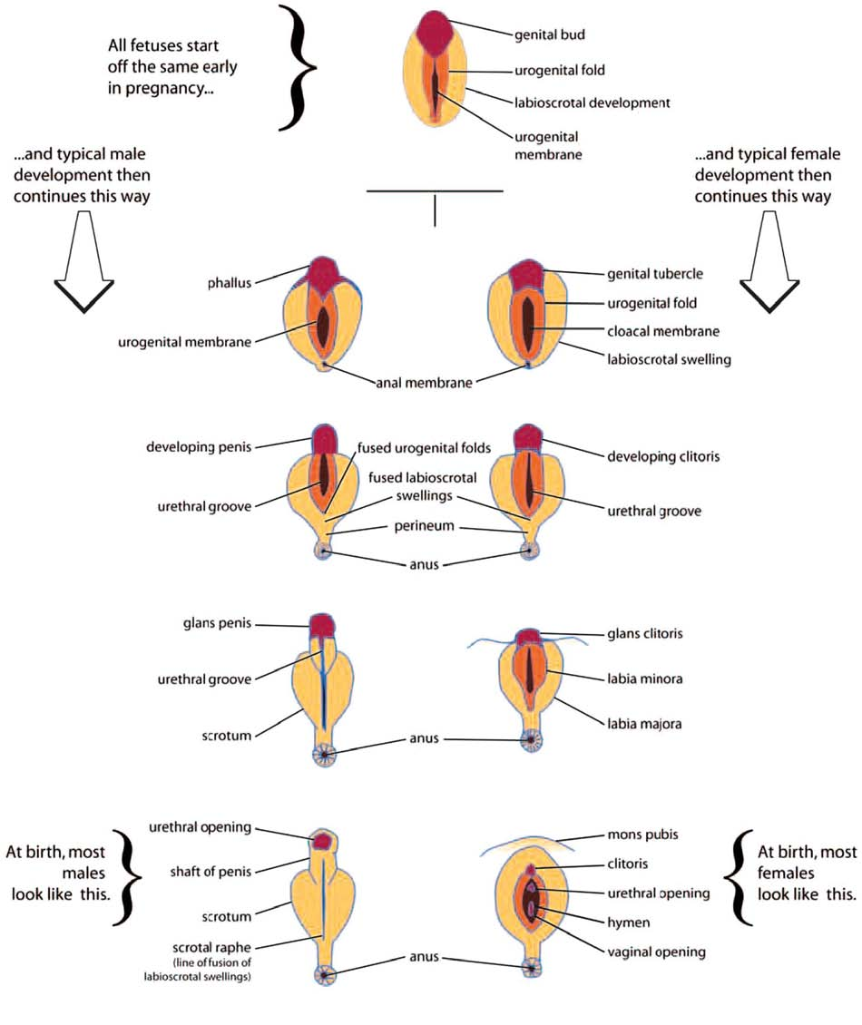
Figure 1 „Genital Development Before Birth“
Source: Accord Alliance (2006), Handbook for Parents, at 72, http://www.accordalliance.org/dsdguidelines/parents.pdf
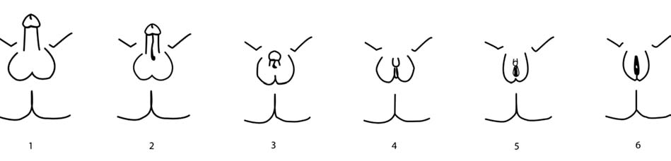
Figure 3 „Genital Variation“ (Diagrams 1-6 corresponding to Prader Scale V-0)
Source: Accord Alliance (2006), Handbook for Parents, at 73, http://www.accordalliance.org/dsdguidelines/parents.pdf

2. How common is Intersex?
Since hospitals, government agencies and health insurances covering intersex surgeries on children until the age of 20, refuse to disclose statistics and costs, there are no exact figures or statistics available). Also, the definition of intersex is often arbitrarily changed by doctors and government agencies in order to get favourable (i.e. lower) figures. Ultimately, all available numbers are mere estimates and extrapolations. Intersex persons and their organisations have been calling for independent data collection and monitoring for some time, however to no avail.
An often quoted number is 1:2000 newborns, however this obviously disregards variations of sex anatomy at risk of “masculinising corrections” (hypospadias). In medical literature, often two different sets of numbers and definitions are given depending on the objective:
a) 1:1000 if it’s about getting access to new patients for paediatric genital surgery, and
b) 1:4500 or less if it’s about countering public concerns regarding human rights violations, often only focusing on “severe cases” while refusing to give total numbers. On the other hand, researchers with an interest in criticising the gender binary often give numbers of up to “as high as 2%”.
However, from a human rights perspective, the crucial question remains: How many children are at risk of human rights violations, e.g. by non-consensual, medically unnecessary, irreversible, cosmetic genital surgeries or other similar treatments justified by a psychosocial indication? Here, the best known relevant number is 1:500 – 1:1000 children are submitted to (often repeated) non-consensual “genital corrections”.

3. Intersex is NOT THE SAME as LGBT
Unfortunately, there are several harmful misconceptions about intersex still prevailing in public, some of which are LGBT-related, e.g. if intersex, and/or intersex status, are represented as a sexual orientation (like gay or lesbian), and/or as a gender identity, as a subset of transgender, as the same as transsexuality, or as a strange, peculiar form of sexual preferences.
The underlying reasons for such misconceptions include lack of public awareness of the situation of real-life intersex persons and the real-live problems they’re facing, as well as – often despite best intentions – a long history of (political) appropriation of intersex going back to the 19th century, including leading LGBT proponents, scholarly authorities and/or interest groups instrumentalising intersex as a means to an end for their own agenda, and/or presenting themselves as intersex and speaking publicly for intersex people.
While some intersex persons position themselves within an LGBT context and many intersex organisations collaborate with LGBT groups on an equal footing to address e.g. discrimination issues, intersex persons and their organisations, as well as their allies, again and again have spoken out clearly against instrumentalising intersex issues as a means for other ends, maintaining that intersex stands for distinct and unique physical variations, and intersex status is not about gender identity or sexual orientation.
Although intersex children born with variations of sex anatomy may face several problems, in the “developed world” the most pressing are the ongoing Intersex Genital Mutilations, which present a distinct and unique issue constituting significant human rights violations, which are different from those faced by the LGBT community. Therefore human rights violations of intersex people can’t be addressed properly by framing and addressing them as LGBT issues, but need to be adequately addressed in a separate section as specific intersex issues.

4. Terminology
There is no terminology universally accepted by all persons concerned. All current terms were or are used by medicine in connection with non-consensual, medically not necessary “genital corrections” (see Annexe “Historical Overview”), and/or as insult or verbal abuse in society, and/or have other negative connotations – but all have also been (re-)claimed by persons concerned and their organisations:
Intersex
+ Term most frequently used by persons concerned, especially human rights related;
reclaimed since 1993.
– In public often leads to misconceptions like “intersex is a sexual orientation,”
“intersexuality is a sexual preference”, etc.;
“Intersexual Constitution” was a racist/nazi medical diagnosis 1920s–1950s,
“Intersex Disorders” was the predominant medical term 1960s–2005.
Please do say: Intersex child, she’s intersexed, this is an intersex human rights issue.
Please don’t say: Intersexuality, intersexual, intersexuals – this is disregarded by many persons concerned today and bound to foster misconceptions.
Hermaphrodite
+ Term most frequently used by public, can dispel misconceptions of intersex as a
sexual orientation, sexual preference, etc.; reclaimed since 1994.
– Can lead to misconceptions related to the ancient mythic notion of intersex
persons “having both sets of genitals and being able to impregnate themselves”;
considered as derogatory by some persons concerned;
“(Pseudo) Hermaphroditism” was the medical terminology until the 1950s,
though it persisted and is sometimes still used by doctors even today.
Please do say: Intersex persons, in the vernacular also known as hermaphrodites, are people with variations of sex anatomy.
Please don’t say: Are you a hermaphrodite? What do your genitals look like?
DSD (Disorders of Sex Development vs. Differences of Sex Development)
“Disorders of Sex Development”, mostly referred to by the acronym “DSD”, is the current medical term, introduced at the “Chicago Consensus Conference 2005” with limited input by persons concerned, but in an intransparent way and without proper consultation. The new nomenclature also included a new taxonomy based on karyotype and focused on conditions (instead of the persisting “Pseudo Hermaphrodite” taxonomy based on gonadal status and focused on “male” and “female”), also the new taxonomy was supposed to more clearly include genital variations irrespective of gender of rearing issues, such as hypospadias, Klinefelter, and MRKH, reflecting the new definition “congenital conditions in which development of chromosomal, gonadal, or anatomic sex is atypical.” Furthermore, in some cases a more cautious approach to early surgery was suggested.
While the use of an acronym for medical purposes, the new taxonomy focused on conditions, clearer inclusion of all genital variations, and the instances of calling for more caution regarding early surgeries were welcomed by persons concerned and their organisations, the term “disorders” was unequivocally abhorred and condemned within the community, because it frames the persons concerned as in need of being (surgically) “corrected”, or “fixed”, e.g. to “relieve[...] parental distress”. However, clinicians readily embraced “disorders.” “Variations of Sex Development (VSD)” was proposed as a less stigmatising alternative in 2006, but rejected by medicine arguing the acronym VSD was already taken. Nonetheless, another proposal in 2008 of “Differences of Sex Development” keeping the DSD acronym has been equally refused by doctors.
Please do say: Differences of Sex Development (DSD).
Please don’t say: Disorders of Sex Development (DSD).
Words are important, words can hurt – however, more important than a wrong word is the continuous regard – or disregard – of the human rights and dignity of the children concerned.
Supplement 3 – IGM Practices:
Non-Consensual, Unnecessary Medical Interventions
1. What are Intersex Genital Mutilations (IGM)?
IGM Practices include non-consensual, medically unnecessary, irreversible, cosmetic genital surgeries, and/or other similar medical treatments, including imposition of hormones, performed on children with variations of sex anatomy, without evidence of benefit for the children concerned, but justified by “psychosocial indications [...] shaped by the clinician’s own values”, the latter informed by societal and cultural norms and beliefs, enabling clinicians to withhold crucial information from both patients and parents, and to submit healthy intersex children to risky and harmful invasive procedures “simply because their bodies did not fit social norms”.
Genital surgery is not necessary for gender assignment, and atypical genitals are not in themselves a health issue. There are only very few situations where some surgery is necessary for medical reasons, such as to create an opening for urine to exit the body.
In addition to the usual risks of anaesthesia and surgery in infancy, IGM practices carry a large number of known risks of physical and psychological harm, including loss or impairment of sexual sensation, poorer sexual function, painful scarring, painful intercourse, incontinence, problems with passing urine (e.g. due to urethral stenosis after surgery), increased sexual anxieties, problems with desire, less sexual activity, dissatisfaction with functional and aesthetic results, lifelong trauma and mental suffering, elevated rates of self-harming behaviour and suicidal tendencies comparable to those among women who have experienced physical or (child) sexual abuse, impairment or loss of reproductive capabilities, lifelong dependency on daily doses of artificial hormones.
2. Most Frequent Surgical and Other Harmful Medical Interventions
Due to space limitations, the following paragraphs summarise the most frequent and egregious forms only. The injuries suffered by intersex people have not yet been adequately documented. For a more comprehensive list and sources, see 2014 CRC NGO Report, p. 63–76.
a) IGM 3 – Sterilising Procedures:
Castration / “Gonadectomy” / Hysterectomy / (Secondary) Sterilisation
“At 2 1/2 months they castrated me, and threw my healthy testicles in the garbage bin.” (2014 Swiss CRC NGO Report, Case No. 2)
Intersex children are frequently subjected to treatments that terminate or permanently reduce their reproductive capacity. Contrary to doctor’s claims, it is known that the gonads by themselves are usually healthy and “effective” hormone-producing organs, often with “complete spermatogenesis [...] suitable for cryopreservation.” Nonetheless, many still undergo early removal of viable gonads (e.g. testes, ovaries, ovotestes) or other reproductive organs (e.g. uterus), leaving them with “permanent, irreversible infertility and severe mental suffering” and lifelong metabolic problems. When unnecessary sterilising procedures are imposed on children e.g. to address a low or hypothetical risk of cancer, the fertility of intersex people is not being valued as highly as that of non-intersex people. Survivors often have to pay themselves for adequate Replacement Hormones.
For almost two decades, persons concerned have protested unnecessary sterilising treatments, and denounced non-factual and psychosocial justifications, e.g. “psychological benefit” to removing “discordant” reproductive structures, demanding access to screening for potential low cancer risks instead of preemptive castrations. Even some doctors have been criticising unnecessary intersex gonadectomies for decades, e.g. endocrinologist G. A. Hauser (the “H” in “MRKH Syndrome”) stated, “The castration of patients without a tumour converts symptomless individuals into invalids suffering from all the unpleasant consequences of castration.”
What’s more, psychosocial justifications often reveal underlying racist preconceptions by clinicians (reminiscent of the racist and eugenic medical views of intersex predominant during the 1920s–1950s, but which obviously persist), namely the infamous premise, “We don’t want to breed mutants.” (see 2014 CRC NGO Report, p. 52, 69)
Nonetheless, and despite recent discussions in medical circles, unnecessary gonadectomies and other sterilising treatments persist internationally in University Children’s Hospitals. Only a while ago, when the Rapporteurs criticised unnecessary gonadectomies, a paediatric surgeon replied: “Well, if a CAIS person is living as female, what do they need their testes for anyway?”
b) IGM 2 – “Feminising Procedures”: Clitoris Amputation/“Reduction”,
“Vaginoplasty”, Dilation
“I can still remember, how it once felt differently between my legs.” (2014 Swiss CRC NGO Report, Case No. 3)
In 19th Century Western Medicine, clitoris amputations a.k.a. “clitoridectomies” on girls were prevalent as a “cure” for a) masturbation, b) hysteria, and c) “enlarged clitoris.” While amputations motivated by a) and b) were mostly abandoned between 1900 and 1945, amputations of “enlarged clitorises” took a sharp rise after 1950, and in the 1960s became the predominant medical standard for intersex children.
For four decades, doctors again and again claimed early clitoris amputation on intersex children would not interfere with orgasmic function. Only in the 1980s–1990s, intersex clitoris amputations were eventually replaced by “more modern” techniques a.k.a. “clitoral reduction” (p. 60), again claimed to preserve orgasmic function, despite persons concerned reporting loss of sexual sensitivity, and/or painful scars – complaints also corroborated by recent medical studies. Tellingly, a current paediatric surgeon’s joke on the topic of potential loss of sexual sensation goes, “They won’t know what they’re missing!”
Despite that in infants there’s no medical (or other) need for surgically creating a vagina “big enough for normal penetration” (“vaginoplasty”), but significant risks of complications (e.g. painful scarring, vaginal stenosis), this is nonetheless standard practice. What’s more, in order to prevent “shrinking” and stenosis, the “corrected” (neo) vagina has to be forcibly dilated by continuously inserting solid objects, a practice experienced as a form of rape and child sexual abuse by persons concerned, and their parents.
Clitoris amputations justified by psychosocial indications were taught in Medical Universities as a suitable “therapy” for intersex children diagnosed with “hypertrophic clitoris” until the 1980s. Despite recent public denials by doctors, hospitals, and health departments, systematic early “clitoris reductions” and “vaginoplasty” performed on intersex infants and justified by psychosocial indications, are still practiced in most University Children’s Clinics throughout the world.
c) IGM 1 – “Masculinising Surgery”: Hypospadias “Repair”
“My operated genital is extremely touch-sensitive and hurts very much when I’m aroused.” (2014 Swiss CRC NGO Report, Case No. 1)
Hypospadias is a medical diagnosis describing a penis with the urethral opening (“meatus”, or “pee hole”) not situated at the tip of the penis, but somewhere below on the underside, due to incomplete tubularisation of the urethral folds during prenatal formation of the penis. Hypospadias “repair” aims at “relocating” the urethral opening to the tip of the penis. The penis is sliced open, and an artificial “urethra” is formed out of the foreskin, or skin grafts (p. 59).
Hypospadias per se does not constitute a medical necessity for interventions. The justification for early surgeries is psychosocial, e.g. to allow for “sex-typical manner for urination (i.e. standing for males).” According to a “pilot study”, surgery is “intended to change the anatomy such that the penis looks normal.” The latest AWMF guidelines with international explicitly include “aestetical-psychological reasons”.
Hypospadias “repair” is notorious for high complication rates of 50% and more, as well as causing serious medical problems where none had been before (e.g. urethral strictures leading to kidney failure requiring dialysis), and frequent “redo-surgeries”. Tellingly, for more than 30 years, surgeons have been officially referring to “hopeless” cases of repeat failed “repair” surgeries as “hypospadias cripples” (i.e. made to a “cripple” by unnecessary surgeries, not by the condition!, p. 59), while in medical publications on hypospadias, “[d]ocumentation on complication rates has declined in the last 10 years” (see 2014 CRC NGO Report, p. 54–56).
For more than 15 years, persons concerned have been criticising impairment or loss of sexual sensitivity. However, doctors still refuse to even consider these claims, let alone promote appropriate, disinterested long-term outcome studies.
Since the “2nd Hypospadias Boom” in the 1990s, hypospadias “repair” is arguably by far the most frequent cosmetic genital surgery done on children with variations of sex anatomy internationally. In University Children’s Hospitals, systematic hypospadias “repair” within the first 18 months of life is still considered common practice for children raised as boys.
d) Systematic Misinformation, “Code of Silence”, Lack of Informed Consent
Systematic misinformation, refusal of access to peer support, and directive counselling by doctors frequently prevent parents from learning about options for postponing permanent interventions, which has been criticised by persons concerned and their parents for two decades, seconded by bioethicists, and corroborated by studies, including a recent exploratory study (see 2014 CRC NGO Report, p. 71).
Nonetheless, internationally it’s still paediatricians, endocrinologists and surgeons managing diagnostics and counselling of parents literally from “day one.” Parents often complain that they only get access to psychological counselling if they consent to “corrective surgery” first, while doctors openly admit seeking early surgeries to facilitate compliance, e.g. referring to “easier management when the patient is still in diapers” (see 2014 CRC NGO Report, p. 72).
Intersex children are systematically lied to and refused access to peer support in order to keep them in the dark about being born intersex, and, if ever told at all, are sworn to secrecy, e.g. “You are a rarity, will never meet another like yourself and should never talk about it to no one” (see 2014 CRC Report, p. 72), severely compounding shame, isolation and psychological trauma in the aftermath of IGM practices.
e) Other Unnecessary and Harmful Medical Interventions and Treatments
“The assistant called in some colleagues to inspect and to touch my genitals as well.”
(2014 Swiss CRC NGO Report, Case No. 3)
Other common harmful treatments include (as detailed in the 2014 CRC NGO Report):
• Forced Mastectomy (p. 70)
• Imposition of Hormones (p. 73)
• Forced Excessive Genital Exams, Medical Display, (Genital) Photography (p. 73)
• Human Experimentation (p. 74)
• Denial of Needed Health Care (p. 75)
• Prenatal “Therapy” (p. 75)
• Selective (Late Term) Abortion (p. 76)
• Preimplantation Genetic Diagnosis (PGD) to Eliminate Intersex Fetuses (p. 76)

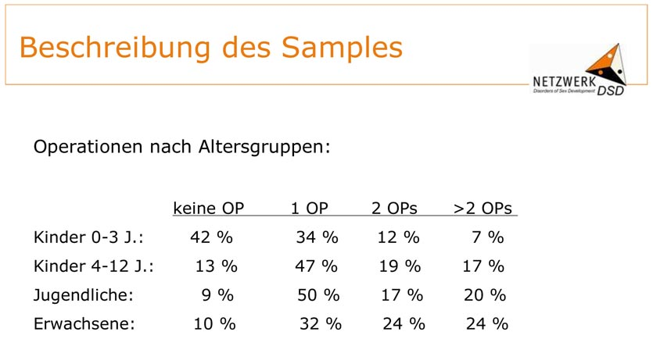
Figure 1 “Surgeries by Age Groups” (No Surgery, 1 Surgery, 2 Surgeries, >2 Surgeries,
Children 0–3 Years, Children 4-12 Years, Adolescents, Adults)
Source: Martina Jürgensen: “Klinische Evaluationsstudie im Netzwerk DSD/Intersexualität: Zentrale Ergebnisse”,
Presentation 27.05.2009, Slide 6, http://kastrationsspital.ch/public/Corpus-delicti_27-5-09.pdf

3. How Common are Intersex Genital Mutilations?
Same as with intersex births (see above p. 34), (university) hospitals, Government agencies and health insurance covering intersex surgeries on children, refuse to disclose statistics and costs, as well as ignoring repeated calls for independent data collection and monitoring (see below p. 47).
What’s more, doctors, government and other institutions involved in IGM practices, if questioned about statistics, are notorious for going to extreme lengths following established patterns of a) disclosing only tiniest fractions of actual treatments, often arbitrarily changing definitions of intersex and variations of sex anatomies in order to justify favourable (i.e. lower) figures, or b) flatly denying any occurrence or knowledge of IGM Practices, while at the same time the same doctors and hospitals, including such under the auspices of said departments, are continuing to publicly promote and perform them. Or, in the rare cases of studies actually “disclosing” numbers, yet another related tactic involves c) manipulation of statistics. For example the world’s largest outcome study on 439 participants, the 2008 “Netzwerk DSD” intersex study, in official publications only gave a misleading overall total figure of “almost 81% of all participants had at least once surgery [...] most of them before entering school.”
The only published numbers that include a breakdown by age groups available from the “Netzwerk DSD” intersex study with participation of clinics in Germany, Austria and Switzerland stem from a semi-official 2009 presentation. They reveal that, contrary to declarations by doctors as well as cantonal and federal governments, in the most relevant age groups of 4+ years, 87%–91% have been submitted to IGM surgeries at least once, with increasing numbers of repeat surgeries the older the children get (see Figure 3 above p. 50 – note, how the table conveniently stops at “>2” surgeries, although, especially with “hypospadias repair”, a dozen or more repeat surgeries are not uncommon).
What’s more, although internationally no official statistics are available, internationally the total number of cosmetic genital surgeries performed on intersex children is known to be still rising.
4. Lack of Legislative Prevention of IGM Practices,
Lack of Access to Redress and Justice for Victims
For more than two decades, persons concerned and sympathetic clinicians and academics have tried to reason with the perpetrators, and for 19 years they’ve been lobbying for legal measures, approaching governments as well as national and international ethics and human rights bodies year after year after year, calling for specific legislation to eliminate IGM practices, and criticising the factual impunity of IGM doctors due to statutes of limitations that – both in criminal and civil law – expire long before survivors of early childhood IGM practices would be able to call a court.
In 2011, the Committee against Torture (CAT) was the first UN body to recognise the lack of adequate laws ensuring redress and investigations, explicitly calling on Germany to
“Undertake investigation of incidents of surgical and other medical treatment of intersex people without effective consent and adopt legal provisions in order to provide redress to the victims of such treatment, including adequate compensation.”
In the meantime, the Committee against Torture issued similar recommendations to Switzerland, Austria, Denmark and Hong Kong, repeating its the call for “legislative measures to ensure redress” while adding, “to undertake legislative, administrative and other necessary measures to ensure the bodily integrity of intersex people, and that no-one is submitted to medical or surgical sex assignment treatments during childhood, which do not constitute a medical emergency”.
In 2012, the Swiss National Advisory Commission on Biomedical Ethics (NEK-CNE) was the first national body to eventually support the call of survivors for legal measures, in Recommendation 12 explicitly urging a legal review of both criminal law and civil liability implications, as well as for a review of associated statutes of limitations, with explicit reference to Art. 124 Criminal Code (FGM).
Paediatric Surgeon Blaise Meyrat, one of only a handful of paediatric surgeons worldwide refusing to do unnecessary surgeries on intersex children, in 2013 was the first doctor to go on record and frankly admit that in the end only legislation will succeed in ending IGM practices, “It’s a pity that, because of a lack of ethical clarity in the medical profession, we have to get legislators involved, but in my opinion it’s the only solution.” And in 2015, on occasion of the 55th Session of the Committee against Torture, Meyrat added, “Only the fear of the judge will make things change. We need statutes of limitation long enough so that victims may sue as adults.”
In 2013, the survivors’s call for legislative measures was seconded by the Special Rapporteur on Torture (SRT), who in his report on “abuses in health-care settings that may cross a threshold of mistreatment that is tantamount to torture or cruel, inhuman or degrading treatment” explicitly stated:
“Children who are born with atypical sex characteristics are often subject to irreversible sex assignment, involuntary sterilization, involuntary genital normalizing surgery, performed without their informed consent, or that of their parents, “in an attempt to fix their sex”, leaving them with permanent, irreversible infertility and causing severe mental suffering.
These procedures [genital-normalizing surgeries] are rarely medically necessary, can cause scarring, loss of sexual sensation, pain, incontinence and lifelong depression and have also been criticized as being unscientific, potentially harmful and contributing to stigma (A/HRC/14/20, para. 23).”
Also in 2013, this call was again seconded by the Council of Europe (COE) in their Resolution 1952 (2013) “Children’s right to physical integrity”, urging states to
“ensure that no-one is subjected to unnecessary medical or surgical treatment that is cosmetic rather than vital for health during infancy or childhood, guarantee bodily integrity, autonomy and self-determination to persons concerned, and provide families with intersex children with adequate counselling and support”
In 2014, an Interagency Statement on Forced Sterilisation by the WHO and 6 more UN bodies explicitly also criticised IGM practices in general:
“Children who are born with atypical sex characteristics are often subjected to cosmetic and other non-medically indicated surgeries performed on their reproductive organs, without their informed consent or that of their parents, and without taking into consideration the views of the children involved.”
In addition, the WHO interagency statement explicitly called for “Remedies and redress”, as well as for “Monitoring and Compliance.”
In 2015, the Committee on the Rights of the Child (CRC) criticised Switzerland for allowing IGM practices to continue, explicitly highlighting “the lack of redress and compensation in such cases,” and classifying IGM practices as “violence against children” and as a “harmful practice”, thus clearly implicating the urgent need for legislative measures to eliminate them, namely “to ensure that no-one is subjected to unnecessary medical or surgical treatment during infancy or childhood, guarantee bodily integrity, autonomy and self-determination to children concerned”.
Also in 2015, in their recommendations to Chile, the Committee on the Rights of the Child added, “ensuring effective remedy for victims, including redress and compensation.”
Also in 2015, the Committee on the Rights of Persons with Disabilities (CRPD), referring to the 2011 CAT Concluding Observations, criticised the failure of “upholding bodily integrity of intersex children”, and urged Germany to “take the necessary measures, including of a legislative nature to [...] [i]mplement all the recommendations of CAT/C/DEU/CO/5, para. 20 relevant to intersex children.”
Again in 2015, the WHO Report “Sexual health, human rights and the law” reiterated:
“It has also been recommended [by human rights bodies and ethical and health professional organizations] that investigation should be undertaken into incidents of surgical and other medical treatment of intersex people without informed consent and that legal provisions should be adopted in order to provide remedies and redress to the victims of such treatment, including adequate compensation.”
Nonetheless, globally so far without even a single exception, states refuse to take legislative action to ensure access to redress for IGM survivors.
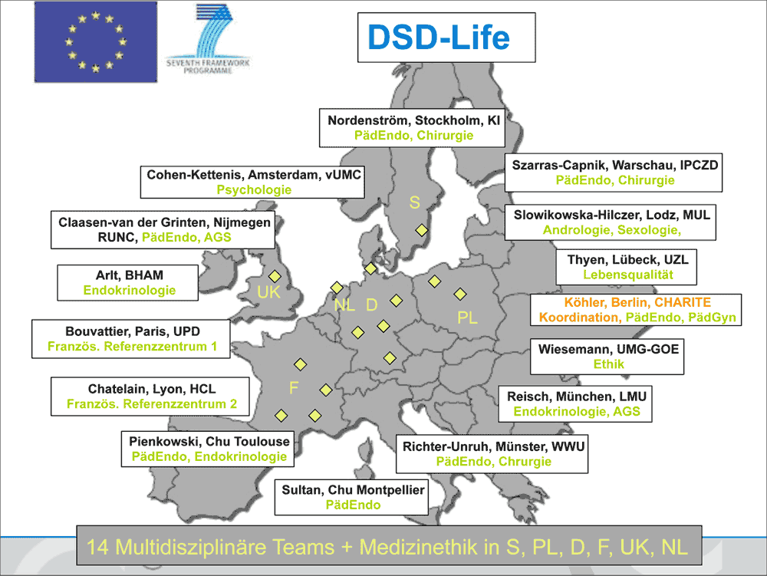
Figure 4 “DSD-Life” IGM Clinics

5. Lack of Disinterested Review, Analysis, Outcome Studies and Research
Persons concerned and their organisations have stressed for almost two decades “the unreliability of research conducted in the setting where the harm was done”, and stressed the imminent need for impartial, disinterested investigation and research, as called for in Art. 12 CAT and the Committee’s own 2011 Concluding Observations, as well as by the 2012 Swiss National Advisory Commission on Biomedical Ethics (NEK-CNE) (Recommendation 9), the 2013 COE Resolution 1952 (para 7), and the 2014 WHO Interagency Statement.
However, to this day, despite repeated calls for impartial investigation and disinterested research, internationally the only “investigations” taking place are the “research” facilitated by the perpetrators themselves, relying on massive state funding.
The only exception proving the rule is an exceptional preliminary research study “Historic Evaluation of Treatment of Persons with Differences of Sex Development” examining 22 cases of clitoris amputations at the Zurich University Children’s Clinic between 1913 and 1968. This preliminary study was initiated and paid for by the University Children’s Clinic (after considerable pressure by intersex NGOs and self-help groups). However, the clinic is still struggling with funding to adequately continue this ground-breaking project constituting a global first, and so far no state body considered supporting it.
On the other hand, currently the European Union and affiliated states are spending millions on exculpating “intersex research projects” facilited by, and in control of the perpetrators.
“DSD-Life” (see Figure 4, above p. 55) and “DSDnet”, two current examples, are conducted by the perpetrators themselves, e.g. in “DSDnet” paediatric endocrinologists, and in “DSD-Life” paediatric endocrinologists and paediatric surgeons taking the lead – exactly the professional groups responsible for IGM practices in the first place. If other disciplines are included at all in the “multidisciplinary teams,” like e.g. psychology or bioethics, let alone persons concerned, they only play a secondary role, and are only included at a later stage, and especially persons concerned serve mostly to recruit participants – same as in the precursor projects “Netzwerk DSD” and “EuroDSD”.
What’s more, all of these perpetrator’s “research projects” continue to openly advocate IGM, as well as to promote the usual psychosocial and non-factual justifications, e.g. “DSDnet”:
“Children with DSD may be born with genitalia that range from being atypical to truly ambiguous and the sex assignment process may be extremely challenging for families and health care professionals. Often, multiple surgical interventions are performed for genital reconstruction to a male or female appearance. The gonads are often removed to avoid malignant development.”
On the other hand, to this day an impartial investigation into past and current IGM practices isn’t even considered by any state.
6. Lack of Independent Data Collection and Monitoring
With no statistics available on intersex births, let alone surgeries and costs, and perpetrators, governments and health departments colluding to keep it that way as long as anyhow possible, persons concerned as well as civil society lack possibilities to effectively highlight and monitor the ongoing mutilations. What’s more, after realising how intersex genital surgeries are increasingly in the focus of public scrutiny and debate, perpetrators of IGM practices respond by suppressing complication rates, as well as refusing to talk to journalists “on record”.
Supplement 4 – “IGM in Medical Textbooks, Part 1: Current Practice”
IGM 1 – “Masculinising Surgery”: “Hypospadias Repair”
“Hypospadias,” i.e. when the urethral opening is not on the tip of the penis, but somewhere on the underside between the tip and the scrotum, is arguably the most prevalent diagnosis for cosmetic genital surgeries. Procedures include dissection of the penis to “relocate” the urinary meatus. Very high complication rates, as well as repeated “redo procedures” — “5.8 operations (mean) along their lives … and still most of them are not satisfied with results!”
Nonetheless, clinicians recommend these surgeries without medical need explicitly “for psychological and aesthetic reasons.” Most hospitals advise early surgeries, usually “between 12 and 24 months of age.” While survivors criticise a.o. impairment or total loss of sexual sensation and painful scars, doctors still fail to provide evidence of benefit for the recipients of the surgeries.
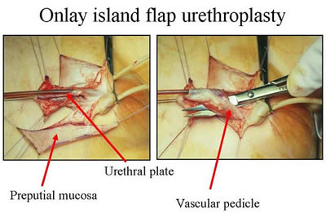
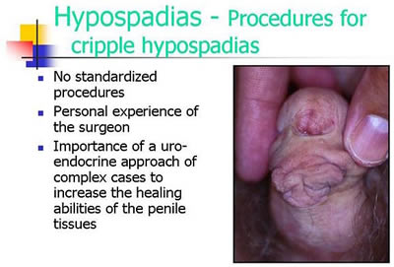
Official Diagnosis “Hypospadias Cripple”
= made a “cripple” by repeat cosmetic surgeries

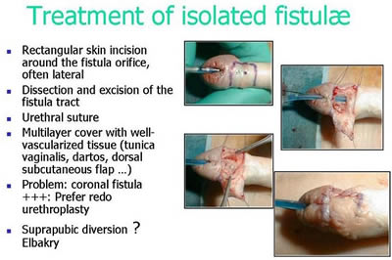
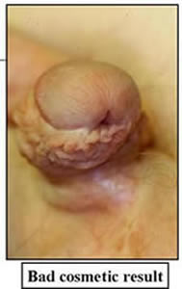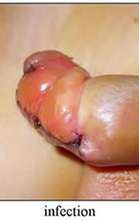
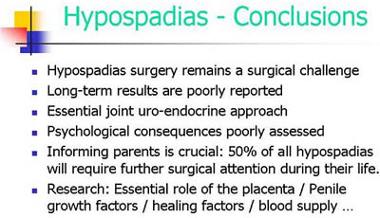
Source: Pierre Mouriquand: “Surgery of Hypospadias in 2006 - Techniques & outcomes”

IGM 2 – “Feminising Surgery”: “Clitoral Reduction”, “Vaginoplasty”
Partial amputation of clitoris, often in combination with surgically widening the vagina followed by painful dilation. “46,XX Congenital Adrenal Hyperplasia (CAH)” is arguably the second most prevalent diagnosis for cosmetic genital surgeries, and the most common for this type (further diagnoses include “46,XY Partial Androgen Insufficiency Syndrome (PAIS)” and “46,XY Leydig Cell Hypoplasia”).
Despite numerous findings of impairment and loss of sexual sensation caused by these cosmetic surgeries, and lacking evidence for benefit for survivors, current guidelines nonetheless advise surgeries “in the first 2 years of life”, most commonly “between 6 and 12 months,” and only 10.5% of surgeons recommend letting the persons concerned decide themselves later.
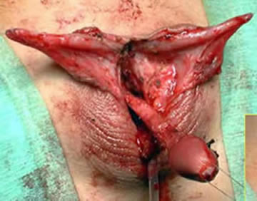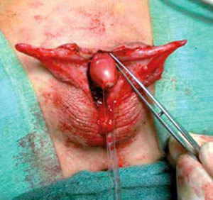
Source: Christian Radmayr: Molekulare Grundlagen und Diagnostik des Intersex, 2004
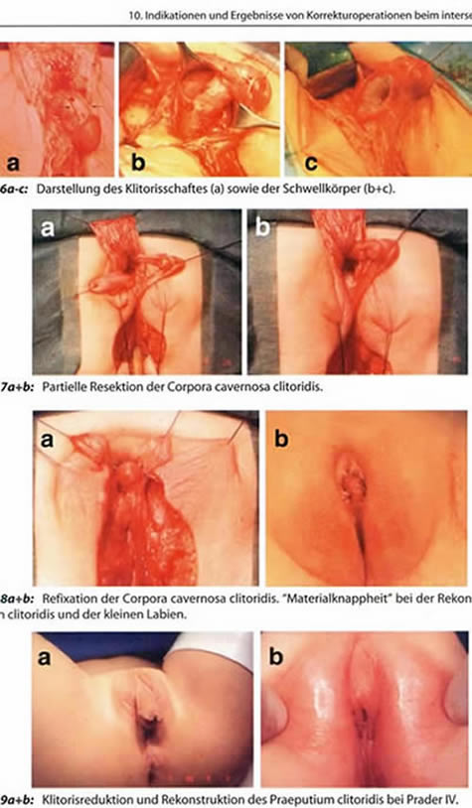
Source: Finke/Höhne: Intersexualität bei Kindern, 2008
Caption 8b: “Material shortage” [of skin] while reconstructing the praeputium clitoridis and the inner labia.
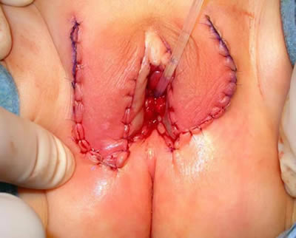
Source: Pierre Mouriquand: “Chirurgie des anomalies du développement sexuel - 2007”, at 81: “Labioplastie”
IGM 3 – Sterilising Surgery: Castration / “Gonadectomy” / Hysterectomy
Removal of healthy testicles, ovaries, or ovotestes, and other potentially fertile reproductive organs. “46,XY Complete Androgen Insufficiency Syndrome (CAIS)” is arguably the 3rd most common diagnosis for cosmetic genital surgeries, other diagnoses include “46,XY Partial Androgen Insufficiency Syndrome (PAIS)”, male-assigned persons with “46,XX Congenital Adrenal Hyperplasia (CAH)”, and other male assigned persons, who have their healthy ovaries and/or uteruses removed.
Castrations usually take place under the pretext of an allegedly blanket high risk of cancer, despite that an actual high risk which would justify immediate removal is only present in specific cases (see table below), and the admitted true reason is “better manageability.” Contrary to doctors claims, it is known that the gonads by themselves are usually healthy and “effective” hormone-producing organs, often with “complete spermatogenesis [...] suitable for cryopreservation.”
Nonetheless, clinicians still continue to recommend and perform early gonadectomies – despite all the known negative effects of castration, including depression, obesity, serious metabolic and circulatory troubles, osteoporosis, reduction of cognitive abilities, loss of libido. Plus a resulting lifelong dependency on artificial hormones (with adequate hormones often not covered by health insurance, but to be paid by the survivors out of their own purse).
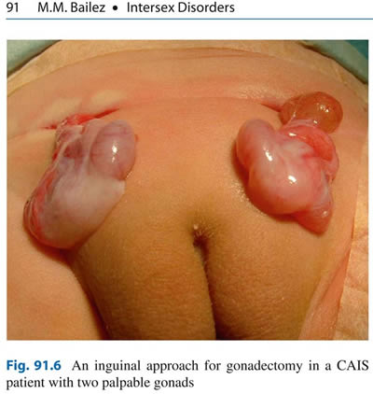
Source: Maria Marcela Bailez: “Intersex Disorders,” in: P. Puri and M. Höllwarth (eds.),
Pediatric Surgery: Diagnosis and Management, Berlin Heidelberg 2009.
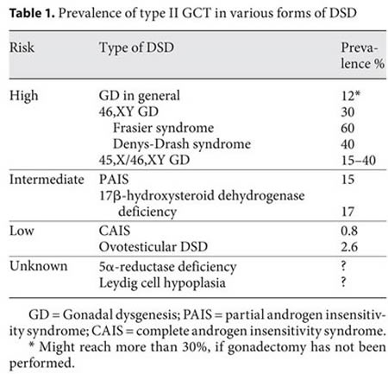
Source: J. Pleskacova, R. Hersmus, J. Wolter Oosterhuis, B.A. Setyawati, S.M. Faradz, Martine Cools, Katja P. Wolffenbuttel, J. Lebl, Stenvert L.S. Drop, Leendert H.J. Looijenga: “Tumor risk in disorders of sex development,” in: Sexual Development 2010 Sep;4(4-5):259-69.
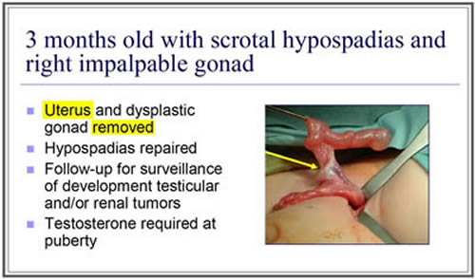
Source: J. L. Pippi Salle: “Decisions and Dilemmas in the Management
of Disorders of Sexual [sic!] Development (DSD),” 2007, at 20.
4. "Bad results" / "Gonadectomy, Feminizing Genitoplasty"
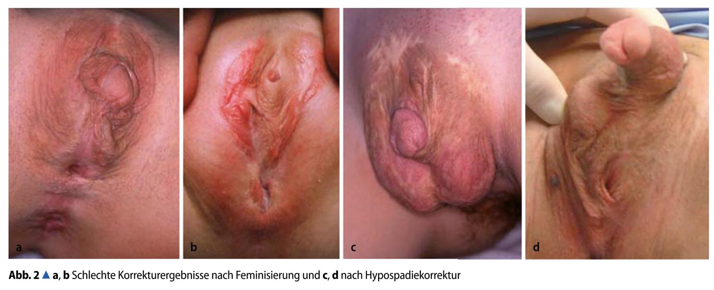
Caption: 2a,b: “Bad Results of Correction after Feminisation, and”, c,d: “after Hypospadias Repair” – Source: M. Westenfelder: “Medizinische und juristische Aspekte zur Behandlung intersexueller Differenzierungsstörungen,” Der Urologe 5 / 2011 p. 593–599.
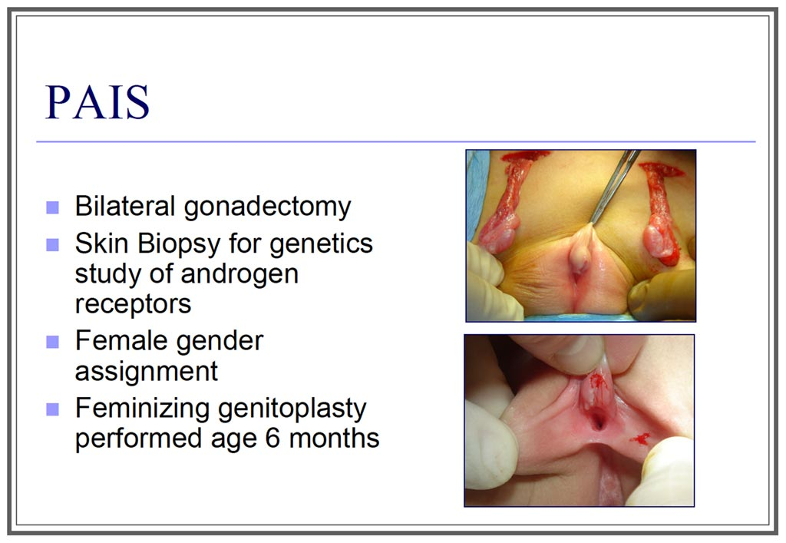
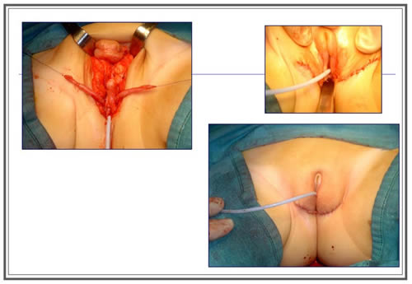
Source: J. L. Pippi Salle: “Decisions and Dilemmas in the Management
of Disorders of Sexual [sic!] Development (DSD)”, 2007, at 20.

Supplement 5 – “IGM in Medical Textbooks, Part 2: Historical Examples”

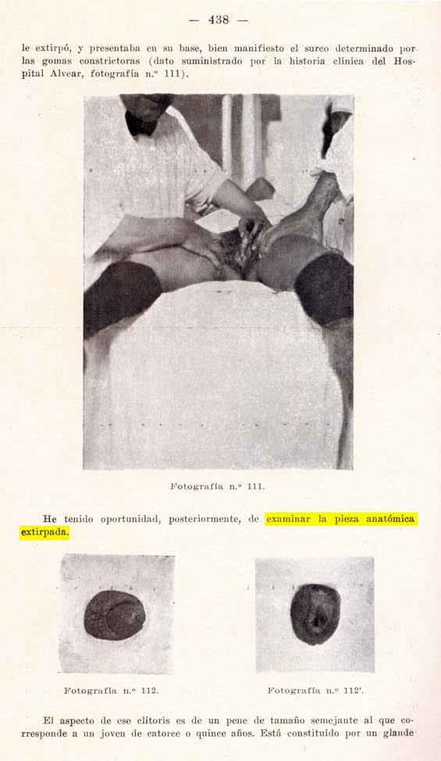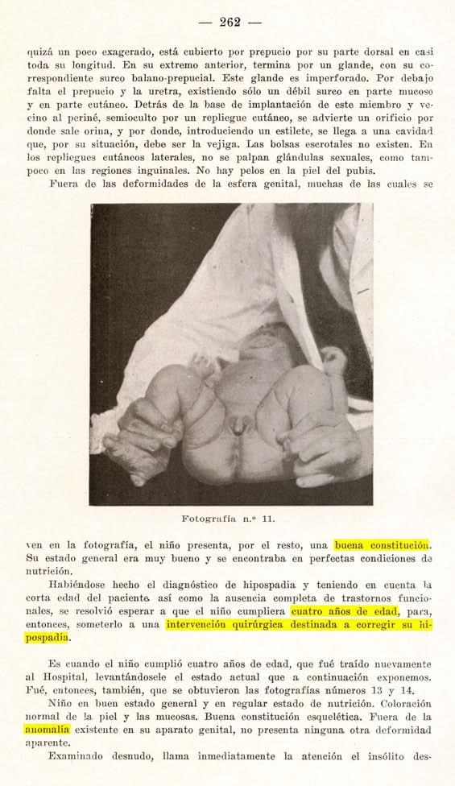
Buenos Aires 1925: Medical Display, “Trophy Shots”,
and Cosmetic Genital Surgeries on Children
“Las deformidades de la sexualidad humana” by Carlos Lagos García (1880-1928) is arguably the first modern medical book dedicated exclusively to “genital abnormalities” and their surgical “cure”. It was highly influential both in Europe and the Americas, pioneering forced medical display, “trophy shots” of amputated healthy genitals and reproductive organs, and advocating cosmetic surgeries on little children, both “feminising” and “masculinising” – expressly without actual medical necessity, but as “correction” for “anomalies”.
Source: Carlos Lagos García: Las deformidades de la sexualidad humana. Buenos Aires, 1925, p. 438, 262.
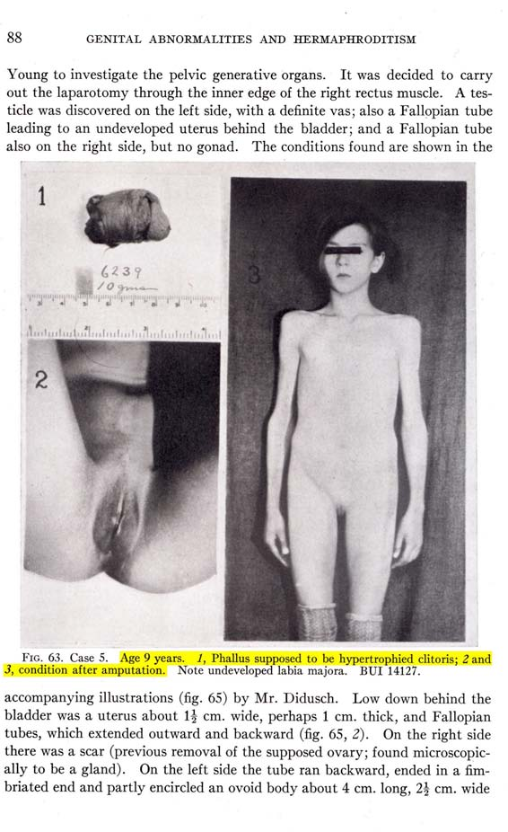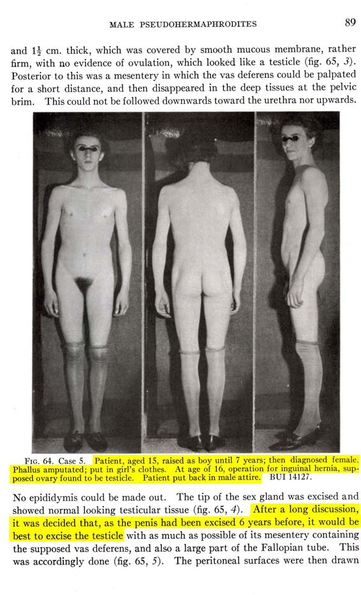
Baltimore 1937: Haphazard Decisions, more “Trophy Shots”,
Step by Step “Genital Corrections”
Hugh Hampton Young (1870-1945), “The Father of American Urology”, also pioneered Intersex Genital Mutilations at the Johns Hopkins University Hospital in Baltimore – a fact nowadays often “neglected” in official hagiographies, despite that Young’s disturbing textbook “Genital Abnormalities, Hermaphroditism, and Related Adrenal Diseases” was considered a breakthrough by his colleagues and was well-received globally. It saw two updated revisions, edited by Young’s successors Howard W. Jones and William Wallace Scott, in 1958 and 1971 under the slightly modified title “Hermaphroditism, Genital Anomalies, and Related Endocrine Disorders”. These later editions still contained many of Young’s original step by step illustrated tutorials e.g. of “Plastic operations to construct a vagina and amputate hypertrophied clitoris”, or how to otherwise freely “cut up and re-assemble” so called “Genital Abnormalities.” Fig. 64 shown above right depicting a the tragically mutilated young person “Case 5 / BUI 14127” appeared again in Jones’ and Scott’s editions, although erroneously attributed to another “Case.” For the 1958 edition, Young’s colleague at Johns Hopkins and the “inventor” of systematic cosmetic genital surgeries on children, Lawson Wilkins, contributed a foreword, praising Young’s original 1937 edition as a “classic.”
Source: Genital Abnormalities, Hermaphroditism, and Related Adrenal Diseases. Baltimore, 1937, p. 8-89.
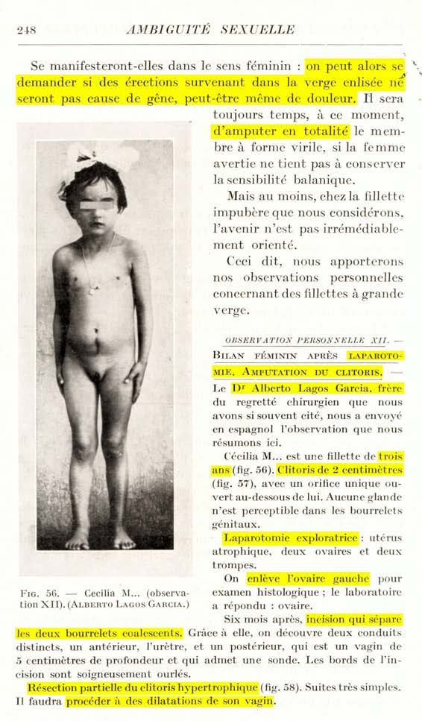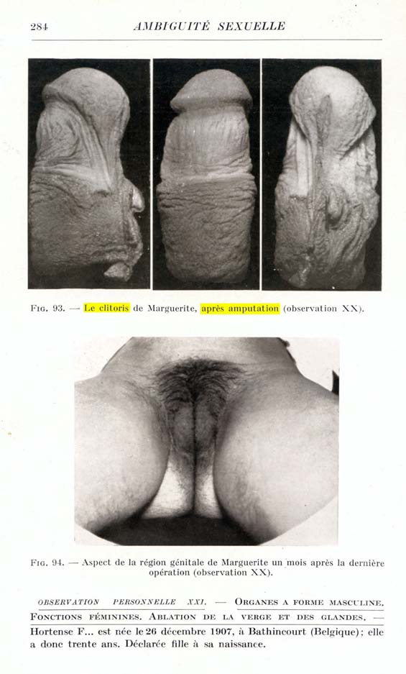
Paris 1939: “Embarrassing Erections”, yet more “Trophy Shots”,
and even younger Children submitted to Cosmetic Genital Surgeries
Louis Ombrédanne (1871-1956) set the standard regarding “scientific” justifications for amputating “enlarged clitorises” on children due to “embarrassing and maybe even painful erections” (note how he’s asking himself, NOT his patients) for more than 50 years, as well as regarding surgical techniques for “hypospadias repair” a.k.a. “masculinising genital corrections”, and was a teacher of Swiss paediatric surgeon Max Grob (Zurich University Children’s Hospital, see below). Ombrédanne’s “Hermaphrodites and Surgery” drew heavily on Carlos Lagos García, as well as featuring a “personal observation” by García’s Brother Alberto Lagos García involving a “partial resection of the hypertrophied clitoris” in combination with “continued vaginal dilatations” on a “girl aged three years” (p. 248), and was received internationally from Zurich to Baltimore and beyond.
Source: Louis Ombrédanne: Les Hermaphrodites et la Chirurgie. Paris, 1939, p. 248, 284.
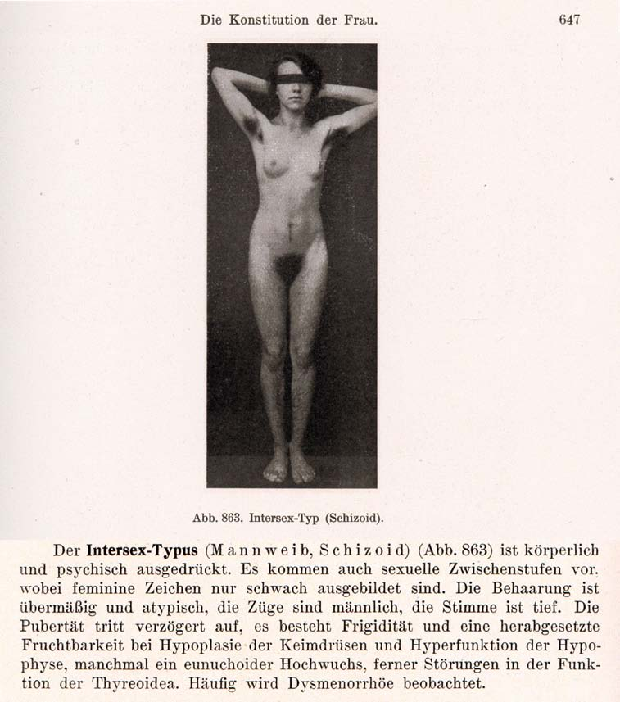
1916–1950s: “Intersexuality = Bastardisation” caused by “Racial Mixing”; Racist Diagnosis “Intersexual Constitution”
Geneticist Richard Goldschmidt (1878–1958), before serving as director at the “Kaiser-Wilhelm-Institut für Biologie” in Berlin, coined the terms “Intersex” and “Intersexuality” when internationally publicising his experiments of crossbreeding “different geographic races” of gypsy moths during a stay in the USA (first in English, later in German), claiming to be able to produce “hermaphroditic” a.k.a. “intersex” specimens of any grade and shape at will, and thereafter extrapolating his findings to humans. Of Jewish descent, Goldschmidt was forced to leave the “Kaiser-Wilhelm-Institute” in 1936 and emigrated to the United States. Despite Goldschmidt’s downplaying the “racial” background of his findings since the early 1930’s and later renouncing the underlying genetic theories altogether, the term “Intersex” and its racial implications prevailed. The derived diagnosis “Intersexual Constitution” (published by Austrian Gynaecologist Paul Mathes and Swiss Gynaecologist Hans Guggisberg in 1924), allegedly “most frequent in Jews” and associated with “biological inferiority”, mental illnesses (see above “schizoid”), “hypertrophied clitoris” and a strict verdict “not fit for marriage,” was particularly popular among prominent eugenicists and Nazi doctors, including Fritz Lenz, Hans Naujoks, Lothar Gottlieb Tirala, Robert Stigler, Wilhelm Weibel, Walther Stoeckel, and kept being used in publications years after World War II.
Sources: Wilhelm Weibel: Lehrbuch der Frauenheilkunde, 7th ed., Berlin/Wien 1944 p. 647 (photo), 648 (text).
Richard Goldschmidt: “Die biologischen Grundlagen der konträren Sexualität und des Hermaphroditismus beim Menschen”, in: Archiv für Rassen- und Gesellschaftsbiologie 12, 1916.
Paul Mathes, Hans Guggisberg: “Die Konstitutionstypen des Weibes, insbesondere der intersexuelle Typus”, in: Josef Halban, Ludwig Seitz: Biologie und Pathologie des Weibes. Bd.3, 1924.
Helga Satzinger: Rasse, Gene und Geschlecht. Zur Konstituierung zentraler biologischer Begriffe bei Richard Goldschmidt und Fritz Lenz, 1916–1936. Research Program “History of the Kaiser Wilhelm Society in the National Socialist Era”, Ergebnisse 15, 2004.
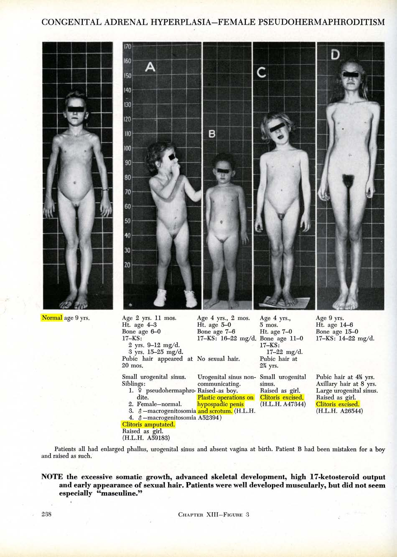
Baltimore 1950: From Experimentation to Medical Extermination
Lawson Wilkins (1894-1963), “The Father of Pediatric Endocrinology”, and teacher of the famous Swiss paediatric endocrinologist Andrea Prader in 1950, was also the “inventor” of systematic cosmetic genital surgeries on children. As his monograph illustrates, in 1950 at Johns Hopkins in Baltimore, any child diagnosed “not normal” was submitted to drastic “Genital Corrections”, either “feminising” or “masculinising”. Often John Money gets erroneously credited as having “invented” the systematic mutilations, however, it was Wilkins (and Prader) who started systematic surgeries; Money “only” delivered a “scientific rationale” five years after the fact.
Source: Lawson Wilkins: The Diagnosis and Treatment of Endocrine Disorders in Childhood and Adolescence. Springfield, 1950.
Alison Redick: American History XY: The Medical Treatment of Intersex, 1916-1955, Dissertation 2004
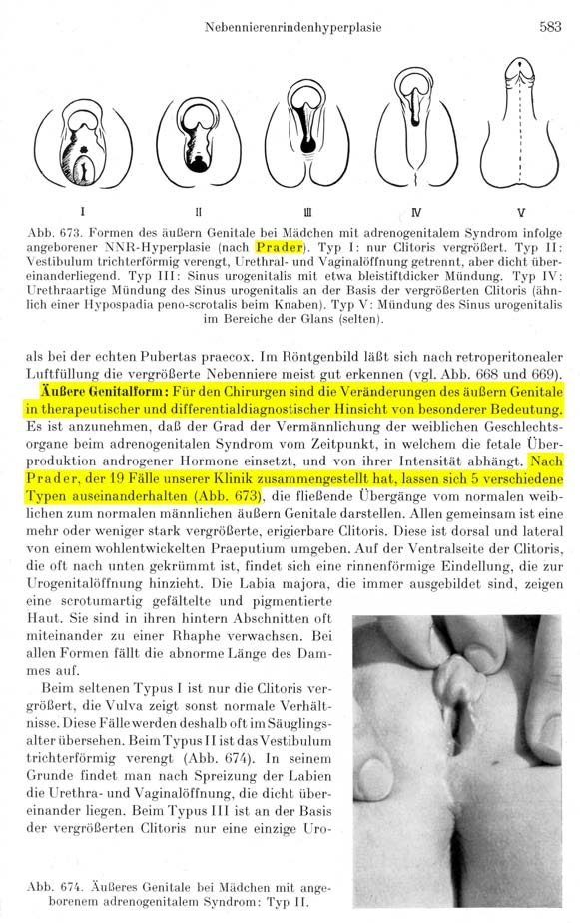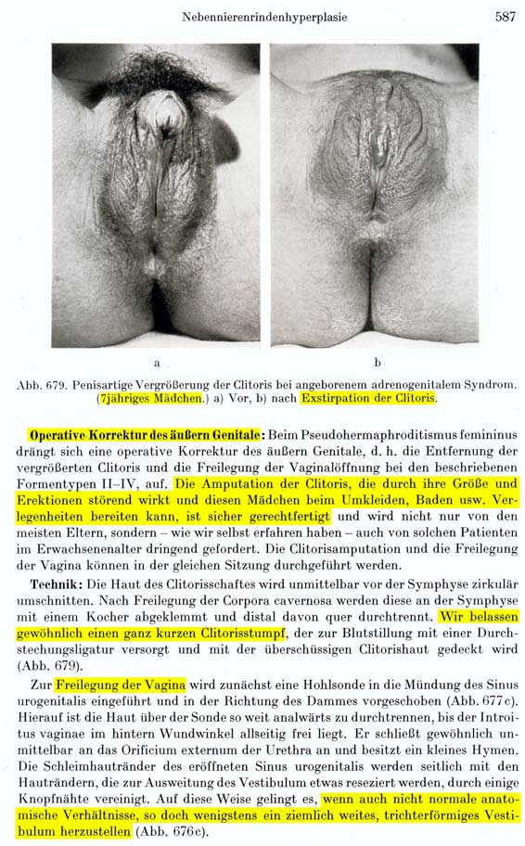
Zurich 1957: Prader Scales, “Surely Justified” Clitoris Amputations, and even more “Embarrassing” Psychosocial Indications
Swiss paediatric surgeon Max Grob (1901-1976), trained in Paris by Ombrédanne, served as director of the Zurich University Children’s Hospital’s paediatric surgery unit 1939-1971, and in 1957 published his influential “Textbook on Paediatric Surgery” with contributing authors Margrit Stockmann (Luzern), and Marcel Bettex, then consulting paediatric surgeon in Zurich. Grob’s “Textbook”, indiscriminatingly hailed by the Zurich University Children’s Hospital till this day, stressed the “special importance” for surgeons of Andrea Prader’s newly developed systematic classification of “genital variations” (“Prader Scales”). In its section on “surgical correction of the external genital” of children with 46,XX CAH (“[T]he removal of the enlarged clitoris [...] suggests itself. [...] Technique: [...] Usually we leave a very short clitoris stump”), Grob proclaimed the psychosocial justifications for cosmetic genital surgery on intersex children still prevalent today “The amputation of the clitoris, which may appear bothersome due to its size and erections, and may lead to embarrassment for these girls in the changing room or while swimming, is surely justified.”) Grob became the founder and first president of the Swiss Society for Paediatric Surgery, and honorary member of the German, Austrian, British and U.S. societies. Grob’s recommendations in the “Textbook” (“surgical correction” in case of Prader Stages II–V, arguably devised at least with input by Prader himself), represented the global standard until the “Chicago DSD Consensus Conference” in 2005 (changing it to III–V).
Source: Max Grob: Lehrbuch der Kinderchirurgie, with Margrit Stockmann and Marcel Bettex, Stuttgart, 1957, p. 583, 587.
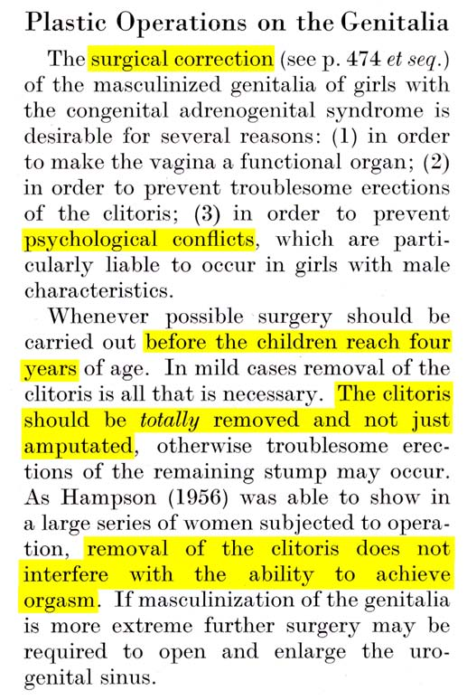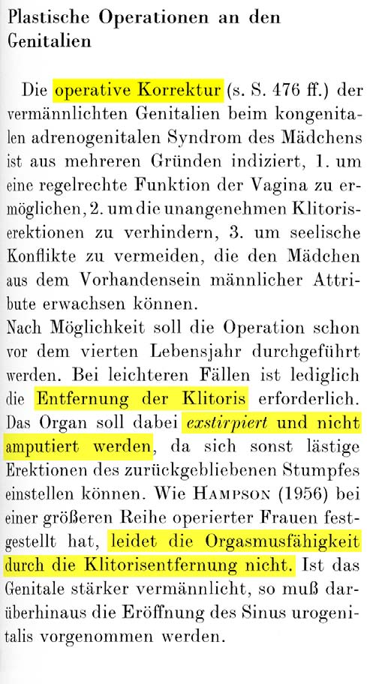
Source: Jürgen R. Bierich: “The Adrenogenital Syndrome”. In: Overzier (ed.), “Intersexuality” (New York 1962, at 379) / “Intersexualität” (Stuttgart 1961, at 387)
1956–1993: “The Clitoris is not essential for normal Coitus.” – “No Evidence of Loss of Orgasm after Clitoris Amputation.”
The number of “Intersex-Experts” and involved clinicians claiming that amputating “enlarged” clitorises was a rational and beneficent thing to do is legion – e.g. Joan Hampson (1956), John Money (1956, 1971), Max Grob (1957, see above), Jürgen Bierich (1963, 1971), Robert E. Gross (1966), Marcel Bettex (1957).
Even in 1993, surgeon Milton Edgerton claimed, unchallenged by his peers: “Not one has complained of loss of sensation, even when the entire clitoris was removed.”
Since then: “Surgery is better now ...”
In 1993, Cheryl Chase founded the first Intersex Lobby Group ISNA by declaring: “Unfortunately the surgery is immensely destructive of sexual sensation and of the sense of bodily integrity.” Since then, the mutilators just changed their mantra to “Surgery is better now” – again without evidence, but despite survivors deploring decrease or total loss of sexual sensation, painful scars and frequent complications also with the “modern improved techniques”, and studies again and again corroborating their grievances.
Sources: See 2014 CRC NGO Report, p. 57–59, online: http://intersex.shadowreport.org/public/2014-CRC-Swiss-NGO-Zwischengeschlecht-Intersex-IGM_v2.pdf

http://www.liberation.fr/debats/2016/05/31/stop-aux-mutilations-des-personnes-intersexuees_1456398
• http://www.histoiresordinaires.fr/Intersexe-Vincent-Guillot-sort-de-la-nuit_a1330.html • http://www.lefigaro.fr/international/2013/11/01/01003-20131101ARTFIG00204-l-allemagne-devient-le-premier-pays-europeen-a-reconnaitre-un-troisieme-sexe.php
http://Zwischengeschlecht.org/ English pages: http://StopIGM.org/
http://zwischengeschlecht.org/post/Statuten
http://intersex.shadowreport.org/public/2014-CRC-Swiss-NGO-Zwischengeschlecht-Intersex-IGM_v2.pdf
http://intersex.shadowreport.org/public/2016-CAT-France-NGO-Zwischengeschlecht-Intersex-IGM.pdf
Pierre Mouriquand et al, “Surgery in disorders of sex development (DSD) with a gender issue: If (why), when, and how?”, Journal of Pediatric Urology (2016, in press), http://www.jpurol.com/article/S1477-5131(16)30012-2/
Ellen Feder and Alice Dreger, “Still ignoring human rights in intersex care”, Journal of Pediatric Urology (2016, in press), http://www.jpurol.com/article/S1477-5131(16)30099-7/
Haute Autorité de Santé (HAS) (eds.), Hyperplasie congénitale des surrénales par déficit en 21-hydroxylase. Protocole national de diagnostic et de soins pour les maladies rares (p. 16) [own translation and emphasis], online: http://www.has-sante.fr/portail/upload/docs/application/pdf/2011-05/ald_hors_liste_-_pnds_sur_lhyperplasie_congenitale_des_surrenales.pdf
CRC/C/FRA/CO/5, paras 47–48; CRC/C/CHE/CO/2-4, paras 42-43; CRC/C/GBR/CO/5, paras 45–46; CRC/C/IRL/CO/3–4, paras 39–40; CRC/C/CHL/CO/4-5, paras 48–49; CRC/C/NPL/CO/3-5 p. 10–11, paras 41–42
CAT/C/FRA/CO/7, paras 32–33; CAT/C/CHE/CO/7, para 20; CAT/C/DEU/CO/5; para 20; CAT/C/AUT/CO/6, paras 44–45; CAT/C/CHN-HKG/CO/5, paras 28–29; CAT/C/DNK/CO/6-7, paras 42–43
A/64/472, para 49 incl. fn 67
A/HRC/32/33, para 56
http://www.lefigaro.fr/international/2013/11/01/01003-20131101ARTFIG00204-l-allemagne-devient-le-premier-pays-europeen-a-reconnaitre-un-troisieme-sexe.php
P. Mouriquand, A. Caldamone, P. Malone, J.D. Frank, P. Hoebeke, “The ESPU/SPU standpoint on the surgical management of Disorders of Sex Development (DSD)”, Journal of Pediatric Urology vol. 10, no. 1 (2014), p. 8-10, http://www.jpurol.com/article/S1477-5131(13)00313-6/pdf
P. Mouriquand et al, “Surgery in disorders of sex development (DSD) with a gender issue: If (why), when, and how?”, Journal of Pediatric Urology (2016, in press), http://www.jpurol.com/article/S1477-5131(16)30012-2/
Ellen Feder and Alice Dreger, “Still ignoring human rights in intersex care”, Journal of Pediatric Urology (2016, in press), http://www.jpurol.com/article/S1477-5131(16)30099-7/ [own emphasis]
CAT/C/CHE/CO/7, 14 August 2015, para 20: http://intersex.shadowreport.org/public/CAT_C_CHE_CO_7-Concl-Obs-Switzerland-2015_G1520151.pdf
French Delegation Speaker Mrs Laurence Rossignol during the review by the Committee on the Rights of the Child, Geneva 13 January 2016, inofficial transcript: http://stop.genitalmutilation.org/post/Geneva-UN-Committee-for-the-Rights-of-the-Child-Questions-France-over-Intersex-Genital-Mutilations
Current Minister of Family, Children and Women’s Rights, Mrs Laurence Rossignol in the French Senate on the topic of prevention of IGM practices (10.02.2016) [own translation], http://stop.genitalmutilation.org/post/France-Gov-claims-perpetrators-best-suited-to-prevent-IGM
Ibid. [own emphasis]
French Delegation Speaker Mr Pascal Froudière during the review by the Committee against Torture, Geneva 20 April 2016, inofficial transcript: http://stop.genitalmutilation.org/post/Geneva-France-Questioned-over-Intersex-Genital-Mutilations-by-UN-Committee-against-Torture
Globally, no survivor of early surgeries ever managed to have their case heard in court. All relevant court cases (3 in Germany, 1 in the USA) were either about surgery of adults, or initiated by foster parents.
CRC/C/FRA/CO/5, 4 February 2016, paras 47-48
CAT/C/FRA/CO/7, 20 April 2016, paras 32–33
Pierre Mouriquand, “Chirurgie des anomalies du développement sexuel - 2007”, slide 97 [own translation and emphasis], http://www.college-chirped.fr/College_National_Hospitalier_et_Universitaire_de_Chirurgie_Pediatrique/Cours_Themes___Uro-Viscerale_files/Chirurgie%20des%20Anomalies%20du%20De%CC%81veloppement%20Sexuel%20-%20Mouriquand%20-%20Mars%202007.pdf
Haute Autorité de Santé (HAS) (eds.), Hyperplasie congénitale des surrénales par déficit en 21-hydroxylase. Protocole national de diagnostic et de soins pour les maladies rares (p. 16) [own translation and emphasis], online: http://www.has-sante.fr/portail/upload/docs/application/pdf/2011-05/ald_hors_liste_-_pnds_sur_lhyperplasie_congenitale_des_surrenales.pdf
Haute Autorité de Santé (HAS) (eds.), Correction d’une courbure congénitale du pénis – Rapport d’évaluation (p. 27) [own translation and emphasis], online: http://www.has-sante.fr/portail/upload/docs/application/pdf/2009-07/rapport_courbure_penis.pdf
Institut de veille sanitaire (InVS) (ed.), Étude des cryptorchidies et hypospadias opérés en France de 1998 à 2008 chez le petit garçon de moins de 7 ans à partir des données du PMSI (p. 25 in PDF, p. 23 within document), online: http://opac.invs.sante.fr/doc_num.php?explnum_id=7073
See e.g. photos in: B. Boillota, Y. Teklalib, R. Moogc, S. Droupy, “Les malformations congénitales du pénis”, http://urofrance.org/nc/science-et-recherche/base-bibliographique/article/html/les-malformations-congenitales-du-penis.html
See e.g. • Pierre Mouriquand: “Prise en charge chirurgicale des Anomalies Congénitales du Développement Génito-Sexuel (DSD): La féminisation” (2015), http://www.college-chirped.fr/College_National_Hospitalier_et_Universitaire_de_Chirurgie_Pediatrique/Cours_Themes___Uro-Viscerale_files/Anomalies%20du%20De%CC%81veloppement%20Sexuel%20-%20Fe%CC%81minisation%20-%20Mouriquand%20-%2007-09-2015.pdf • Pierre Mouriquand: “Anomalies congénitales du développement génito-sexuel (DSD). (2012)”, http://www.college-chirped.fr/College_National_Hospitalier_et_Universitaire_de_Chirurgie_Pediatrique/Cours_Themes___Uro-Viscerale_files/Anomalies%20Conge%CC%81nitales%20du%20De%CC%81velloppement%20Sexuel%20-%20Mouriquand%20-%20Septembre%202012.pdf • Daniela Gorduza et al., “Late prenatal dexamethasone and phenotype variations in 46,XX CAH:Concerns about current protocols and benefits for surgical procedures”, Journal of Pediatric Urology, Volume 10, Issue 5, Pages 941–947, October 2014
Haute Autorité de Santé (HAS) (eds.), Hyperplasie congénitale des surrénales par déficit en 21-hydroxylase. Protocole national de diagnostic et de soins pour les maladies rares (p. 50), online: http://www.has-sante.fr/portail/upload/docs/application/pdf/2011-05/ald_hors_liste_-_pnds_sur_lhyperplasie_congenitale_des_surrenales.pdf
see COST homepage (funder of “DSDnet”), online: http://www.cost.eu/COST_Actions/bmbs/BM1303?management
“DSD-Life” homepage, online: http://www.dsd-life.eu/the-group/consortium/universite-claude-bernard-lyon-1-hopital-mere-enfant-de-lyon/
see “DSD-Life” homepage [own emphasis], online: http://www.dsd-life.eu/the-group/consortium/assistance-publique-hopitaux-de-paris/
B. Köhler, W. Arlt, C. Bouvattier et al., Clinical European study on the outcome of hormone therapies, surgery and psychological support in disorders/variations of sex development (DSD) (2014), slide 4, online: http://pts-seksuologia.pl/images/ckeditor_photos/DSD-Life_ECE_2014.pdf_____53ba76c288f63.pdf
http://pap-pediatrie.com/endocrinologie/72/docteur-est-ce-un-gar%C3%A7on-ou-une-fille
Clinic homepage, http://robertdebre.aphp.fr/equipes-cliniques/pole-chirurgie/chirurgie-viscerale-urologique/
Arthur Lauriot Dit Prevost (Clinique de chirurgie de l’enfant, Urologie pédiatrique) et al., “Incidence of hypospadias: Spatial analysis by cluster detection”, abstract S14-1, in: 26th ESPU Congress, Joint Meeting with ICCS + SPU + AAP/SOU + AAPU + SFU, S14: HYPOSPADIAS 2, http://www.espu.org/olas/abstract_view.php?mid=12&sid=15 See also: Société Française de Chirurgie Pédiatrique, 72ème Congrès 2015 Lille, Session scientifique: Urologie 2, Thème: DSD, p. 24-25, http://www.chirpediatric.fr/upload/documents/70e_congres/SFCP15programme_2408.pdf
Elodie Haraux (University Hospital, Pediatric surgery) et al., “Prospective study of a cohort of hypospadias in Picary region (France)”, abstract S14-13, in: 26th ESPU Congress, Joint Meeting with ICCS + SPU + AAP/SOU + AAPU + SFU, S14: HYPOSPADIAS 2, http://www.espu.org/olas/abstract_view.php?mid=12&sid=15
The currently still official medical terminology “Disorders of Sex Development” is strongly refused by persons concerned. See 2014 CRC NGO Report, p. 12 “Terminology”, online: http://intersex.shadowreport.org/public/2014-CRC-Swiss-NGO-Zwischengeschlecht-Intersex-IGM_v2.pdf
http://intersex.shadowreport.org/public/2014-CRC-Swiss-NGO-Zwischengeschlecht-Intersex-IGM_v2.pdf
Swiss National Advisory Commission on Biomedical Ethics NEK-CNE (2012), On the management of differences of sex development. Ethical issues relating to “intersexuality”, Opinion No. 20/2012, at 15–17, http://www.nek-cne.ch/fileadmin/nek-cne-dateien/Themen/Stellungnahmen/en/NEK_Intersexualitaet_En.pdf
Rainer Finke, Sven-Olaf Höhne (eds.) (2008), Intersexualität bei Kindern, Preface, at 4
e.g. “fewer than 2 out of every 10,000 births”, Leonard Sax (2002), How common is intersex? a response to Anne Fausto-Sterling, The Journal of Sex Research 39(3):174-178, at 178
Melanie Blackless, Anthony Charuvastra, Amanda Derryck, Anne Fausto-Sterling, Karl Lauzanne, Ellen Lee (2000), How sexually dimorphic are we? Review and synthesis, American Journal of Human Biology 12:151-166.
Intersex Society of North America (ISNA), How common is intersex?, http://www.isna.org/faq/frequency
E.g. the Swiss Federal Government in 2011 in answers to patliamentary questions consistently described intersex as “True and Untrue Transsexualism”, e.g. 11.3286, http://www.parlament.ch/d/suche/seiten/geschaefte.aspx?gesch_id=20113286
• Raven Kaldera (2001), Dangerous Intersections: Intersex and Transgender Differences, http://www.ravenkaldera.org/gender-archive/intersection/dangerous-intersections.html • Emi Koyama, Lisa Weasel (2002), From Social Construction to Social Justice: Transforming How We Teach About Intersexuality, Women’s Studies Quarterly 30(3-4), http://www.ipdx.org/pdf/wsq-intersex.pdf • Chris Somers (2002), The appropriation of the Intersexed, dAISy, AIS Support Group Australia’s Newsletter, Issue Sept 2002:20, http://www.aissga.org.au/daisy/dAISy%20Sept02.pdf • Georg Klauda (2002), Fürsorgliche Belagerung. Über die Verstümmelung von Hermaphroditen, Out of Dahlem 1, http://web.archive.org/web/20070603233246/http://gigi.x-berg.de/texte/belagerung • Morgan Holmes, in: Cindra Feuer (2005), Is there an I in LGBT?, Pride 05:63-64, at 64, http://stop.genitalverstuemmelung.org/public/Pride05_Feuer_Is-there-an-I-in-LGBT_web.pdf • Joke Janssen (2006/2009), Theoretisch intersexuell. Wie intersexuelle Menschen zwischen den Zeilen bleiben, in: AG Queer Studies (eds.): Verqueerte Verhältnisse. Intersektionale, ökono-miekritische und strategische Interventionen, at 165-184f • Gabriele Dietze (2006), Schnittpunkte. Gender Studies und Hermaphroditismus, in: Gabriele Di-etze, Sabine Hark (eds.): Gender kontrovers. Genealogie und Grenzen einer Kategorie, 46-68, at 56 • Zwischengeschlecht.info (2007), Die Rede von der “psychischen Intersexualität”, http://blog.zwischengeschlecht.info/post/2007/12/11/Die-Rede-von-der-psychischen-Intersexualitat • Natasha Jiménez, Mauro Cabral (2009), Con voz propria. Conversatión con Natasha Jiménez, in: Mauro Cabral (ed.) (2009), Interdicciones. Escrituras de la intersexualidad en castellano, 123-130, at 128, http://www.mulabi.org/Interdicciones2.pdf • OII Australia (2013), Discussion Paper: The term “Sex and Gender Diversity”, and intersex people, http://oii.org.au/wp-content/uploads/downloads/2013/01/OII-SGD.pdf • Public Statement by the Third International Intersex Forum (2013), http://old.ilga-europe.org/home/news/latest/intersex_forum_2013 • OII Australia (2014), NSW Registrar of Births, Deaths and Marriages v. Norrie: implications for intersex people, http://oii.org.au/wp-content/uploads/2014/01/OII-Aus-NSW-v-Norrie-High-Court.pdf
Zwischengeschlecht.org, Advocates for Informed Choice (AIC) (2013), CONCERNS Re: Intersex Genital Mutilation, Joint Statement for UN Special Rapporteur on Torture, 05.03.2013, http://zwischengeschlecht.org/public/Zwischengeschlecht_AIC_SRT-meeting.pdf
Peter Trinkl (2006), I Am Neither “Pseudo” nor “Disordered”, in: Proceedings of the ISNA/GLMA DSD Symposium: 48-49, http://www.isna.org/files/DSD_Symposium_Proceedings.pdf
David Sandberg PhD, Cheryl Chase, Eric Vilain: Report on Chicago Consensus Conference, in: Proceedings of the ISNA/GLMA DSD Symposium (2006): 17-38, at 22, http://www.isna.org/files/DSD_Symposium_Proceedings.pdf
Barbara Thomas: The Chicago Consensus – a patient perspective, at 2, http://www.aissg.org/PDFs/Barbara-Lubeck2-Talk.pdf
Peter A. Lee, Christopher P. Houk, S. Faisal Ahmed, Ieuan A. Hughes, LWPES/ESPE Consensus Group (2006), Consensus statement on management of intersex disorders, Pediatrics 118:e488-e500, at e488, http://pediatrics.aappublications.org/content/118/2/e488.full.pdf
Peter Trinkl (2006), I Am Neither “Pseudo” nor “Disordered”, in: Proceedings of the ISNA/GLMA DSD Symposium: 48-49, http://www.isna.org/files/DSD_Symposium_Proceedings.pdf
“It is generally felt that surgery that is performed for cosmetic reasons in the first year of life relieves parental distress and improves attachment between the child and the parents [48–51]; the systematic evidence for this belief is lacking.” Peter A. Lee, Christopher P. Houk, S. Faisal Ahmed, Ieuan A. Hughes, LWPES/ESPE Consensus Group (2006), Consensus statement on management of intersex disorders, Pediatrics 118:e488-e500, at e491, http://pediatrics.aappublications.org/content/118/2/e488.full.pdf
Milton Diamond, Hazel Beh (2006), Variations of Sex Development Instead of Disorders of Sex Development, Letter to the Editor, published in: Archives of Disease in Childhood (26 July 2006), http://www.hawaii.edu/PCSS/biblio/articles/2005to2009/2006-variations.html
Milton Diamond, Hazel Beh (2008), Changes in the Management of Children with Intersex Conditions, Nature Clinical Practice, Endocrinology & Metabolism 4(1), http://www.hawaii.edu/PCSS/biblio/articles/2005to2009/2008-changes-in-management.html
UN SRT (2013), A/HRC/22/53, at para 77: “Children who are born with atypical sex characteristics are often subject to [...] involuntary sterilization, involuntary genital normalizing surgery, performed without their informed consent, or that of their parents”, http://www.ohchr.org/Documents/HRBodies/HRCouncil/RegularSession/Session22/A.HRC.22.53_English.pdf On why parents can’t legally consent to medically unnecessary cosmetic genital surgeries on their healthy children, including IGM Practices, see: Mirjam Werlen (2014), Persönlichkeitsschutz des Kindes. Abhandlungen zum Schweizerischen Recht 180, at N 1026 (A–C), N 1032, N 698 ff.
Council of Europe (2013), Resolution 1952 (2013), at 2 (7.5.3.): “unnecessary medical or surgical treatment that is cosmetic rather than vital for health”, http://www.assembly.coe.int/nw/xml/XRef/X2H-Xref-ViewPDF.asp?FileID=20174&lang=en
Jörg Woweries (2010), Intersexualität: Eine kinderrechtliche Perspektive, frühe Kindheit 0310: 18-22, at 20-21, http://kastrationsspital.ch/public/fK_0310_Woweries.pdf
“2. The surgery is irreversible. Tissue removed from the clitoris can never be restored; scarring produced by surgery can never be undone.” Intersex Society of North America (ISNA) (1998), ISNA’s Amicus Brief to the Constitutional Court of Colombia, http://www.isna.org/node/97
“It is generally felt that surgery that is performed for cosmetic reasons in the first year of life relieves parental distress and improves attachment between the child and the parents [48–51]; the systematic evidence for this bselief is lacking.” Peter A. Lee, Christopher P. Houk, S. Faisal Ahmed, Ieuan A. Hughes, LWPES/ESPE Consensus Group (2006), Consensus statement on management of intersex disorders, Pediatrics 118:e488-e500, at e491, http://www.ncbi.nlm.nih.gov/pmc/articles/PMC2082839/
“The final ethical problem was the near total lack of evidence—indeed, a near total lack of interest in evidence—that the concealment system was producing the good results intended.” Alice Domurat Dreger (2006), Intersex and Human Rights: The Long View, in: Sharon Sytsma (ed.) (2006), Ethics and Intersex: 73-86, at 75
Jörg Woweries (2010), Intersexualität: Eine kinderrechtliche Perspektive, frühe Kindheit 0310: 18-22, at 21, http://kastrationsspital.ch/public/fK_0310_Woweries.pdf
Swiss National Advisory Commission on Biomedical Ethics NEK-CNE (2012), On the management of differences of sex development. Ethical issues relating to “intersexuality”, Opinion No. 20/2012, at 16 (footn. 18), http://www.nek-cne.ch/fileadmin/nek-cne-dateien/Themen/Stellungnahmen/en/NEK_Intersexualitaet_En.pdf
ibid., at 18 and 15.
“sociological and ideological reasons”, WHO Genomic Resource Centre, Genetic Components of Sex and Gender, http://www.who.int/genomics/gender/en/index1.html
“In cases of intersex clinicians were intentionally withholding and misrepresenting critical medical information.” Alice Domurat Dreger (2006), Intersex and Human Rights: The Long View, in: Sharon Sytsma (ed.) (2006), Ethics and Intersex: 73-86, at 75
UN SRT (2013), A/HRC/22/53, at para 77, http://www.ohchr.org/Documents/HRBodies/HRCouncil/RegularSession/Session22/A.HRC.22.53_English.pdf
Alice Domurat Dreger (2006), Intersex and Human Rights: The Long View, in: Sharon Sytsma (ed.) (2006), Ethics and Intersex: 73-86, at 75
Anne Tamar-Mattis (2013), Report to the Inter-American Commission on Human Rights: Medical Treatment of People with Intersex Conditions as a Human Rights Violation, at 2, http://www.aph.gov.au/DocumentStore.ashx?id=432c5135-4336-472e-bb24-59c89eb4a643
ibid., at 3
Jörg Woweries (2010), Intersexualität: Eine kinderrechtliche Perspektive, frühe Kindheit 0310: 18-22, at 20, http://kastrationsspital.ch/public/fK_0310_Woweries.pdf
Anne Tamar-Mattis (2013), Report to the Inter-American Commission on Human Rights, at 2–7, http://www.aph.gov.au/DocumentStore.ashx?id=432c5135-4336-472e-bb24-59c89eb4a643
Heinz-Jürgen Voß (2012), Intersexualität – Intersex. Eine Intervention, at 50–65
Rare examples of publications documenting and reviewing reports by persons concerned include: • J. David Hester (2006), Intersex and the Rhetorics of Healing, in: Sharon Sytsma (ed.) (2006), Ethics and Intersex: 47–72 • Cheryl Chase (1998), Surgical Progress Is Not the Answer to Intersexuality, in: Alice Dreger (ed.) (1999), Intersex in the Age of Ethics:148–159 • Katrina Karkazis (2008), Fixing Sex: Intersex, Medical Authority, and Lived Experience • Kathrin Zehnder (2010), Zwitter beim Namen nennen. Intersexualität zwischen Pathologie, Selbstbestimmung und leiblicher Erfahrung • Claudia Lang (2006), Intersexualität. Menschen zwischen den Geschlechtern
K. Czeloth et al., “Function of Uncorrected Cryptorchid Testes”, 25th ESPU 2014, http://stop.genitalmutilation.org/post/Undescended-Testes-Provide-Vital-Hormones-And-Often-Complete-Spermatogenesis
UN SRT (2013), A/HRC/22/53, at para 77, http://www.ohchr.org/Documents/HRBodies/HRCouncil/RegularSession/Session22/A.HRC.22.53_English.pdf
see 2014 CRC NGO Report, p. 68 http://intersex.shadowreport.org/public/2014-CRC-Swiss-NGO-Zwischengeschlecht-Intersex-IGM_v2.pdf
Georges André Hauser (1963), Testicular feminization, in: Claus Overzier (ed.) (1963), Intersexuality:255–276, relevant excerpts http://kastrationsspital.ch/public/Intersex_CAIS_Castration_1961_1963.pdf (original German edition 1961)
see 2014 CRC NGO Report, p. 57–58
Crouch NS, Minto CL, Laio LM, Woodhouse CR, Creighton SM (2004), Genital sensation after feminizing genitoplasty for congenital adrenal hyperplasia. BJU Int 93:135-138.
Personal communication by a doctor attending the 23rd Annual Meeting of ESPU, Zurich 2012
Daniel Weber, Verena Schönbucher, Rita Gobet, A. Gerber, MA. Landolt (2009), Is there an ideal age for hypospadias repair? A pilot study, Journal of Pediatric Urology 5(5):345–350, at 351
Deutsche Gesellschaft für Kinderchirurgie (2002), AWMF-Leitlinie 006/026 Hypospadie, http://kastrationsspital.ch/public/006-026-hypospadie-dgkch-2002.pdf
e.g. Eastern Switzerland Children’s Hospital St. Gallen (2014), Zwischen den Geschlechtern, slide 8, http://kastrationsspital.ch/public/kispisg_09_vortrag_zwischen_den_geschlechtern_2.pdf
http://intersex.shadowreport.org/public/2014-CRC-Swiss-NGO-Zwischengeschlecht-Intersex-IGM_v2.pdf
Eva Kleinemeier, Martina Jürgensen (2008), Erste Ergebnisse der Klinischen Evaluationsstudie im Netzwerk Störungen der Geschlechtsentwicklung/Intersexualität in Deutschland, Österreich und Schweiz, Januar 2005 bis Dezember 2007, at 16, http://kastrationsspital.ch/public/Bericht_Klinische_Evaluationsstudie.pdf
https://web.archive.org/web/20130124010236/http://www.netzwerk-dsd.uk-sh.de/index.php?id=28
e.g. “The UK National Health Services Hospital Episode Statistics in fact shows an increase in the number of operations on the clitoris in under-14s since 2006”, Sarah M. Creighton, Lina Michala, Imran Mushtaq, Michal Yaron (2014), Childhood surgery for ambiguous genitalia: glimpses of practice changes or more of the same?, Psychology & Sexuality 5(1):34-43, at 38
e.g. Italy: “Boom in Surgeries on Children with ‘Indeterminate’ Sex, in Rome 50% Increase during the Last 5 Years, 25% Increase on National Level”, according to Aldo Morrone, Director General of the Ospedale San Camillo-Forlanini di Roma, quoted in: “Boom di bimbi con sesso ‘incerto’, a Roma un aumento del 50 per cento”, leggo.it 20.06.2013, https://web.archive.org/web/20131110113723/http://www.leggo.it/NEWS/ITALIA/boom_di_bimbi_con_sesso_quot_incerto_quot_a_roma_aumentano_del_50_per_cento/notizie/294638.shtml
CAT/C/DEU/CO/5, 12 December 2011, para 20, http://www2.ohchr.org/english/bodies/cat/docs/co/CAT.C.DEU.CO.5_en.pdf
here: CAT/C/CHE/CO/7, 14 August 2015, para 20: http://tbinternet.ohchr.org/Treaties/CAT/Shared%20Documents/CHE/CAT_C_CHE_CO_7_21385_F.pdf, see also: CAT/C/AUT/CO/6, 9 December 2015, paras 44–45, http://tbinternet.ohchr.org/_layouts/treatybodyexternal/Download.aspx?symbolno=CAT%2fC%2fAUT%2fCO%2f6&Lang=en CAT/C/DNK/CO/6-7, 9 December, paras 42–43, http://tbinternet.ohchr.org/_layouts/treatybodyexternal/Download.aspx?symbolno=CAT%2fC%2fDNK%2fCO%2f6-7&Lang=en CAT/C/CHN-HKG/CO/4-5, 9 December 2015, paras 28–29, http://tbinternet.ohchr.org/_layouts/treatybodyexternal/Download.aspx?symbolno=CAT%2fC%2fCHN-HKG%2fCO%2f5&Lang=en
Isabelle Eichenberger (2013), A human right: Third gender fights for recognition, http://www.swissinfo.ch/eng/swiss_news/Third_gender_fights_for_recognition.html?cid=34791620
Tribune de Genève / 24 heures, 03.08.2016, p. 5 respectively 6. English translation: http://stop.genitalmutilation.org/post/IGM-Only-Fear-of-the-Judge-Will-Make-Surgeons-Change
A/HRC/22/53, 1 February 2013, paras 77, 76: http://www.ohchr.org/Documents/HRBodies/HRCouncil/RegularSession/Session22/A.HRC.22.53_English.pdf
Council of Europe (COE), Resolution 1952 (2013) “Children’s right to physical integrity”, 1 October 2013, para 7: http://www.assembly.coe.int/nw/xml/XRef/X2H-Xref-ViewPDF.asp?FileID=20174&lang=en
OHCHR, UN Women, UNAIDS, UNDP, UNFPA, UNICEF and WHO, Eliminating forced, coercive and otherwise involuntary sterilization. An interagency statement, May 2014, http://www.who.int/iris/bitstream/10665/112848/1/9789241507325_eng.pdf?ua=1
CRC/C/CHE/CO/2-4, p. 8-9, paras. 42-43: http://tbinternet.ohchr.org/_layouts/treatybodyexternal/Download.aspx?symbolno=CRC/C/CHE/CO/2-4&Lang=En
CRC/C/CHL/CO/4-5, 2 October 2015, paras 48–49, http://tbinternet.ohchr.org/_layouts/treatybodyexternal/Download.aspx?symbolno=CRC%2fC%2fCHL%2fCO%2f4-5&Lang=en
CRPD/C/DEU/CO/1, p. 6–7, paras 37-38: http://tbinternet.ohchr.org/_layouts/treatybodyexternal/Download.aspx?symbolno=CRPD/C/DEU/CO/1
p. 27, http://apps.who.int/iris/bitstream/10665/175556/1/9789241564984_eng.pdf?ua=1
Tiger Howard Devore (1996), Endless Calls for “More Research” as Harmful Interventions Continue, Hermaphrodites With Attitude, Fall/Winter 1996:2, http://www.isna.org/files/hwa/winter1996.pdf (emphasis in original)
CAT/C/DEU/CO/5, 12 December 2011, para 20, http://www2.ohchr.org/english/bodies/cat/docs/co/CAT.C.DEU.CO.5_en.pdf
http://www.kispi.uzh.ch/de/zuweiser/fachbereiche/urologie/Documents/Bericht_DSD_Sandra_Eder_Kinderspital_Zuerich.pdf
http://www.cost.eu/about_cost/who/%28type%29/5/%28wid%29/1438
http://www.cost.eu/domains_actions/bmbs/Actions/BM1303?management
http://www.dsd-life.eu/the-group/consortium/, for a more accessible graphic overview of the consortium see: http://stop.genitalmutilation.org/post/IGM-Primer-2-The-Global-Cartel
“DSDnet” (2013), Memorandum of Understanding, at 4, http://w3.cost.eu/fileadmin/domain_files/BMBS/Action_BM1303/mou/BM1303-e.pdf
Personal communication by journalist SRF (Swiss National Radio and TV), 2013

