Intersex Genital Mutilations
Human Rights Violations Of Persons
With Variations Of Sex Anatomy

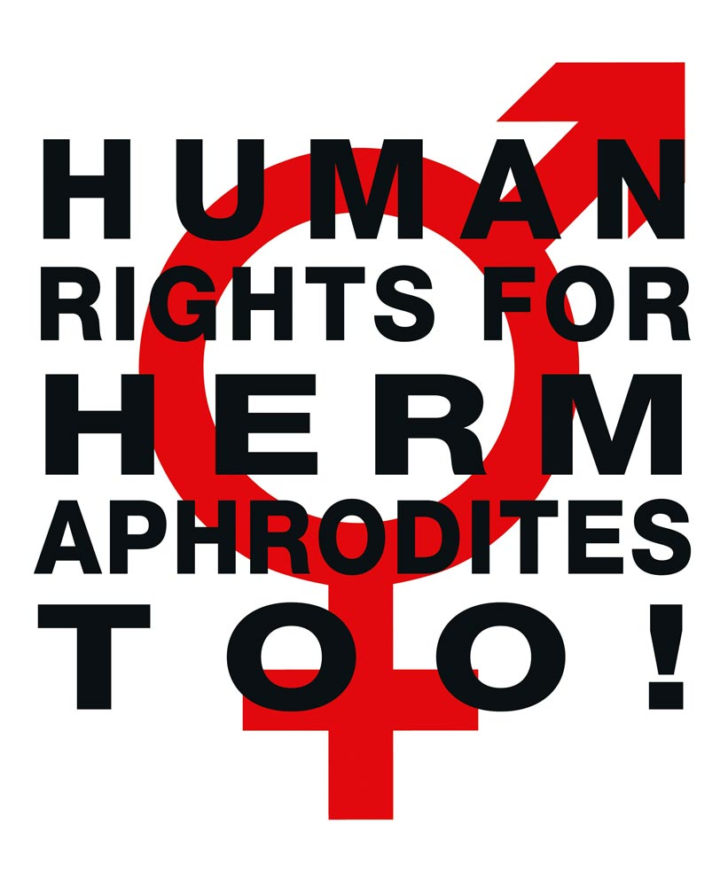

NGO Report
on the Answers to the List of Issues (LoI) in Relation
to the Initial Periodic Report of Germany on the
Convention on the Rights of Persons with Disabilities (CRPD)

Compiled by:

Zwischengeschlecht.org (International Intersex Human Rights NGO)
Markus Bauer
Daniela Truffer
Zwischengeschlecht.org
P.O.Box 2122
8031 Zurich
info_at_zwischengeschlecht.org
http://Zwischengeschlecht.org/
http://StopIGM.org/

March 4, 2015 v2.0: PDF accessability improved, some errors and typos corrected, HTML and DOC versions added.

This NGO Report online:
PDF: http://intersex.shadowreport.org/public/2015-CRPD-LoI-Germany_NGO-Report_Zwischengeschlecht_Intersex-IGM.pdf
HTML: http://intersex.shadowreport.org/public/2015-CRPD-LoI-Germany_NGO-Report_Zwischengeschlecht_Intersex-IGM.html
DOC: http://intersex.shadowreport.org/public/2015-CRPD-LoI-Germany_NGO-Report_Zwischengeschlecht_Intersex-IGM.doc

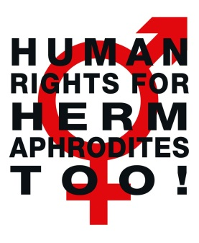
NGO Report
On the Answers to the List of Issues (LoI)
In Relation to the Initial Periodic Report of Germany on the
Convention on the Rights of Persons with Disabilities (CRPD)
Table of Contents
Executive Summary 3
Introduction 5
A. What is Intersex? 6
1. Variations of Sex Anatomy 6
2. How common is Intersex? 7
B. IGM Practices: Non-Consensual, Unnecessary Medical Interventions 8
1. What are Intersex Genital Mutilations (IGMs)? 8
2. Most Frequent Surgical and Other Harmful Medical Interventions 9
a) Clitoris Amputation/“Reduction”, “Vaginoplasty”, Forced Vaginal Dilation 10
b) Hypospadias “Repair” 10
c) Castrations / “Gonadectomies” / Hysterectomies / (Secondary) Sterilisation 11
d) Systematic Misinformation, “Code of Silence”, Lack of Informed Consent 11
e) Other Unnecessary and Harmful Medical Interventions and Treatments 12
3. How Common are Intersex Genital Mutilations? 13
4. Lack of Disinterested Review, Analysis, Outcome Studies and Research 14
5. Lack of Data Collection, Statistics and Independent Monitoring 15
6. Urgent Need for Legislation to Ensure an End to IGM practices 15
C. Intersex People in Germany and the CRPD 16
D. Issues mentioned in the LoI 18
1. Data Collection and Statistics (Art. 16, LoI issue 12 / Art. 31) 18
Recommendation 1 19
2. Legislation to Stop IGM Practices (Art. 16, LoI issue 12 / Art. 4, 7, 15, 17) 19
Recommendation 2 21
E. Issues not mentioned in the LoI 21
1. Lack of Access to Redress and Justice (Art. 12, 13) 21
a) Criminal Law 21
b) Civil Law 22
c) Victim’s Compensation Law (Opferentschädigungsgesetz, OEG) 22
2. Denial of Needed Health Care (Art. 25) 24
Recommendation 3 25
Annexe 1 – Bibliography: Intersex & Human Rights Mechanisms 26
1. International Bodies Recognising Human Rights Violations of Intersex Children 26
2. State Bodies Recognising Human Rights Violations of Intersex Children 30
3. National Ethics Bodies Recognising Human Rights Violations of Intersex Children 30
4. NGO, NHRI Reports on Human Rights Violations of Intersex Children 30
Annexe 2 – “Medical Textbooks” 33
1. “Hypospadias Repair” a.k.a. “Masculinising Surgeries” 33
2. “Clitoral Reduction”, “Vaginoplasty” a.k.a. “Feminising Surgeries” 36
3. Castration / “Gonadectomy” / Hysterectomy / (Secondary) Sterilisation 38
4. “Bad Results” / “Gonadectomy, Feminizing Genitoplasty” 40
Executive Summary
People born with intersex conditions, or variations of sex anatomy, face a wide range of violations of their rights to inherent dignity, bodily integrity and individual autonomy, as well as to their sexual and reproductive rights. In the “developed world” the most pressing issue are the ongoing Intersex Genital Mutilations (IGM), which present a distinct and unique issue constituting significant human rights violations. German Universities, State and Private Clinics keep performing IGM practices, including non-consensual, irreversible, unnecessary cosmetic genital surgeries, sterilising procedures, human experimentation, medical display and photography of the genitals, forced excessive genital examinations, and other unnecessary harmful medical treatments on intersex infants and adolescents – treatments described by persons concerned as genital mutilations, and as a form of child sexual abuse.
IGM practices cause lifelong serious physical and psychological consequences, including loss or impairment of sexual sensation, impairing metabolic problems and lifelong dependency of artificial hormones after castration, painful scarring, painful intercourse, incontinence, serious problems with passing urine, increased sexual anxieties, less sexual activity, dissatisfaction with functional and aesthetic results, impairment or loss of reproductive capabilities, significantly elevated rates of self-harming behaviour and suicidal tendencies, lifelong mental suffering and trauma.
While persons with intersex variations per se are not disabled, as a result of having been submitted to IGM practices, many intersex people have actual physical and psychological impairments and medical needs, can’t work anymore, and live in poverty. In Germany, many survivors of IGM practices have therefore successfully applied for disability status, resulting in acknowledged disability grades (Grad der Behinderung, GdB) of up to 90%.
IGM practices have repeatedly been recognised by UN and other human rights and ethics bodies as serious human rights violations, as constituting at least cruel, inhumane or degrading treatment (CIDT) or torture, as a form of violence, and as a harmful practice.
Nonetheless, as this report demonstrates, despite having been criticised by human rights bodies and in parliament for many years, Germany stubbornly keeps refusing to acknowledge the human rights violations of past and present treatment of intersex people, and crucially, to take urgently needed legislative action to ensure the human rights of persons concerned, specifically
- to stop IGM practices,
- to ensure access to redress and justice,
- to collect and disseminate relevant data and statistics, and
- to ensure the availability, approval and coverage by health insurances of vital medications.
Introduction
This thematic report has been prepared by the NGO Zwischengeschlecht.org in ongoing direct collaboration with German intersex persons represented therein. Unless stated otherwise, all information has been obtained via personal interviews.
Zwischengeschlecht.org, co-founded in 2007 by the rapporteurs, is an international intersex human rights NGO based in Switzerland, lead by intersex persons, their partners, families and friends, and works to represent the interests of intersex people and their relatives, raise awareness, and fight IGM practices and other human rights violations perpetrated on intersex people, according to our motto, “Human Rights for Hermaphrodites, too!” According to its charter, Zwischengeschlecht.org has worked from the beginning to support persons concerned seeking redress and justice, and has continuously collaborated with members of parliament and other bodies in order to call on Governments and Clinics to collect and disclose statistics of intersex births and IGM practices.
This thematic NGO report elaborates on the paragraphs on intersex and IGM practices in the BRK-Allianz NGO Report (p. 36–37), in the List of Issues (LoI) (issue 12), in Germany’s Answer to the LoI (paras 73–78), and in the BRK-Allianz Response to the LoI (p. 11–12), and it draws heavily on the 2014 CRC Thematic NGO Report on Intersex and IGM practices co-authored by the rapporteurs.
Intersex Genital Mutilations and other human rights violations of persons with variations of sex anatomy are a special and emerging human rights issue, unfortunately still often neglected by human rights bodies, mostly due to lack of access to comprehensive information. However, to assess the current practice at national level, it is crucial to gain some general knowledge of the most pressing human rights violations faced by intersex people in Germany as well as all over the “developed world.” Therefore, this NGO report also includes some summarised general information on intersex and IGM practices. For further reference, the Rapporteurs would like to refer the Committee to the thematic Supplements “IGM – Historical Overview” and “The 17 Most Common Form of IGMs” included in the thematic 2014 CRC NGO Report.

A. What is Intersex?
1. Variations of Sex Anatomy
Intersex persons, in the vernacular also known as hermaphrodites, or medically as persons with “Differences of Sex Development (DSD),” are people born with “atypical” sex and reproductive anatomies, including
a) “ambiguous genitalia”, e.g. “enlarged” clitoris, urethral opening not on the tip of the penis, but somewhere below on the underside of the penis (Hypospadias), fused labia, absence of vagina (vaginal agenesis, or Mayer-Rokitansky-Küster-Hauser syndrome MRKH), unusually small penis or micropenis, breast development in “males”; and/or
b) atypical hormone producing organs, or atypical hormonal response, e.g. a mix of ovarian and testicular tissue in gonads (ovotestes, “True Hermaphroditism”), the adrenal gland of the kidneys (partly) producing androgens (e.g. testosterone) instead of cortisol (Congenital Adrenal Hyperplasia CAH), low response to testosterone (Androgen Insensitivity Syndrome AIS), undescended testes (e.g. in Complete Androgen Insensitivity Syndrome CAIS), little active testosterone producing Leydig cells in testes (Leydig Cell Hypoplasia), undifferentiated streak gonads (Gonadal Dysgenesis GD if both gonads are affected, or Mixed Gonadal Dysgenesis MGD with only one streak gonad); and/or
c) atypical genetic make-up, e.g. XXY (Klinefelter Syndrome), X0 (Ullrich Turner Syndrome), different karyotypes in different cells of the same body (mosaicism and chimera).
Variations of sex anatomy include
- “atypical characteristics” either on one or on more of the above three planes a)–c),
- or, while individual planes appear “perfectly normal”, together they “don’t match”, e.g. a newborn with male exterior genitals but an uterus, ovaries and karyotype XX (some cases of Congenital Adrenal Hyperplasia CAH), or with female exterior genitals but (abdominal) testicles and karyotype XY (Complete Androgen Insensitivity Syndrome CAIS).
While many intersex forms are usually detected at birth or earlier during prenatal testing, others may only become apparent at puberty or later in life.
Everybody started out as a hermaphrodite: Until the 7th week of gestation, every fetus has “indeterminate” genitals, two sets of basic reproductive duct structures, and bipotential gonads. Only after the 7th week of gestation, fetuses undergo sexual differentiation mostly resulting in typically male or female sex anatomy and reproductive organs. However, with some fetuses, sex development happens along a less common pathway, e.g. due to unusual level of certain hormones, or an unusually high or low ability to respond to them, resulting in intersex children born with in-between genitals and/or other variations of sex anatomy.
For more information and references on genital development and appearance, please see 2014 CRC NGO Report (A 2–3, p. 8–10.)
2. How common is Intersex?
Since German hospitals, federal and state government agencies, and health assurances covering intersex surgeries refuse to disclose statistics and costs (see below), there are no exact figures or statistics available (for some contradicting figures given by federal and state governments, clinics and doctors see below). Also, the definition of intersex is often arbitrarily changed by doctors and government agencies in order to get favourable (i.e. lower) figures. Therefore, all available numbers are mere estimates and extrapolations. Intersex persons and their organisations have been calling for independent data collection and monitoring for some time, however to no avail.
An often quoted number is 1:2000 newborns, however this obviously disregards variations of sex anatomy at risk of “masculinising corrections” (hypospadias), nowadays the most common form of non-consensual, medically unnecessary surgeries on persons with variations of sex anatomy.
In medical literature, often two different sets of numbers and definitions are given depending on the objective:
a) 1:1000 if it’s about getting access to new patients for paediatric genital surgery, and
b) 1:4500 or less if it’s about countering public concerns regarding human rights violations, often only focusing on “severe cases” while refusing to give total numbers. On the other hand, researchers with an interest in criticising the gender binary often give numbers of up to “as high as 2%”.
However, from a human rights perspective, the crucial question remains: How many children are at risk of human rights violations, e.g. by non-consensual, medically unnecessary, irreversible, cosmetic genital surgeries or other similar treatments justified by a psychosocial indication? Here, the best known relevant number is 1:500 – 1:1000 children are submitted to (often repeated) non-consensual “genital corrections”.

B. IGM Practices: Non-Consensual, Unnecessary Medical Interventions
1. What are Intersex Genital Mutilations (IGM)?
Intersex Genital Mutilations include non-consensual, medically unnecessary, irrever-sible, cosmetic genital surgeries, and/or other similar medical treatments, including imposition of hormones, performed on children with variations of sex anatomy, without evidence of benefit for the children concerned, but justified by “psychosocial indications [...] shaped by the clinician’s own values”, the latter informed by societal and cultural norms and beliefs, enabling clinicians to withhold crucial information from both patients and parents, and to submit healthy intersex children to risky and harmful invasive procedures “simply because their bodies did not fit social norms”.
Genital surgery is not necessary for gender assignment, and atypical genitals are not in themselves a health issue. There are only very few situations where some surgery is necessary for medical reasons, such as to create an opening for urine to exit the body.
In addition to the usual risks of anaesthesia and surgery in infancy, IGMs carry a large number of known risks of physical and psychological harm, including loss or impairment of sexual sensation, poorer sexual function, painful scarring, painful intercourse, incontinence, problems with passing urine (e.g. due to urethral stenosis after surgery), increased sexual anxieties, problems with desire, less sexual activity, dissatisfaction with functional and aesthetic results, lifelong trauma and mental suffering, elevated rates of self-harming behaviour and suicidal tendencies comparable to those among women who have experienced physical or (child) sexual abuse, impairment or loss of reproductive capabilities, lifelong dependency on daily doses of artificial hormones.
2. Most Frequent Surgical and Other Harmful Medical Interventions
Due to space limitations, the following paragraphs summarise the most frequent and egregious forms only. The injuries suffered by intersex people have not yet been adequately documented.
For a more comprehensive list of 17 common forms of IGM practices and detailed sources, please see our 2014 CRC NGO Report, p. 63-76.
a) Clitoris Amputation/“Reduction”, “Vaginoplasty”, Forced Vaginal Dilatation
In 19th Century Western Medicine, clitoris amputations a.k.a. “clitoridectomies” on girls were prevalent as a “cure” for a) masturbation, b) hysteria, and c) “enlarged clitoris.” While amputations motivated by a) and b) were mostly abandoned between 1900 and 1945, amputations of “enlarged clitorises” took a sharp rise after 1950, and in the 1960s became the predominant medical standard for intersex children.
For four decades, doctors like e.g. the German Professor Jürgen R. Bierich claimed these clitoris amputations would not interfere with orgasmic function. Only in the 1980s–1990s, amputations were eventually replaced by “more modern” techniques a.k.a. “clitoral reduction” (see Annexe 2; 2.), again claimed to preserve orgasmic function, despite ongoing complaints by persons concerned also corroborated by recent medical studies.
Despite that in infants there’s no medical (or other) need for surgically creating a vagina “big enough for normal penetration” (“vaginoplasty”), but significant risks of complications (e.g. painful scarring, vaginal stenosis), this remains standard practice. Also, in order to prevent “shrinking” and stenosis, the “corrected” (neo) vagina has to be forcibly dilated by continuously inserting solid objects, a practice experienced as a form of rape and child sexual abuse by persons concerned.
b) Hypospadias “Repair”
Hypospadias is a medical diagnosis describing a penis with the urethral opening (“meatus”, or “pee hole”) not situated at the tip of the penis, but somewhere below on the underside, due to incomplete tubularisation of the urethral folds during prenatal formation. Hypospadias “repair” aims at “relocating” the urethral opening to the tip of the penis. The penis is sliced open, and an artificial “urethra” is formed out of the foreskin, or skin grafts (see Annexe 2; 1.).
Hypospadias per se does not constitute a medical necessity for interventions. The justification for early surgeries is psychosocial, e.g. to allow for “sex-typical manner for urination (i.e. standing for males).” The most recent AWMF guidelines explicitly include “aestetical-psychological reasons”.
Hypospadias “repair” is notorious for high complication rates of 50% and more, as well as creating serious medical problems where none were before (e.g. urethral strictures leading to kidney failure requiring dialysis, in a German case reported to Zwischengeschlecht.org), and frequent “redo-surgeries”. Tellingly, surgeons refer to “hopeless cases” as “hypospadias cripples” (i.e. made to a “cripple” by unnecessary surgeries, not by the condition!), while in medical publications on hypospadias, “[d]ocumentation on complication rates has declined in the last 10 years”.
For almost two decades, persons concerned have been criticising impairment or loss of sexual sensitivity. However, doctors still refuse to even consider these claims, let alone promote appropriate, disinterested long-term outcome studies.
c) Castrations / “Gonadectomies” / Hysterectomies / (Secondary) Sterilisation
Intersex children are frequently subjected to treatments that terminate or permanently reduce their reproductive capacity. While some intersex people are born infertile, and some retain their fertility after medical treatment, many undergo early removal of viable and hormone producing organs (e.g. gonads, testes, ovaries, ovotestes) or other “discordant” reproductive organs (e.g. uterus), leaving them with “permanent, irreversible infertility and severe mental suffering” and lifelong metabolic problems. When unnecessary sterilising procedures are imposed on children e.g. to address a low or hypothetical risk of cancer, the fertility of intersex people is not being valued as highly as that of non-intersex people.
For almost two decades, persons concerned have protested unnecessary gonadectomies and other irreversible, potentially sterilising treatments, and denounced non-factual and psychosocial justifications, e.g “psychological benefit” to removing “discordant” reproductive structures, demanding access to screening for potential low cancer risks instead of preemptive castrations. What’s more, psychosocial justifications often reveal underlying racist preconceptions by clinicians (reminiscent of the racist and eugenic medical views of intersex predominant during the 1920s–1950s, but which obviously persist), namely the infamous premise, “We don’t want to breed mutants.”
d) Systematic Misinformation, “Code of Silence”, Lack of Informed Consent
Systematic misinformation, refusal of access to peer support, and directive counselling by doctors frequently prevent parents from learning about options for postponing permanent interventions, and persons concerned from learning the truth about themselves via imposition of secrecy and a “code of silence”, leading to serious psychological trauma, which has been criticised by persons concerned and their parents for more than two decades, seconded by bioethicists, and corroborated by studies.
Nonetheless, it’s still paediatricians, endocrinologists and surgeons managing diagnostics and counselling of parents and persons concerned. Parents often complain that they only get access to psychological counselling if they consent to “corrective surgery” first, while doctors openly admit seeking early surgeries to facilitate compliance, e.g. referring to “easier management when the patient is still in diapers”.
e) Other Harmful and Unnecessary Medical Interventions and Treatments
Other common harmful treatments include:
- Forced Mastectomy
- Imposition of Hormones
- Forced Excessive Genital Exams, Medical Display and (Genital) Photography
- Human Experimentation
- Denial of Needed Health Care
- Prenatal “Therapy”
- Selective (Late Term) Abortion
- Preimplantation Genetic Diagnosis (PGD) to Eliminate Intersex Fetuses
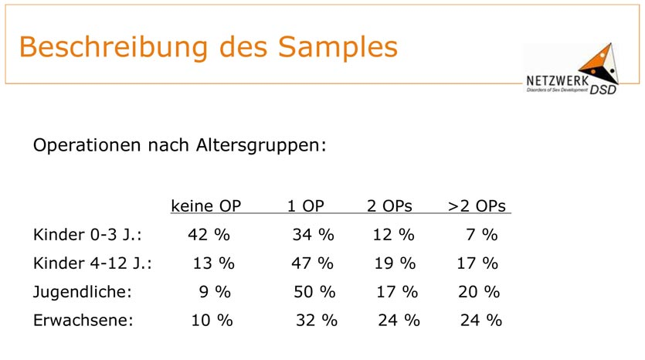
Figure 1 “Surgeries by Age Groups” (No Surgery, 1 Surgery, 2 Surgeries, >2 Surgeries,
Children 0–3 Years, Children 4-12 Years, Adolescents, Adults)
Source: Martina Jürgensen: “Klinische Evaluationsstudie im Netzwerk DSD/Intersexualität: Zentrale Ergebnisse”,
Presentation 27.05.2009, Slide 6, http://kastrationsspital.ch/public/Corpus-delicti_27-5-09.pdf

3. How Common are Intersex Genital Mutilations?
Same as with intersex births (see above), German Hospitals, Government Agencies and Health Assurances covering intersex surgeries refuse to disclose statistics and costs, as well as ignoring repeated calls for independent data collection and monitoring, but going to extreme lengths following established patterns of non-disclosure and denial (for examples by German Government bodies, see below).
In the rare cases of studies actually “disclosing” numbers, a common tactic involves manipulation of statistics, e.g. in the case of the world’s largest outcome study on 439 participants, the German 2008 “Netzwerk DSD” intersex study funded by the German Government (Federal Ministry of Education and Research BMBF), official publications only gave an overall total figure of “almost 81% of all participants had at least once surgery [...] most of them before entering school.”
However, the most significant numbers on intersex children submitted to IGM in Germany stem from a 2009 presentation of the “Netzwerk DSD” intersex study, revealing that, contrary to declarations by doctors as well as government bodies, in the most relevant age groups of 4+ years, 87%–91% have been submitted to IGMs at least once, with increasing numbers of repeat surgeries the older the children get (see Figure 1 above – note, how the table conveniently stops at “>2” surgeries, though especially with “hypospadias repair”, a dozen or more repeat surgeries are not uncommon).
What’s more, though for Germany officially no current figures are available, internationally the total number of cosmetic genital surgeries performed on intersex children evidently is still rising.

4. Lack of Disinterested Review, Analysis, Outcome Studies and Research
Persons concerned and their organisations have stressed for almost two decades “the unreliability of research conducted in the setting where the harm was done”, and stressed the imminent need for disinterested research and analysis
Currently, millions of Euros are spent on “intersex research projects” involving German funding and/or participation, as well as German Federal Government representation.
“DSD-Life” and “DSDnet”, two current examples, are conducted by the perpetrators themselves, e.g. in “DSDnet” paediatric endocrinologists, and in “DSD-Life” paediatric endocrinologists and paediatric surgeons taking the lead – exactly the professional groups responsible for IGMs in the first place. If other disciplines are included at all in the “multidisciplinary teams,” like e.g. psychology or bioethics, let alone persons concerned, they only play a secondary role, and are only included at a later stage, and especially persons concerned serve mostly to recruit participants – same as in the precursor projects “Netzwerk DSD” and “EuroDSD”.
What’s more, all these “research projects” continue to openly advocate IGM practices, as well as to promote the usual psychosocial and non-factual justifications.

5. Lack of Data Collection, Statistics and Independent Monitoring
With no statistics available on intersex births, let alone surgeries and costs, and perpetrators, governments and health departments obviously consistently colluding to keep it that way as long as anyhow possible, persons concerned as well as civil society lack possibilities to effectively highlight and monitor the ongoing mutilations. What’s more, after realising how intersex genital surgeries are increasingly in the focus of public scrutiny and debate, perpetrators of IGMs respond by suppressing complication rates, as well as refusing to talk to journalists “on record” if IGM practices are the topic.

6. Urgent Need for Legislation to Ensure an End to IGM Practices
For more than two decades, persons concerned and sympathetic clinicians and academics have tried to reason with the perpetrators, and for 19 years they’ve been lobbying for legal measures, approaching governments as well as national and international ethics and human rights bodies year after year after year, calling for specific legislation to finally end IGM practices.
In 2011, the Committee against Torture (CAT) supported this call, explicitly urging Germany to “Undertake investigation of incidents of surgical and other medical treatment of intersex people without effective consent and adopt legal provisions in order to provide redress to the victims of such treatment, including adequate compensation”.
In 2013, the Special Rapporteur on Torture and the Council of Europe (COE) also called for legislative measures.
In 2015, the Committee on the Rights of the Child (CRC) recognised IGMs explicitly as “violence” and “harmful practice”.
Nonetheless, to the present day Columbia is still the only state to at least partially restrict IGM practices.

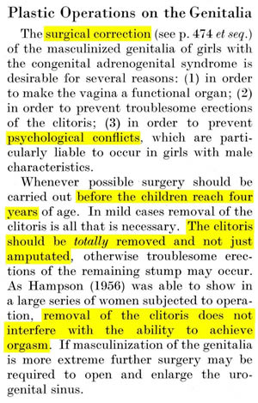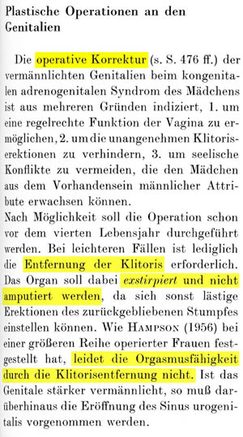
Prof. Dr. Jürgen W. Bierich: “The removal of the clitoris does not interfere with the ability to achieve orgasm”
In: Overzier (ed.), “Intersexuality” (1962, at 379) / “Intersexualität” (1961, at 387)
To this day, every year, the German Society for Endocrinology (DGE) proudly awards its “Bierich Prize” – but refuses to come to terms with past and present involvement in IGM practices ...
Incidentally, the number of the “large series of women” referred to by Bierich above, used to allegedly prove that “removal of the clitoris does not interfere with the ability to achieve orgasm”, was 6 (see: Katrina Karkazis (2008), Fixing Sex. Intersex, Medical Authority, and Lived Experience, at 149).
C. Intersex People in Germany and the CRPD
It is important to note that persons with intersex variations per se are not disabled, and that only one specific and comparably rare intersex condition (CAH in the salt-losing or “salt-wasting” form) constitutes a vital (metabolical) medical need (i.e. daily substitution of lacking cortisol – however, this does NOT constitute a need for genital surgeries!). Nonetheless, doctors constantly use this single exception as a justification for imposing unnecessary surgical and other treatments on ALL persons with variations of sex anatomy.Therefore, generally intersex people don’t consider themselves as disabled. Nonetheless, doctors traditionally have been describing (and “treating”) intersex variations as a form of disability per se, often with racist, eugenic and national socialist undertones.
On the other hand, as a result of having been submitted to IGM practices, many intersex people have actual physical and psychological impairments and medical needs (chronic pain, loss of sexual sensibility, lifelong psychological trauma, metabolic problems and need for daily hormone substitution after castration, etc.), can’t work anymore, and live in poverty. In Germany, many survivors of IGM practices have therefore successfully applied for disability status, resulting in acknowledged disability grades (Grad der Behinderung, GdB) of up to 90%.
On another level, since, apart from being at risk of being submitted to IGM practices, one crucial problem intersex people are confronted with is (fear of) stigmatisation, ostracism and rejection by modern society because of their (sometimes) “unusual appearance”, compounded by doctors’ constant conjuring up the birth of an intersex child as a “psycho-social emergency”, and considering the actual impairments as a result of IGM practices “done to prevent this”, as well as (actual and/or perceived) barriers for intersex people to full participation in life and society because of being perceived and/or (medically) treated as “different”, many intersex persons and groups are applying the social model of disability to devise strategies in their fight for bodily integrity and autonomy, and for social recognition as actual human beings, and many collaborate (formally or informally) with disability groups.
D. Issues mentioned in the LoI
1. Data Collection and Statistics (Art. 16, LoI issue 12 / Art. 31)
While the answer of the State Party (para 73), “The Federal Government does not have statistics on the number of surgical interventions mentioned in the question” is not factually untrue, it is still far from the whole truth, as it conveniently omits the ongoing complaints by persons concerned, that the Federal Government as well as State and Communal Governments have been actively refusing to collect and disclose statistics regarding IGM practices for almost two decades, despite having been repeatedly asked to do so in parliament, and having announced to do so for a long time:
- 1996, the Federal Government was formally asked to provide statistics, but in their answer merely ignored the question.
- 2001, the Federal Government, when again asked for statistics, claimed data collection would be possible soon: “Starting 2002, the Federal Statistical Office is expected to conduct the statistics on hospital diagnoses on the basis of the international ICD 10 classification.”Thereafter, statistics on “intersex diagnoses” would become available.
- 2007, the Federal Government, when again asked for statistics, reverted to “not hav[ing] nationwide coherent data collection and statistics”, but referring to “findings of medical associations” of only “8.000 – 10.000 persons in Germany with serious aberrancy of sex development”, while refusing to give total numbers of all relevant cases.
- 2009, the Federal Government repeated “not hav[ing] nationwide coherent data collection and statistics”, adding, “Presently, the Federal Government does not plan [to collect such data].”
- 2009, the State Government of Hamburg claimed, since “no unambiguous definition of the term ‘intersex’ as a diagnosis exists, [giving statistics of IGM practices] is not possible,” therefore “the requested data is not collected statistically,” further referring to “medical confidentiality and data protection.”
- 2010, the State Government of Berlin claimed having “no knowledge of practical cases of such surgical interventions or therapies”, adding: “Nor are there findings, if and which clinics undertook such treatments on children.”
- 2012, the Communal Government of Munich claimed, “Numbers of cases are not collected systematically,” adding an enquiry at all relevant clinics would be “outside the scope of a parliamentary question.”
- 2014, the State Government of Bavaria censored a relevant question, while secretly declaring, data were available, however “data on above mentioned surgical interventions are business and trade secrets of the [mostly state controlled] clinics,” and therefore “secret” and “not allowed to be published according to art. 30 VwVfG,” further referring to “data protection.”
On the other hand, as the single exception proving the rule, the State Government Hamburg, in a 2013 answer to a parliamentary question, proved that it’s not only possible to collect relevant data, but also to publish relevant statistics legally.
We therefore would like to affirm, and elaborate on, the concerns and recommendations of the BRK-Alliance (p. 11-12), in order to finally ensure data collection and statistics:
Recommendation 1
The Federal Government must take tangible steps in order to establish data collection and regular dissemination of statistics on the number of all forms of IGM practices performed on children with variations of sex anatomy in German clinics, including a breakdown of type of intervention, age groups and clinics, in close cooperation with the organisations of the persons concerned and the national monitoring body (German Institute for Human Rights).
Within one year, the Federal Government shall disseminate the first statistics and file an interim report on this issue to the Committee.
2. Legislation to Stop IGM Practices (Art. 16, LoI issue 12 / Art. 4, 7, 15, 17)
The evasive answer of the State Party (para 74–78) betrays the Federal Government’s established unwillingness to stop IGM practices in Germany, as well as the keenness of both the Federal and State Governments to defend them, referring to the very same “best interest of the child” according to § 1627 BGB as in their current answer (para 77), as documented in various answers to parliamentary questions:
- 1996, the Federal Government stated: “The treatment of the children concerned takes place individually considering the specific occurrence of the individual clinical picture and the special circumstances of the child concerned. To prevent psychological effects, the necessary sex correction is usually carried out in the first two years of life. [...]The legal basis is the contract governing medical treatment, which is closed by the parents in the knowledge of the fate of untreated children suffering from such diseases.”
- 2001, the Federal Government, when asked on their position on a general legal ban of sex-assigning surgeries on minors lacking capacity, in their answer simply ignored the question; adamantly refused to even consider complaints by persons concerned that “surgical corrections” might constitute CIDT as “not very helpful in the interest of a factual and professionally competent debate”; declared “intersex corrections” to be “medically-therapeutic interventions” as opposed to “genital-mutilating interventions in some African cultures”; and claimed the “corrections” to be compatible with the best interest of the children concerned according to § 1627 BGB.
- 2007, the Federal Government, when again asked on their position on a general legal ban of sex-assigning surgeries on minors lacking capacity, simply referred to their above 2001 (non-)answers; including an additional reference to § 1627 BGB.
- 2009, the Federal Government once more simply referred to their above 2001 (non-)answers.
- 2013, the State Government of Hamburg declared, “The association of such interventions with ‘cosmetic genital surgeries’, ‘forced genital normalizing surgeries’ or even ‘genital mutilations’ is not applicable.”
In contrast, in 2011, the Committee against Torture (CAT) explicitly urged Germany to “adopt legal provisions in order to provide redress to the victims of such treatment, including adequate compensation”. In 2013, the Special Rapporteur on Torture and the Council of Europe (COE) seconded this call for legislative measures. Nonetheless, the Federal Government to this day still refuses to undertake tangible steps.
What’s more, in 2013, at the request and with the votes of the then-and-now leading coalition party, the Federal Parliament voted down 3 motions calling for a legal review of IGM practices.
In contrast, in 2014, the 24th Conference of Ministers for Women’s Issues and Equality (GFMK) explicitly called for a “legal ban of medically unnecessary surgical and pharmacological [...] interventions on intersex minors,” explicitly referring to the need of intersex children for similar protection against sterilisation (§ 1631c BGB) and female genital mutilation (§ 226a StGB) that other children and girls already enjoy.
What’s more, in a 2012 judgement by the Bayreuth Social Court in Bavaria denying the plaintiff, a survivor of IGM practices, any recompensation according to the Victim’s Compensation Law (OEG), the court explicitly stated, for the plaintiff to be eligible for compensation, “there would have to be laws [against IGM practices] in place. However, there aren’t” (see also below E.1.) – again in stark contrast to the claims in the answer of the Federal Government to the LoI, as well as to the mentioned objective of the interministerial working group to once more (for how long?) “discuss” the obvious, i.e. “[w]hether further measures are needed to supplement the existing regulations in German law, to protect intersexual children from irreversible surgical interventions that are neither medically essential nor in the best interests of the child”? (para 78)
We therefore would like to affirm, and elaborate on, the concerns and recommendations of the BRK-Alliance (p. 11-12), in order to finally ensure adequate legislation against IGM practices to preserve persons concerned from harm in the future, and in addition to ensure access to redress and justice for survivors (see below E.1.):
Recommendation 2
The Federal Government must closely cooperate with the organisations of the persons concerned in order to immediately initiate legislative measures to stop IGM practices, and to ensure access to redress and justice for survivors, including appropriate reform of
- Criminal Law
- Civil Liability
- Victim’s Compensation Law (Opferentschädigungsgesetz OEG)
- Associated Limitation Periods.
Within one year, the Federal Government shall update the Committee on this issue in an interim report.
E. Issues not mentioned in the LoI
1. Lack of Access to Redress and Justice (Art. 12, 13)
The lack of access to redress and justice for survivors of IGM practices in Germany is well known and near total:
a) Criminal Law
- No survivor of IGM practices ever succeeded in filing criminal charges.
- In case of average early surgeries according to AWMF guidelines (“in the first two years of life”), all statutes of limitations have long passed before survivors come of age.
- To this day, persons concerned and their organisations in vain call for a legal review of the statutes of limitations in cases of IGM practices, referring to current and recent legal reviews regarding adjournment or suspension of the statutes of limitation in cases of child sexual abuse (§§ 176 ff. StGB), and female genital mutilation (§ 226a StGB).
- As already noted above (D.2.), in 2014, the 24th Conference of Ministers for Women’s Issues and Equality (GFMK) explicitly called for a “legal ban of medically unnecessary surgical and pharmacological [...] interventions on intersex minors,” explicitly referring to the need of intersex children for similar protection against sterilisation (§ 1631c BGB) and female genital mutilation (§ 226a StGB) that other children and girls already enjoy.
b) Civil Law
- No survivor of childhood IGM practices ever succeeded in filing civil charges.
- Only 3 survivors of IGM practices so far succeeded in filing civil charges – all of them only for surgeries they were submitted to as adults of 18 years or older. The first case in Cologne 2007-2009 resulted in a surgeon being sentenced to pay 100’000 Euros damages. Two more cases filed 2011 in Nuremberg and 2012 in Munich are currently (slowly) under way.
- All other survivors of IGM practices attempting to sue so far were prevented by the statutes of limitations.
- Already in 2009 during an intersex hearing of the State Parliament of Hamburg, specialised local lawyer Dr. Oliver Tolmein stated: “Interestingly, a great many [intersex] persons come to our lawyer’s office wanting to sue their doctors for damages [however, so far all were prevented by the statutes of limitations]”.
c) Victim’s Compensation Law (Opferentschädigungsgesetz, OEG)
- So far, no survivor of IGM practices succeeded in winning any compensation.
Case 1: Survivor of IGM practices with acknowledged disability grade (GdB), unable to work. Right to recompensation denied by court on the grounds of lacking “hostile intent” (“feindselige Absicht”) of perpetrating doctors, referring to lack of “own financial interests of treating clinicians”.
Case 2: Survivor of IGM practices with acknowledged disability grade (GdB) of 80%, unable to work. Right to recompensation denied by court on the grounds of lacking “hostile intent” (“feindselige Absicht”) of perpetrating doctors. As mentioned above (D.2.), in addition the court explicitly stated, for the plaintiff to be eligible for compensation “there would have to be laws [against IGM practices] in place. However, there aren’t.”
Case 3: Survivor of IGM practices with acknowledged disability grade (GdB) of 60%, unable to work. Right to recompensation denied by court on the grounds of lacking “hostile intent” (“feindselige Absicht”) of perpetrating doctors.
Case 4: Survivor of IGM practices with acknowledged disability grade (GdB) of 50%, unable to work. Right to recompensation denied by state ministry on the grounds of lacking “hostile intent” (“feindselige Absicht”), stating the injuries in question, including non-consensual clitoridectomy, imposition of “Androcur,” and human experimentation, would not constitute a punishable criminal offense.
- A 2014 Working Paper “Right of Compensation of Intersex People” published by the Humboldt Law Clinic Human Rights (HLCMR) of the Humboldt University Berlin concludes, without a revivion of the OEG, or at least an adapted legal interpretation of “hostile intent” (“feindselige Absicht”) within the OEG, survivors of IGM will never have a chance of winning recompensation, despite the discrepancy to the stated intent of the OEG “to create a financial compensation in cases of the state failing its mission to prevent crimes,” and in marked contrast to Art. 3 EMRK and the Concluding Observations for Germany by the Committee against Torture (CAT/C/DEU/CO/5), and similar findings also apply to the right of compensation due to other established forms of recompensation, specifically Government Liability (Amtshaftung, § 839 BGB in connection with Art. 34 GG) and General Liability (Allgemeiner Aufopferungsanspruch, according to Common Law).
Recommendation:
(See above Recommendation 2, which already includes remedies for lack of access to redress and justice regarding the laws mentioned in this section.)
2. Denial of Needed Health Care (Art. 25)
As mentioned in (C.), there is only one specific and comparably rare intersex condition, the salt-losing form of Congenital Adrenal Hyperplasia (CAH), that constitutes a vital (metabolical) medical need, i.e. for daily substitution for lacking cortisol. (However, this does NOT constitute a need for genital surgeries. Nonetheless, doctors constantly use this single exception as a justification for imposing IGM practices on ALL persons with variations of sex anatomy.)
Provided a suitable substitute in adequate dosage and form is always readily available, CAH in the salt-losing form is per se not an impairment for work or sports (however, most persons with this diagnosis have been submitted to massive “feminising genital corrections” as children, with all the resulting health detriments). Nonetheless, for persons concerned, lack of suitable substitute availability means risk of imminent death.
In Germany, the established substitute is Fludrocortisone (also called 9-fluorocortisol or 9α-fluorohydrocortisone), a synthetic corticosteroid which is on the “World Health Organisation’s List of Essential Medicines,” a list of the most important medication needed in a basic health system. Fludrocortisone is usually taken orally in tablet form. Under special circumstances, e.g. if a faster uptake is required, or in case of nausea preventing oral ingestion, suppositories containing Prednisone in adequate dosage are the preferred medication.
During the past decade, the Federal Government as well as the German medical associations regularly claim to have invested Millions of Euros and considerable effort in the improvement of medical care for and the life quality of intersex persons. Nonetheless, for intersex persons concerned, in 2015 the availability of suitable Fludrocortisone medications, as well as Prednisone suppositories in adequate dosage, has either already vanished or is presently highly at risk, while specifically the Federal Government refuses to ensure that persons concerned can continue to have this vital medications readily available and covered by the mandatory health insurance:
- By the end of 2014, clinics, doctors and persons concerned were warned by Merck Serono pharmaceuticals, producers of “Astonin H,” the only Fludrocortisone medication approved in Germany, that because of a “supply bottleneck” for Fludrocortisone, the tablets would vanish from the market for an unforeseeable period of time. By end of January 2015 for example in Hamburg, packages of 50 pc. of “Astonin H” were already sold out completely, and packages of 100 pc. were only limitedly available in the form of re-imports, but expected to deplete soon. Persons concerned were advised to switch to private imports of “Florinef” (produced by E.R. Squibb & Sons Ltd.). However, such private imports of non-approved “off-label” pharmaceuticals lead to potentially considerable bureaucratic effort and financial risk for persons concerned, since health insurances usually state they’re not allowed to reimburse non-approved products (see also below “Rectodelt”), and according §73 Abs. 3 AMG only prescriptions for “small quantities” are allowed. Also, contrary to “Astonin H”, “Florinef” tablets must be refrigerated at 2–8°C, which reduces mobility in case of vacations, and makes it more complicated to have an emergency ration ready e.g. at work.
- In 2004, “Rectodelt” suppositories containing Prednisone in the dosage of 30 mg (as well as in the dosages of 5 and 10 mg) were taken off the market. Only the dosage of 100 mg is still available, which is not suitable as an emergency medication for CAH in the salt-losing form. On inquiry, persons concerned were informed that the producer Trommsdorff Arzneimittel was forced to do so because the fees for a renewed approval would exceed expected profits. When a person concerned therefore switched to a replacement of 30 mg suppositories specially manufactured in a pharmacy, health insurance Barmer GEK refused to cover the costs, stating they were prohibited to pay for non-approved “off-label” medication.
We therefore would like to affirm, and elaborate on, the concerns and recommendations of the BRK-Alliance (p. 11-12) to sustainably improve the living situation of persons concerned:
Recommendation 3
The Federal Government must closely cooperate with the organisations of the persons concerned in order ensure the availability, approval, and financial coverage by health insurances, of all needed medication for persons concerned, especially in the case of persons with CAH in the salt-losing form, and to sustainably improve the living situation of persons concerned in general.
Within one year, the Federal Government shall update the Committee on this issue in an interim report.
Annexe 1 – Bibliography: Intersex & Human Rights Mechanisms
1. International Bodies Recognising Human Rights Violations of Intersex Children
2006: UN WHO, Genomic resource centre, Gender and Genetics: Genetic Components of Sex and Gender (online)
http://www.who.int/genomics/gender/en/index1.html
Gender Assignment of Intersex Infants and Children
Intersex is defined as a congenital anomaly of the reproductive and sexual system. An estimate about the birth prevalence of intersex is difficult to make because there are no concrete parameters to the definition of intersex. The Intersex Initiative, a North-American based organization, estimates that one in 2,000 children, or five children per day in the United States, are born visibly intersex. (36) This estimate sits within range; from genital anomalies, such as hypospadias, with a birth prevalence of around 1:300 to complex genital anomalies in which sex assignment is difficult, with a birth prevalence of about 1:4500. (37) Many intersex children have undergone medical intervention for health reasons as well as for sociological and ideological reasons. An important consideration with respect to sex assignment is the ethics of surgically altering the genitalia of intersex children to “normalize” them.
Clitoral surgery for intersex conditions was promoted by Hugh Hampton Young in the United States in the late 1930s. Subsequently, a standardized intersex management strategy was developed by psychologists at Johns Hopkins University (USA) based on the idea that infants are gender neutral at birth. (38) Minto et al. note that “the theory of psychosexual neutrality at birth has now been replaced by a model of complex interaction between prenatal and postnatal factors that lead to the development of gender and, later, sexual identity”. (39) However, currently in the United States and many Western European countries, the most likely clinical recommendation to the parents of intersex infants is to raise them as females, often involving surgery to feminize the appearance of the genitalia. (40)
Minto et al. conducted a study aiming to assess the effects of feminizing intersex surgery on adult sexual function in individuals with ambiguous genitalia. As part of this study, they noted a number of ethical issues in relation to this surgery, including that:
- there is no evidence that feminizing genital surgery leads to improved psychosocial outcomes;
- feminizing genital surgery cannot guarantee that adult gender identity will develop as female; and that
- adult sexual function might be altered by removal of clitoral or phallic tissue. (41)
2009: UN CEDAW, CEDAW/C/DEU/CO/6, 10 February 2009, para 61–62:
http://www2.ohchr.org/english/bodies/cedaw/docs/co/CEDAW-C-DEU-CO6.pdf
Cooperation with non-governmental organizations
61. [...] The Committee regrets, however, that the call for dialogue by non-governmental organizations of intersexual [...] people has not been favourably entertained by the State party.
62. The Committee request the State party to enter into dialogue with non-governmental organizations of intersexual [...] people in order to better understand their claims and to take effective action to protect their human rights.
Follow-up to concluding observations
67. The Committee requests the State party to provide, within two years, written information on the steps undertaken to implement the recommendations contained in paragraphs 40 and 62.
2009: UN SR Health, A/64/472, 10 August 2009, para 49:
http://www.refworld.org/pdfid/4aa762e30.pdf
IV. Vulnerable groups and informed consent
A. Children
49. Health-care providers should strive to postpone non-emergency invasive and irreversible interventions until the child is sufficiently mature to provide informed consent. [67] [Fn. 67: This is particularly problematic in the case of intersex genital surgery, which is a painful and high-risk procedure with no proven medical benefits; see, e.g., Colombian Constitutional Court, Sentencia SU-337/99 and Sentencia T-551/99.] Safeguards should be in place to protect children from parents withholding consent for a necessary emergency procedure.
2011: UNHCHR, A/HRC/19/41, 17 November 2011, para 57:
http://www.ohchr.org/Documents/Issues/Discrimination/A.HRC.19.41_English.pdf
“In addition, intersex children, who are born with atypical sex characteristics, are often subjected to discrimination and medically unnecessary surgery, performed without their informed consent, or that of their parents, in an attempt to fix their sex.”
2011: UN CAT, CAT/C/DEU/CO/5, 12 December 2011, para 20:
http://www2.ohchr.org/english/bodies/cat/docs/co/CAT.C.DEU.CO.5_en.pdf
Intersex people
20. The Committee takes note of the information received during the dialogue that the Ethical Council has undertaken to review the reported practices of routine surgical alterations in children born with sexual organs that are not readily categorized as male or female, also called intersex persons, with a view to evaluating and possibly changing current practice. However, the Committee remains concerned at cases where gonads have been removed and cosmetic surgeries on reproductive organs have been performed that entail lifelong hormonal medication, without effective, informed consent of the concerned individuals or their legal guardians, where neither investigation, nor measures of redress have been introduced. The Committee remains further concerned at the lack of legal provisions providing redress and compensation in such cases (arts. 2, 10, 12, 14 and 16).
The Committee recommends that the State party:
(a) Ensure the effective application of legal and medical standards following the best practices of granting informed consent to medical and surgical treatment of intersex people, including full information, orally and in writing, on the suggested treatment, its justification and alternatives;
(b) Undertake investigation of incidents of surgical and other medical treatment of intersex people without effective consent and adopt legal provisions in order to provide redress to the victims of such treatment, including adequate compensation;
(c) Educate and train medical and psychological professionals on the range of sexual, and related biological and physical, diversity; and
(d) Properly inform patients and their parents of the consequences of unnecessary surgical and other medical interventions for intersex people.
2013: UN SR Torture, A/HRC/22/53, 1 February 2013, paras 77, 76, 88:
http://www.ohchr.org/Documents/HRBodies/HRCouncil/RegularSession/Session22/A.HRC.22.53_English.pdf
77. Children who are born with atypical sex characteristics are often subject to irreversible sex assignment, involuntary sterilization, involuntary genital normalizing surgery, performed without their informed consent, or that of their parents, “in an attempt to fix their sex”, [107] leaving them with permanent, irreversible infertility and causing severe mental suffering.
76. [...] These procedures [genital-normalizing surgeries] are rarely medically necessary,[106] can cause scarring, loss of sexual sensation, pain, incontinence and lifelong depression and have also been criticized as being unscientific, potentially harmful and contributing to stigma (A/HRC/14/20, para. 23). [...]
88. The Special Rapporteur calls upon all States to repeal any law allowing intrusive and irreversible treatments, including forced genital-normalizing surgery, involuntary sterilization, unethical experimentation, medical display, “reparative therapies” or “conversion therapies”, when enforced or administered without the free and informed consent of the person concerned. He also calls upon them to outlaw forced or coerced sterilization in all circumstances and provide special protection to individuals belonging to marginalized groups.
2013: Council of Europe (COE), Resolution 1952 (2013) “Children’s right to physical integrity”, 1 October 2013, paras 2, 6, 7:
http://www.assembly.coe.int/nw/xml/XRef/X2H-Xref-ViewPDF.asp?FileID=20174&lang=en
2. The Parliamentary Assembly is particularly worried about a category of violation of the physical integrity of children, which supporters of the procedures tend to present as beneficial to the children themselves despite clear evidence to the contrary. This includes, amongst others, female genital mutilation, the circumcision of young boys for religious reasons, early childhood medical interventions in the case of intersex children and the submission to or coercion of children into piercings, tattoos or plastic surgery.
6. The Assembly strongly recommends that member States promote further awareness in their societies of the potential risks that some of the above mentioned procedures may have on children’s physical and mental health, and take legislative and policy measures that help reinforce child protection in this context.
7. The Assembly therefore calls on member States to:
7.1. examine the prevalence of different categories of non-medically justified operations and interventions impacting on the physical integrity of children in their respective countries, as well as the specific practices related to them, and to carefully consider them in light of the best interests of the child in order to define specific lines of action for each of them;
7.2. initiate focused awareness-raising measures for each of these categories of violation of the physical integrity of children, to be carried out in the specific contexts where information may best be conveyed to families, such as the medical sector (hospitals and individual practitioners), schools, religious communities or service providers; [...]
7.4. initiate a public debate, including intercultural and interreligious dialogue, aimed at reaching a large consensus on the rights of children to protection against violations of their physical integrity according to human rights standards;
7.5. take the following measures with regard to specific categories of violation of children’s physical integrity: [...]
7.5.3. undertake further research to increase knowledge about the specific situation of intersex people, ensure that no-one is subjected to unnecessary medical or surgical treatment that is cosmetic rather than vital for health during infancy or childhood, guarantee bodily integrity, autonomy and self-determination to persons concerned, and provide families with intersex children with adequate counselling and support; [...]
7.7. raise awareness about the need to ensure the participation of children in decisions concerning their physical integrity wherever appropriate and possible, and to adopt specific legal provisions to ensure that certain operations and practices will not be carried out before a child is old enough to be consulted.
2014: UN CRPD, CRPD/C/DEU/Q/1, 17 April 2014, paras 12–13:
http://tbinternet.ohchr.org/Treaties/CRPD/Shared%20Documents/DEU/CRPD_C_DEU_Q_1_17084_E.doc
Freedom from exploitation, violence and abuse (art. 16)
12. How many irreversible surgical procedures have been undertaken on intersexual children before an age at which they are able to provide informed consent? Does the State party plan to stop this practice?
13. Please provide up to date statistics on forced sterilizations of persons, i.e. without their free and informed consent.
2014: OHCHR, UN Women, UNAIDS, UNDP, UNFPA, UNICEF and WHO, Eliminating forced, coercive and otherwise involuntary sterilization. An interagency statement, May 2014, paras 2, 6, 7:
http://www.who.int/iris/bitstream/10665/112848/1/9789241507325_eng.pdf?ua=1
Background
Some groups, such as […] intersex persons, also have a long history of discrimination and abuse related to sterilization, which continues to this day. […] Intersex persons, in particular, have been subjected to cosmetic and other nonmedically necessary surgery in infancy, leading to sterility, without informed consent of either the person in question or their parents or guardians. Such practices have also been recognized as human rights violations by international human rights bodies and national courts (15, 64).
[…] [I]ntersex persons
Intersex persons may be involuntarily subjected to so-called sex-normalizing or other procedures as infants or during childhood, which, in some cases, may result in the termination of all or some of their reproductive capacity. Children who are born with atypical sex characteristics are often subjected to cosmetic and other non-medically indicated surgeries performed on their reproductive organs, without their informed consent or that of their parents, and without taking into consideration the views of the children involved (64; 147, para 57; 148; 149). As a result, such children are being subjected to irreversible interventions that have lifelong consequence for their physical and mental health (64; 150, para 20; 151).
Medical procedures that might result in sterility may sometimes be justified because of benefits to health, including the reduction of cancer risk (152). Such treatments may be recommended for […] intersex persons; however, they may be proposed on the basis of weak evidence, without discussing alternative solutions that would retain the ability to procreate (151, 153–157). Parents often consent to surgery on behalf of their intersex children, including in circumstances where full information is lacking (151, 158, 159).
It has been recommended by human rights bodies, professional organizations and ethical bodies that full, free and informed consent should be ensured in connection with medical and surgical treatments for intersex persons (64, 150) and, if possible, irreversible invasive medical interventions should be postponed until a child is sufficiently mature to make an informed decision, so that they can participate in decision-making and give full, free and informed consent (15, 149). It has also been recommended that health-care professionals should be educated and trained about bodily diversity as well as sexual and related biological and physical diversity, and that professionals should properly inform patients and their parents of the consequences of surgical and other medical interventions (149; 150, para 20; 160–162).
Remedies and redress
- Recognize past or present policies, patterns or practices of coercive sterilization, and issue statements of regret or apology to victims, as components of the right to remedy for these practices.
- Provide notification, through appropriate and humane means, to people who have been subjected to coercive sterilization, and who may be unaware of their situation, and provide information on the possibility of seeking administrative and judicial redress.
- Promptly, independently and impartially investigate all incidents of forced sterilization with due process guarantees for the alleged suspect, and ensure appropriate sanctions where responsibility has been established.
- Provide access, including through legal aid, to administrative and judicial redress mechanisms, remedies and reparations for all people who were subjected to forced, coercive or involuntary sterilization procedures, including compensation for the consequences and acknowledgement by governments and other responsible authorities of wrongs committed. Enable adults to seek redress for interventions to which they were subjected as children or infants.
- Guarantee access to reversal procedures, where possible, or assisted reproductive technologies for individuals who were subjected to forced, coercive or otherwise involuntary sterilization.
Monitoring and compliance
- Establish monitoring mechanisms for the prevention and documentation of forced, coercive and otherwise involuntary sterilization, and for the adoption of corrective policy and practice measures.
- Collect data regarding forced, coercive and otherwise involuntary sterilization, in order to assess the magnitude of the problem, identify which groups of people may be affected, and conduct a comprehensive situation and legal analysis.
- Providers of sterilization services should implement quality improvement programmes to ensure that recommendations aimed at preventing forced, coercive and otherwise involuntary sterilization are followed and procedures are properly documented.
- Establish mechanisms for obtaining patient feedback on the quality of services received, including from marginalized populations.
2015: UN CRC, CRC/C/CHE/CO/2-4, 4 February 2015, paras 42–43:
http://tbinternet.ohchr.org/Treaties/CRC/Shared%20Documents/CHE/CRC_C_CHE_CO_2-4%20ADVANCE%20UNEDITED%20VERSION_19492_E.doc
E. Violence against children (arts. 19, 24, para. 3, 28, para. 2, 34, 37 (a) and 39) […]
Harmful practices
42. While welcoming the adoption of a new provision of criminal law prohibiting genital mutilation, the Committee is deeply concerned at: […]
(b) Cases of medically unnecessary surgical and other procedures on intersex children, which often entail irreversible consequences and can cause severe physical and psychological suffering, without their informed consent, and the lack of redress and compensation in such cases.
43. The Committee draws the attention of the State party to the Joint General Comment No. 18 on harmful practices (2014), together with the Committee on the Elimination of Discrimination against Women, and urges the State party to: […]
(b) In line with the recommendations on ethical issues relating to intersexuality by the National Advisory Commission on Biomedical Ethics, ensure that no-one is subjected to unnecessary medical or surgical treatment during infancy or childhood, guarantee bodily integrity, autonomy and self-determination to children concerned, and provide families with intersex children with adequate counselling and support.

2. State Bodies Recognising Human Rights Violations of Intersex Children
2005: San Francisco Human Rights Commission (SFHRC), A Human Rights Investigation into the “Normalization” of Intersex People, 28 April 2005
http://sf-hrc.org/modules/showdocument.aspx?documentid=1798
2013: Australian Senate, Community Affairs References Committee, Involuntary or coerced sterilisation of intersex people in Australia, October 2013
http://www.aph.gov.au/Parliamentary_Business/Committees/Senate/Community_Affairs/Involuntary_Sterilisation/Sec_Report/~/media/Committees/Senate/committee/clac_ctte/involuntary_sterilisation/second_report/report.ashx

3. National Ethics Bodies Recognising Human Rights Violations of Intersex Children
2011: German Ethics Council, Opinion Intersexuality, 23 February 2012
http://www.ethikrat.org/files/opinion-intersexuality.pdf
2012: Swiss National Advisory Commission on Biomedical Ethics (NEK-CNE), On the management of differences of sex development. Ethical issues relating to “intersexuality”, Opinion No. 20/2012, 9 November 2012
http://www.nek-cne.ch/fileadmin/nek-cne-dateien/Themen/Stellungnahmen/en/NEK_Intersexualitaet_En.pdf
4. NGO, NHRI Reports on Human Rights Violations of Intersex Children
2004: CESCR Argentina, Mauro Cabral
http://ilga.org/ilga/en/article/61
2008: CEDAW Germany, Intersexuelle Menschen e.V./XY-Frauen
http://intersex.shadowreport.org/public/Association_of_Intersexed_People-Shadow_Report_CEDAW_2008.pdf
2010: CESCR Germany, Intersexuelle Menschen e.V./XY-Frauen
http://intersex.shadowreport.org/public/Association_of_Intersexed_People-Shadow_Report_CESCR_2010.pdf
2011: CEDAW Costa Rica, IGLHRC / MULABI, p. 8–11
http://intersex.shadowreport.org/public/IGLHRC_Shadow-Report_Costa-Rica_CEDAW_2011.pdf
2011: CAT Germany, Intersexuelle Menschen e.V./XY-Frauen, Humboldt Law Clinic
http://intersex.shadowreport.org/public/Association_of_Intersexed_People-Shadow_Report_CAT_2011.pdf
2012: UPR Switzerland, Swiss NGO Coalition for the UPR, para 18
http://lib.ohchr.org/HRBodies/UPR/Documents/Session14/CH/JS3_UPR_CHE_S14_2012_JointSubmission3_E.pdf
2012: UN SRT, Advocates for Informed Choice (AIC), unpublished submission
2012: CRC Luxemburg, Radelux
http://www.ances.lu/attachments/article/162/RADELUX_sppl%20report%202012%20English%20Version.pdf
2012: WHO, Advocates for Informed Choice (AIC), Zwischengeschlecht.org,
2 unpublished submissions for forthcoming WHO Statement on Involuntary Sterilization
2013: CRPD Germany, BRK-Allianz, Germany, p. 36–37
http://www.brk-allianz.de/attachments/article/93/Alternative_Report_German_CRPD_Alliance_final.pdf
2013: UPR Germany, German Institute for Human Rights (GIHR), para 23
http://lib.ohchr.org/HRBodies/UPR/Documents/Session16/DE/GIHR_UPR_DEU_S16_2013_GermanInstituteforHumanRightsE.pdf
- German CRPD ALLIANCE, para 15
http://lib.ohchr.org/HRBodies/UPR/Documents/Session16/DE/js4_upr16_deu_s16_2013_jointsubmission4_e.pdf
- National Coalition for the Implementation of the UN Convention on the Rights of the Child in Germany (NC), para 4
http://lib.ohchr.org/HRBodies/UPR/Documents/Session16/DE/js5_upr_deu_s16_2013_jointsubmission5_e.pdf
- Forum Menschenrechte, paras 38, 39, 58
http://lib.ohchr.org/HRBodies/UPR/Documents/Session16/DE/js6_upr_deu_s16_2013_jointsubmission6_e.pdf
2013: CRC Germany, German Institute for Human Rights (GIHR), para 2.b.
http://www.institut-fuer-menschenrechte.de/uploads/tx_commerce/GIHR_Suggested_topics_to_be_taken_into_account_for_the_preparation_of_a_list_of_issues_by_the_CRC_on_the_implementation_of_the_Convention_on_the_Rights_of_the_Child_in_Germany.pdf
- National Coalition for the Implementation of the UN Convention on the Rights of the Child in Germany (NC), lines 789–791, 826–828
http://www2.ohchr.org/english/bodies/crc/docs/ngos/Germany_National%20Coalition%20for%20the%20Implementation%20of%20the%20UNCRC%20in%20Germany_CRC%20ReportCRCWG65.pdf
2013: Inter-American Commission on Human Rights, Advocates for Informed Choice (AIC)
http://www.aph.gov.au/DocumentStore.ashx?id=432c5135-4336-472e-bb24-59c89eb4a643
+ Hearing
2014: UNHRC, Canadian HIV/AIDS Legal Network, joined by International Lesbian and Gay Association
http://oii.org.au/24756/intersex-human-rights-panel-meeting-un-human-rights-council/
2014: CRC Switzerland, Child Rights Network Switzerland, p. 25–26
http://www.netzwerk-kinderrechte.ch/fileadmin/nks/aktuelles/ngo-bericht-UN-ausschuss/NGO_Report_CRC_CRNetworkSwitzerland_English.pdf
2014: CRC Switzerland, Zwischengeschlecht.org, Intersex.ch, SI Selbsthilfe Intersexualität
http://intersex.shadowreport.org/public/2014-CRC-Swiss-NGO-Zwischengeschlecht-Intersex-IGM_v2.pdf

Annexe 2: “IGM in Medical Textbooks”
1. “Hypospadias Repair” a.k.a. “Masculinising Surgeries”
“Hypospadias,” i.e. when the urethral opening is not on the tip of the penis, but somewhere on the underside between the tip and the scrotum, is arguably the most prevalent diagnosis for cosmetic genital surgeries. Procedures include dissection of the penis to “relocate” the urinary meatus. Very high complication rates, as well as repeated “redo procedures” — “5.8 operations (mean) along their lives … and still most of them are not satisfied with results!”
Nonetheless, clinicians recommend these surgeries without medical need explicitly “for psychological and aesthetic reasons.” Most hospitals advise early surgeries, usually “between 12 and 24 months of age.” While survivors criticise a.o. impairment or total loss of sexual sensation and painful scars, doctors still fail to provide evidence of benefit for the recipients of the surgeries.
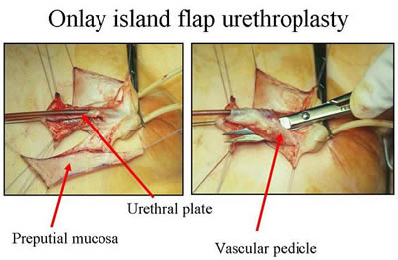
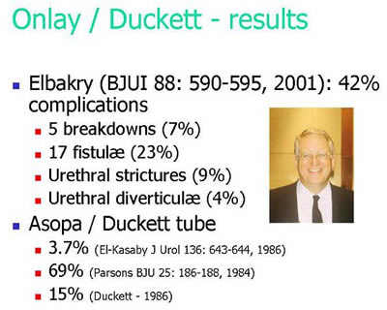
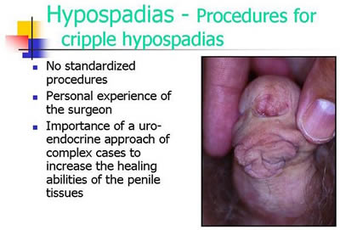
Official Diagnosis “Hypospadias Cripple”
= made a “cripple” by repeat cosmetic surgeries

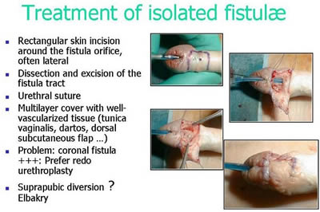
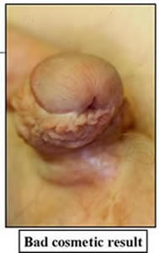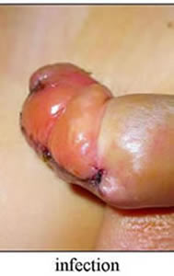
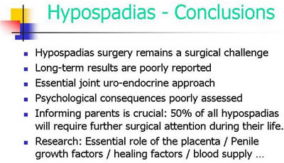
Source: Pierre Mouriquand: “Surgery of Hypospadias in 2006 - Techniques & outcomes”

2. “Clitoral Reduction”, “Vaginoplasty” a.k.a. “Feminising Surgeries”
Partial amputation of clitoris, often in combination with surgically opening or widening of the vagina. “46,XX Congenital Adrenal Hyperplasia (CAH)” is arguably the second most prevalent diagnosis for cosmetic genital surgeries, and the most common for this type (further diagnoses include “46,XY Partial Androgen Insufficiency Syndrome (PAIS)” and “46,XY Leydig Cell Hypoplasia”).
Despite numerous findings of loss of sexual sensation caused by these cosmetic surgeries and lacking evidence, current guidelines nonetheless advise surgeries „in the first 2 years of life”, most commonly “between 6 and 12 months,” and only 10.5% of surgeons recommend letting the persons concerned decide themselves later.
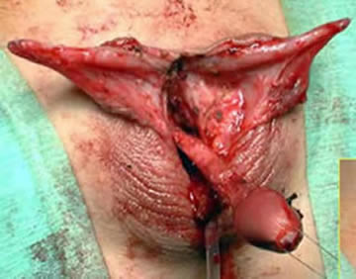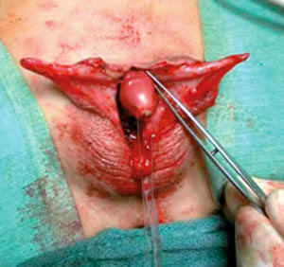
Source: Christian Radmayr: Molekulare Grundlagen und Diagnostik des Intersex, 2004

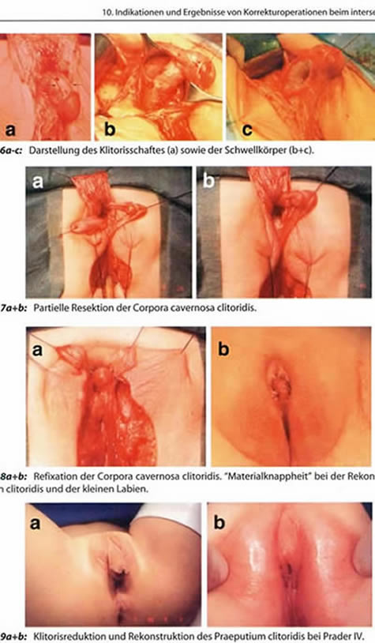
Source: Finke/Höhne: Intersexualität bei Kindern, 2008
Caption 8b: “Material shortage” [of skin] while reconstructing the praeputium clitoridis and the inner labia.

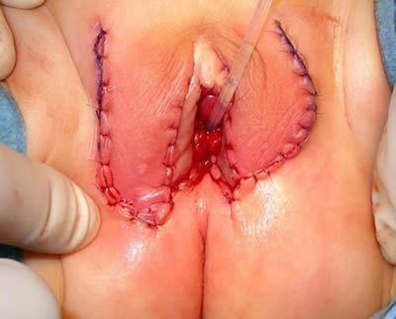
Source: Pierre Mouriquand: “Chirurgie des anomalies du développement sexuel - 2007”, at 81: “Labioplastie”
3. Castration / “Gonadectomy” / Hysterectomy / (Secondary) Sterilisation
Removal of healthy testicles, ovaries, or ovotestes, and other potentially fertile reproductive organs. “46,XY Complete Androgen Insufficiency Syndrome (CAIS)” is arguably the 3rd most common diagnosis for cosmetic genital surgeries, other diagnoses include “46,XY Partial Androgen Insufficiency Syndrome (PAIS)”, male-assigned persons with “46,XX Congenital Adrenal Hyperplasia (CAH)”, or other male assigned persons, who have their healthy ovaries and/or uteruses removed.
Castrations usually take place under the pretext of an allegedly blanket high risk of cancer, despite that an actual high risk which would justify immediate removal is only present in specific cases (see table below), and the true reason is “better manageability.” Although in many cases persons concerned have no or limited fertility, the gonads by themselves are usually healthy and important hormone-producing organs.
Nonetheless, clinicians still continue to recommend and perform early gonadectomies – despite all the known negative effects of castration, including depression, obesity, metabolic and circulatory troubles, osteoporosis, reduction of cognitive abilities, loss of libido. Plus a resulting lifelong dependency on artificial hormones (and adequate hormones are often not covered by health insurance, but have to be paid by the survivors out of their own purse).
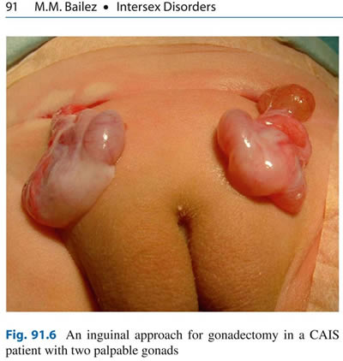
Source: Maria Marcela Bailez: “Intersex Disorders,” in: P. Puri and M. Höllwarth (eds.), Pediatric Surgery: Diagnosis and Management, Berlin Heidelberg 2009.
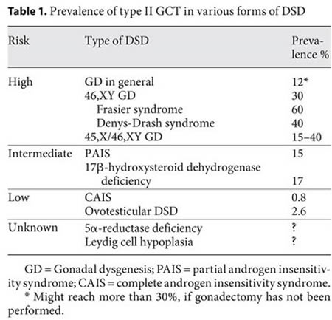
Source: J. Pleskacova, R. Hersmus, J. Wolter Oosterhuis, B.A. Setyawati, S.M. Faradz, Martine Cools, Katja P. Wolffenbuttel, J. Lebl, Stenvert L.S. Drop, Leendert H.J. Looijenga: “Tumor risk in disorders of sex development,” in: Sexual Development 2010 Sep;4(4-5):259-69.
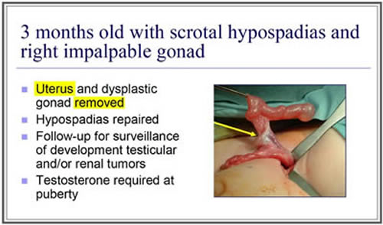
Source: J. L. Pippi Salle: “Decisions and Dilemmas in the Management of Disorders of Sexual [sic!] Development (DSD),” 2007, at 20.

4. "Bad results" / "Gonadectomy, Feminizing Genitoplasty"
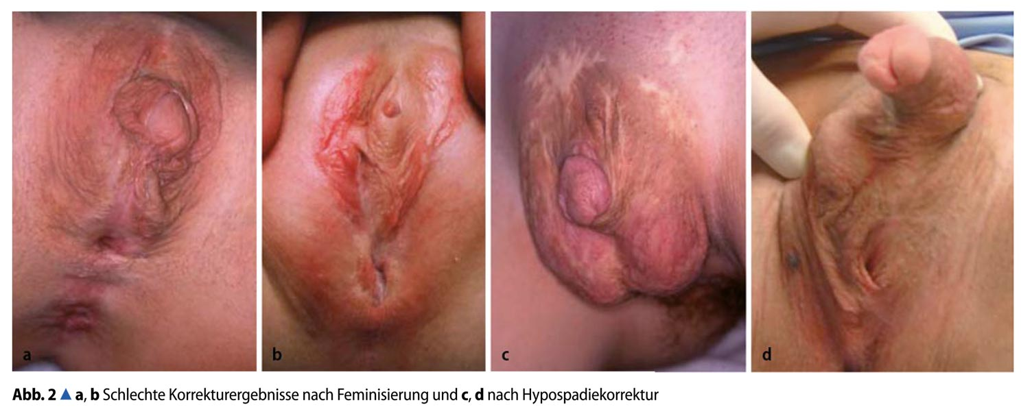Caption: 2a,b: “Bad Results of Correction after Feminisation, and”, c,d: “after Hypospadias Repair” – Source: M. Westenfelder: “Medizinische und juristische Aspekte zur Behandlung intersexueller Differenzierungsstörungen,” Der Urologe 5 / 2011 p. 593–599.
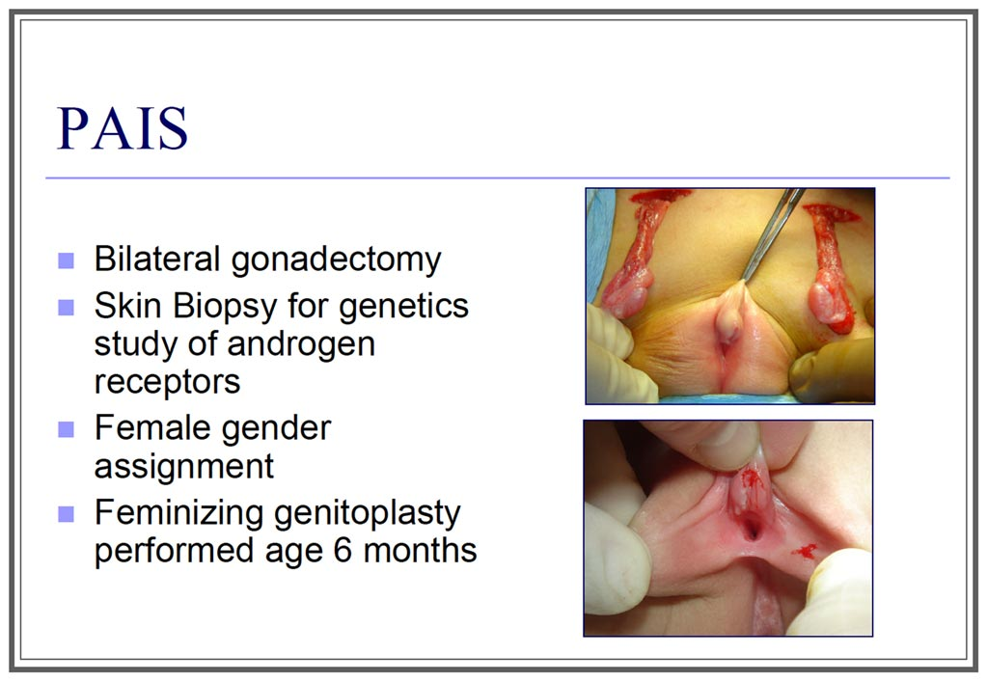
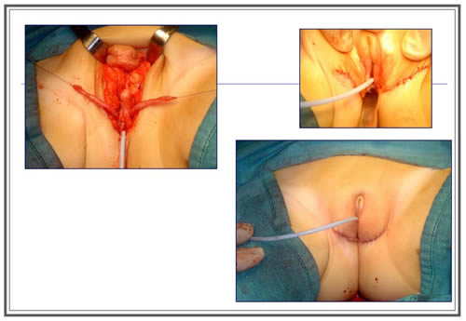
Source: J. L. Pippi Salle: “Decisions and Dilemmas in the Management of Disorders of Sexual [sic!] Development (DSD)”, 2007, at 20.

English homepage: http://StopIGM.org/ German: http://zwischengeschlecht.org/
http://zwischengeschlecht.org/post/Statuten
Zwischengeschlecht.org, Intersex.ch, SI Selbsthilfe Intersexualität: NGO Report to the 2nd, 3rd and 4th Periodic Report of Switzerland on the Convention on the Rights of the Child (CRC). Online: http://intersex.shadowreport.org/public/2014-CRC-Swiss-NGO-Zwischengeschlecht-Intersex-IGM_v2.pdf
Supplement 1: “IGM – Historical Overview”, p. 49–62 Supplement 2: “The 17 Most Common Forms of IGMs”, p. 48–76
The currently still official terminology “Disorders of Sex Development” is strongly refused by persons concerned.
Online: http://intersex.shadowreport.org/public/2014-CRC-Swiss-NGO-Zwischengeschlecht-Intersex-IGM_v2.pdf
Rainer Finke, Sven-Olaf Höhne (eds.) (2008), Intersexualität bei Kindern, Preface, at 4. See also: German Federal Government (2001), quoting the Fehlbildungsmonitoring Sachsen-Anhalt, Drucks. 14/5627, at 3-4. Online: http://dip21.bundestag.de/dip21/btd/14/056/1405627.pdf
German Federal Government (2007), quoting Thyen et al., Drucks. 16/4786, at 3. Online: http://dip21.bundestag.de/dip21/btd/14/056/1405627.pdf
Melanie Blackless, Anthony Charuvastra, Amanda Derryck, Anne Fausto-Sterling, Karl Lauzanne, Ellen Lee (2000), How sexually dimorphic are we? Review and synthesis, American Journal of Human Biology 12:151-166.
Intersex Society of North America (ISNA), How common is intersex?, http://www.isna.org/faq/frequency
UN SRT 2013, A/HRC/22/53, at para 77: “Children who are born with atypical sex characteristics are often subject to [...] involuntary sterilization, involuntary genital normalizing surgery, performed without their informed consent, or that of their parents”, http://www.ohchr.org/Documents/HRBodies/HRCouncil/RegularSession/Session22/A.HRC.22.53_English.pdf On why parents actually can’t legally consent to medically unnecessary cosmetic genital surgeries on their healthy children, see 2014 CRC NGO Report, p. 22
Council of Europe (2013), Resolution 1952 (2013), at 2 (7.5.3.): “unnecessary medical or surgical treatment that is cosmetic rather than vital for health”, http://www.assembly.coe.int/nw/xml/XRef/X2H-Xref-ViewPDF.asp?FileID=20174&lang=en
Jörg Woweries (2010), Intersexualität: Eine kinderrechtliche Perspektive, frühe Kindheit 0310: 18-22, at 20-21, http://kastrationsspital.ch/public/fK_0310_Woweries.pdf
“2. The surgery is irreversible. Tissue removed from the clitoris can never be restored; scarring produced by surgery can never be undone.” Intersex Society of North America (ISNA) (1998), ISNA’s Amicus Brief to the Constitutional Court of Colombia, http://www.isna.org/node/97
“It is generally felt that surgery that is performed for cosmetic reasons in the first year of life relieves parental distress and improves attachment between the child and the parents [48–51]; the systematic evidence for this belief is lacking.” Peter A. Lee, Christopher P. Houk, S. Faisal Ahmed, Ieuan A. Hughes, LWPES/ESPE Consensus Group (2006), Consensus statement on management of intersex disorders, Pediatrics 118:e488-e500, at e491, http://pediatrics.aappublications.org/content/118/2/e488.full.pdf
“The final ethical problem was the near total lack of evidence—indeed, a near total lack of interest in evidence—that the concealment system was producing the good results intended.” Alice Domurat Dreger (2006), Intersex and Human Rights: The Long View, in: Sharon Sytsma (ed.) (2006), Ethics and Intersex: 73-86, at 75
Jörg Woweries (2010), Intersexualität: Eine kinderrechtliche Perspektive, frühe Kindheit 0310: 18-22, at 21, http://kastrationsspital.ch/public/fK_0310_Woweries.pdf
Swiss National Advisory Commission on Biomedical Ethics NEK-CNE (2012), On the management of differences of sex development. Ethical issues relating to “intersexuality”, Opinion No. 20/2012, at 16 (footn. 18), http://www.nek-cne.ch/fileadmin/nek-cne-dateien/Themen/Stellungnahmen/en/NEK_Intersexualitaet_En.pdf
ibid., at 18 and 15.
“sociological and ideological reasons”, WHO Genomic Resource Centre, Genetic Components of Sex and Gender, http://www.who.int/genomics/gender/en/index1.html
“In cases of intersex clinicians were intentionally withholding and misrepresenting critical medical information.” Alice Domurat Dreger (2006), Intersex and Human Rights: The Long View, in: Sharon Sytsma (ed.) (2006), Ethics and Intersex: 73-86, at 75
UN SRT 2013, A/HRC/22/53, at para 77, http://www.ohchr.org/Documents/HRBodies/HRCouncil/RegularSession/Session22/A.HRC.22.53_English.pdf
Alice Domurat Dreger (2006), Intersex and Human Rights: The Long View, in: Sharon Sytsma (ed.) (2006), Ethics and Intersex: 73-86, at 75
Anne Tamar-Mattis (2013), Report to the Inter-American Commission on Human Rights: Medical Treatment of People with Intersex Conditions as a Human Rights Violation, at 2, http://www.aph.gov.au/DocumentStore.ashx?id=432c5135-4336-472e-bb24-59c89eb4a643
ibid., at 3
Jörg Woweries (2010), Intersexualität: Eine kinderrechtliche Perspektive, frühe Kindheit 0310: 18-22, at 20, http://kastrationsspital.ch/public/fK_0310_Woweries.pdf
Anne Tamar-Mattis (2013), Report to the Inter-American Commission on Human Rights: Medical Treatment of People with Intersex Conditions as a Human Rights Violation, at 2–7, http://www.aph.gov.au/DocumentStore.ashx?id=432c5135-4336-472e-bb24-59c89eb4a643
Heinz-Jürgen Voß (2012), Intersexualität – Intersex. Eine Intervention, at 50–65
Rare examples of publications documenting and reviewing reports by persons concerned include: • J. David Hester (2006), Intersex and the Rhetorics of Healing, in: Sharon Sytsma (ed.) (2006), Ethics and Intersex: 47–72 • Cheryl Chase (1998), Surgical Progress Is Not the Answer to Intersexuality, in: Alice Dreger (ed.) (1999), Intersex in the Age of Ethics:148–159 • Katrina Karkazis (2008), Fixing Sex: Intersex, Medical Authority, and Lived Experience • Kathrin Zehnder (2010), Zwitter beim Namen nennen. Intersexualität zwischen Pathologie, Selbstbestimmung und leiblicher Erfahrung • Claudia Lang (2006), Intersexualität. Menschen zwischen den Geschlechtern
Online: http://intersex.shadowreport.org/public/2014-CRC-Swiss-NGO-Zwischengeschlecht-Intersex-IGM_v2.pdf
see 2014 CRC NGO Report, p. 57–58
Deutsche Gesellschaft für Kinderchirurgie (2002), AWMF-Leitlinie 006/026 Hypospadie, http://kastrationsspital.ch/public/006-026-hypospadie-dgkch-2002.pdf
see 2014 CRC NGO Report, p. 65, 77. Online: http://intersex.shadowreport.org/public/2014-CRC-Swiss-NGO-Zwischengeschlecht-Intersex-IGM_v2.pdf
see 2014 CRC NGO Report, p. 66.
UN SRT (2013), A/HRC/22/53, at para 77, http://www.ohchr.org/Documents/HRBodies/HRCouncil/RegularSession/Session22/A.HRC.22.53_English.pdf
see 2014 CRC NGO Report, p. 68 http://intersex.shadowreport.org/public/2014-CRC-Swiss-NGO-Zwischengeschlecht-Intersex-IGM_v2.pdf
see 2014 CRC NGO Report, p. 52, 69
see 2014 CRC NGO Report, p. 70–73
see 2014 CRC NGO Report, p. 70
see 2014 CRC NGO Report, p. 70
see 2014 CRC NGO Report, p. 73
see 2014 CRC NGO Report, p. 74
see 2014 CRC NGO Report, p. 75
see 2014 CRC NGO Report, p. 75
see 2014 CRC NGO Report, p. 76
see 2014 CRC NGO Report, p. 76
“vom BMBF finanziell gefördert” http://www.netzwerk-dsd.de/
Eva Kleinemeier, Martina Jürgensen (2008), Erste Ergebnisse der Klinischen Evaluationsstudie im Netzwerk Störungen der Geschlechtsentwicklung/Intersexualität in Deutschland, Österreich und Schweiz, Januar 2005 bis Dezember 2007, at 16, http://www.netzwerk-dsd.uk-sh.de/fileadmin/documents/netzwerk/evalstudie/Bericht_Klinische_Evaluationsstudie.pdf
http://www.netzwerk-dsd.uk-sh.de/index.php?id=28
e.g. “The UK National Health Services Hospital Episode Statistics in fact shows an increase in the number of operations on the clitoris in under-14s since 2006”, Sarah M. Creighton, Lina Michala, Imran Mushtaq, Michal Yaron (2014), Childhood surgery for ambiguous genitalia: glimpses of practice changes or more of the same?, Psychology & Sexuality 5(1):34-43, at 38
e.g. Italy: “Boom in Surgeries on Children with ‘Indeterminate’ Sex, in Rome 50% Increase during the Last 5 Years, 25% Increase on National Level”, according to Aldo Morrone, Director General of the Ospedale San Camillo-Forlanini di Roma, quoted in: “Boom di bimbi con sesso ‘incerto’, a Roma un aumento del 50 per cento”, leggo.it 20.06.2013, http://www.leggo.it/NEWS/ITALIA/boom_di_bimbi_con_sesso_quot_incerto_quot_a_roma_aumentano_del_50_per_cento/notizie/294638.shtml
Tiger Howard Devore (1996), Endless Calls for “More Research” as Harmful Interventions Continue, Hermaphrodites With Attitude, Fall/Winter 1996:2, http://www.isna.org/files/hwa/winter1996.pdf (emphasis in original)
http://www.fp7peoplenetwork.eu/200811214/fp7/fp7-the-7th-framework-programme-of-the-european-union-for-research-and-development.html
e.g. “DSDnet”, http://www.cost.eu/domains_actions/bmbs/Actions/BM1303?management “Netzwerk DSD” http://www.netzwerk-dsd.uk-sh.de/index.php?id=28
http://www.cost.eu/about_cost/who/%28type%29/5/%28wid%29/30546/%28costid%29/44160
http://www.cost.eu/domains_actions/bmbs/Actions/BM1303?management
http://www.dsd-life.eu/the-group/consortium/, for a more accessible graphic overview of the consortium see: http://stop.genitalmutilation.org/post/IGM-Primer-2-The-Global-Cartel
E.g. “Children with DSD may be born with genitalia that range from being atypical to truly ambiguous and the sex assignment process may be extremely challenging for families and health care professionals. Often, multiple surgical interventions are performed for genital reconstruction to a male or female appearance. The gonads are often removed to avoid malignant development.” “DSDnet” (2013), Memorandum of Understanding, at 4, http://w3.cost.eu/fileadmin/ domain_files/BMBS/Action_BM1303/mou/BM1303-e.pdf
Personal communication by a journalist of ARD Mittagsmagazin, who thereafter had to cancel a scheduled report, 2015
2014 CRC NGO Report, p. 21–22. http://intersex.shadowreport.org/public/2014-CRC-Swiss-NGO-Zwischengeschlecht-Intersex-IGM_v2.pdf 2015 CRC Briefing, p. 8–11 http://intersex.shadowreport.org/public/Zwischengeschlecht_2015-CRC-Briefing_Intersex-IGM_web.pdf
CAT/C/DEU/CO/5, para 22 (b) http://www2.ohchr.org/english/bodies/cat/docs/co/CAT.C.DEU.CO.5_en.pdf
A/HRC/22/53, paras 77, 76, 88 http://www.ohchr.org/Documents/HRBodies/HRCouncil/RegularSession/Session22/A.HRC.22.53_English.pdf
Resolution 1952 (2013) “Children’s right to physical integrity”, paras 2, 6, 7 http://www.assembly.coe.int/nw/xml/XRef/X2H-Xref-ViewPDF.asp?FileID=20174&lang=en
CRC/C/CHE/CO/2-4, paras 42 (b), 43 (b)
This excuse constitutes also the historic root for imposing systematic unnecessary early surgeries, see 2014 CRC NGO report, p. 54–56
2014 CRC NGO Report, p. 52, 69, 84
In the WHO “World Atlas of Birth Defects (2nd Edition)”, many intersex diagnoses are listed, including “indeterminate sex” and “hypospadias” http://www.prenatal.tv/lecturas/world%20atlas%20of%20birth%20defects.pdf
“The Racist Roots of Intersex Genital Mutilations” http://stop.genitalmutilation.org/post/Racist-Roots-of-Intersex-Genital-Mutilations-IGM
“Nazi-‘Erbkrankheiten’: Intersex, Rassenmischung, Hypospadie, Scheinzwittertum, Epispadie, D$D (Baur, Fischer, Lenz)” http://blog.zwischengeschlecht.info/post/2014/10/08/Rassenmischung-Intersex-Hypospadie-Scheinzwittertum-Epispadie-DSD-Baur-Fischer-LenzErblehre-Rassenhygiene
see e.g. the most recent German intersex guidelines, AWMF 027/022 “Störungen der Geschlechtsentwicklung”, at 5
13/5916, at 2 http://dip21.bundestag.de/dip21/btd/13/059/1305916.pdf
14/5627, at 4 http://dip21.bundestag.de/dip21/btd/14/056/1405627.pdf
16/4786, at 3 http://dip21.bundestag.de/dip21/btd/16/047/1604786.pdf
16/13269, at 5 http://dipbt.bundestag.de/dip21/btd/16/132/1613269.pdf
19/1993, at 2, 3, 7 http://www.landtag.nrw.de/portal/WWW/dokumentenarchiv/Dokument/GGD19-1993.pdf
16/14436, at 2, 1 http://kastrationsspital.ch/public/Anfrage-Berlin-2010_ka16_14436.pdf
30.03.2012, at 2, 4 http://www.ris-muenchen.de/RII/RII/DOK/ANTRAG/2679843.pdf
17/3884 [leaked uncensored version of answer to original question no. 3, p. 1 – in the official answer, the relevant original question no. 3 was secretly omitted, see p. 2] http://blog.zwischengeschlecht.info/public/Bayern_2014_Anfrage_17-3884_Intersex_IGM_Zensur_web.pdf
20/6850 http://www.landtag.nrw.de/portal/WWW/dokumentenarchiv/Dokument/GGD20-6850.pdf
14/5627, at 2–3 http://dip21.bundestag.de/dip21/btd/13/059/1305916.pdf
14/5627, at 10–11, 11, 11–12, 13 http://dip21.bundestag.de/dip21/btd/14/056/1405627.pdf
16/4786, at 4–5, 3 http://dip21.bundestag.de/dip21/btd/16/047/1604786.pdf
16/13269, at 3, 5 http://dipbt.bundestag.de/dip21/btd/16/132/1613269.pdf
i.e. the very definition used by the UN Special Rapporteur on Torture in A/HRC/22/53, para 88, which was explicitly referenced in the parliamentary question
20/6850, at 4 http://www.landtag.nrw.de/portal/WWW/dokumentenarchiv/Dokument/GGD20-6850.pdf
CAT/C/DEU/CO/5, para 22 (b)
A/HRC/22/53, paras 77, 76, 88
Resolution 1952 (2013) “Children’s right to physical integrity”, paras 2, 6, 7
17/12851 http://dip21.bundestag.de/dip21/btd/17/128/1712851.pdf 17/12853 http://dip21.bundestag.de/dip21/btd/17/132/1713253.pdf 17/12859 http://dip21.bundestag.de/dip21/btd/17/128/1712859.pdf
at 52-54 http://www.gleichstellungsministerkonferenz.de/documents/2014_10_13_Beschluesse_GESAMT_Extern.pdf
Judgement of 01.08.2012, Az. S 4 VG 5/11 (unpublished); see also relevant quote in Nürnberger Nachrichten (04.11.2013) https://web.archive.org/web/20131114044728/http://www.nordbayern.de/nuernberger-nachrichten/region-bayern/schmerzliche-suche-nach-dem-eigenen-geschlecht-1.3257295
at 52-54 http://www.gleichstellungsministerkonferenz.de/documents/2014_10_13_Beschluesse_GESAMT_Extern.pdf
OLG Köln 03.09.2008, Az. 5 U 51/08 http://www.justiz.nrw.de/nrwe/olgs/koeln/j2008/5_U_51_08beschluss20080903.html
LG Köln 12.08.2009, Az. 25 O 179/07 http://www.justiz.nrw.de/nrwe/lgs/koeln/lg_koeln/j2009/25_O_179_07schlussurteil20090812.html
LG Nürnberg-Fürth, Az. 4 O 7000/11. 1st day in court was 26.02.2015.
LG München, Az. 9 O 27981/12. 1st day in court is not yet foreseeable.
Wortprotokoll, at 11 http://kastrationsspital.ch/public/19_10_HH_Wortpr_Intersex.pdf
Although this person is personally known to the rapporteurs, here the case details are taken from: Franziska Brachthäuser, Theresa Richarz (2014): Zwischen Norm und Geschlecht – Erste Entwürfe möglicher nationaler Entschädigungs- und Schadensersatzansprüche intersexueller Menschen gegen die Bundesrepublik Deutschland, Humboldt Law Clinic Menschenrechte (HLCMR) Working Paper Nr. 5, at 9, 11 (i.e. 6, 8 according to page numbers within document) http://hlcmr.de/wp-content/uploads/2015/01/Working_Paper_Nr.5.pdf (All other cases are based on personal interviews.)
SG Trier, 07.02.2012 Az. S 6 VG 10/ 11 Tr. (unpublished)
SG Bayreuth, 01.08.2012, Az. S 4 VG 5/11 (unpublished); see also relevant quote in Nürnberger Nachrichten (04.11.2013) https://web.archive.org/web/20131114044728/http://www.nordbayern.de/nuernberger-nachrichten/region-bayern/schmerzliche-suche-nach-dem-eigenen-geschlecht-1.3257295
SG Nürnberg, 16.07.2014, Az. S 15 VG 9/12 (unpublished)
State Ministry for Work, Social Affairs, Family and Intergration (BASFI) Hamburg, 14.10.2014, Az. FS 5222- AI-Nr. 17770/10#1 (unpublished)
Franziska Brachthäuser, Theresa Richarz (2014): Zwischen Norm und Geschlecht – Erste Entwürfe möglicher nationaler Entschädigungs- und Schadensersatzansprüche intersexueller Menschen gegen die Bundesrepublik Deutschland, Humboldt Law Clinic Menschenrechte (HLCMR) Working Paper Nr. 5, at 22–24 (i.e. 19–21 according to pagination within document) http://hlcmr.de/wp-content/uploads/2015/01/Working_Paper_Nr.5.pdf
This excuse constitutes also the historic root for imposing systematic unnecessary early surgeries, see 2014 CRC NGO report, p. 54–56
Deutsches Ärzteblatt, Jg. 111, Heft 51–52, 22.12.2014, at A 2287
ibid.
“Stellungnahme Sektion Nebenniere zu Lieferengpass Astonin H” https://www.ags-initiative.de/jdownloads/Aktuelles/stellungnahme_sektion_nebenniere_zu_lieferengpass_astonin_h_12-2014.pdf

