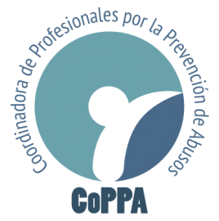

Committee on the Rights of the Child
United Nations
Geneva, Switzerland

January 19th, 2018

RE: Genital mutilations in Spain of Children with Variations in Sex Characteristics

Distinguished members of the Committee on the Rights of the Child:

The Coordinadora of Profesionales por la Prevención de Abusos (CoPPA), an international network of professionals and experts in psychology, psychiatry, sociology, criminology, pedagogy and human rights who are devoted to protecting vulnerable groups in Spain and Latin America, would like to assert that:

Our delegation in Spain has noted the unfortunate prevalence of the harmful practice of non-consensual genital mutilation, as well as other detrimental procedures that are imposed on Intersex children and adolescents in various clinics in Spain. As an NGO dedicated to the prevention of violence and the defense of vulnerable groups, particularly children, we are extremely worried about the consequences of subjecting healthy children to these unnecessary, painful and non-consensual surgeries. These procedures produce lifelong sequelae and damage that impair health and sexual function, and can have detrimental impacts on the child’s social development, physical and mental health.

Therefore, in view of the upcoming 77th Session of the Committee that will examine this State Party’s compliance with the Convention on the Rights of the Child, we would like to highlight the need for Spain to adopt stringent measures to prevent intersex genital mutilation and other unnecessary medical treatments aimed at intersex children; as well as the urgency of promoting educational programs at the state level to instruct medical professionals on the importance of respecting the physical integrity and self-determination of children with variations in sex characteristics.

In closing, we reiterate our endorsement of the suggestions made by the NGOs Brújula Intersexual and StopIGM.org that aim to address this problem in Spain, and trust that you will take them into consideration in the Committee’s Final Observations.

With sincere appreciation for your important work, we remain at your disposal for any clarification you may require.

On behalf of Coordinadora de Profesionales por la Prevención de Abusos (CoPPA),

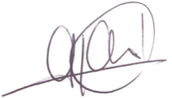
Dr. Gabriela Cruz Ares
Legal and Forensic Psychiatrist
gabrielacruz@coppaprevencion.com

Coordinadora de Profesionales por la Prevención de Abusos
Route de Tréchillonnel 12,
1822 Chernex, Suiza
www.coppaprevencion.com

