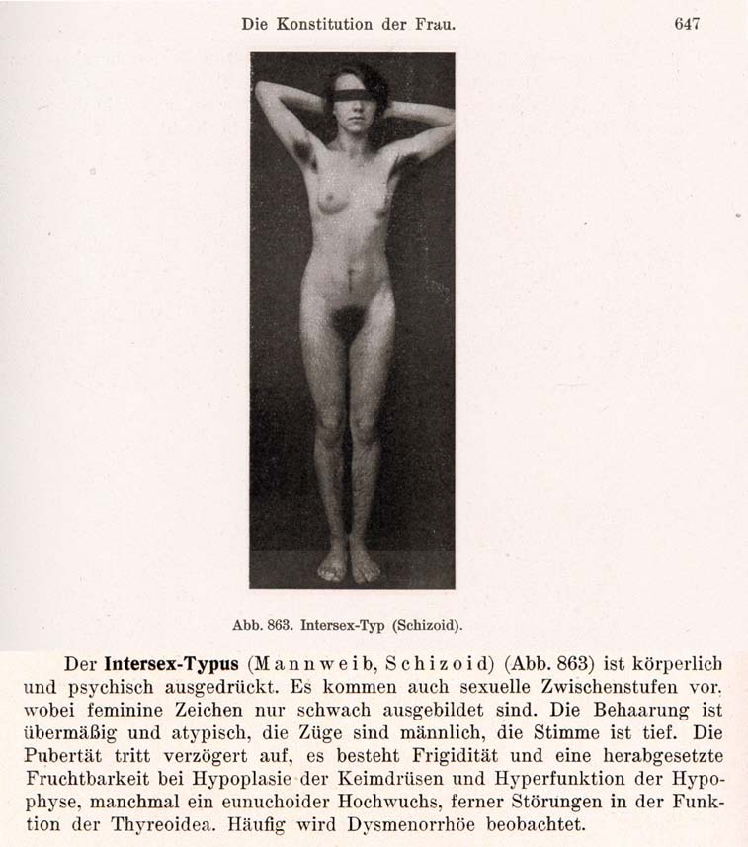
Austria has been the country of origin of the harmful medical diagnosis “intersexual constitution”.
Rooted in gender stereotypes and racist notions alike, it introduced the term intersex to medicine and was first published by the Austrian gynaecologist Paul Mathes.
It soon became internationally popular with prominent eugenicists and nazi doctors, including Fritz Lenz, Hans Naujoks, Lothar Gottlieb Tirala, Robert Stigler, Wilhelm Weibel, Walther Stoeckel, Hans Guggisberg, and kept being used in medical textbooks until the 1950s.
Mathes described the cause for intersex in “miscegenation”, and already in the 1920s advocated “surgical correction”, namely clitoris amputation, “[i]n cases where the intersexual woman was too far removed from the male ideal” (Satzinger).
Women diagnosed with “intersexual constitution” were described as “biologically inferior”, prone to mental illnesses (see above “schizoid”), “hypertrophied clitoris”, “most frequent in Jews”, “not fit for marriage”.
To this day, in Austria there has been no coming to terms with neither the historic nor the ongoing harmful misrepresentation of healthy intersex children as “inferior”, “deformed”, disordered”, or “degenerated”, nor with the ongoing mutilations.
Sources:
• Wilhelm Weibel (1944): Lehrbuch der Frauenheilkunde, 7th ed., Berlin/Wien 1944, p. 647 (photo), 648 (text).
• Paul Mathes, Hans Guggisberg (1924): “Die Konstitutionstypen des Weibes, insbesondere der intersexuelle Typus”, in: Josef Halban, Ludwig Seitz: Biologie und Pathologie des Weibes. Bd.3, 1924.
• Helga Satzinger (2009): “Racial Purity, Stable Genes, and Sex Difference. Gender in the Making of Genetic Concepts by Richard Goldschmidt and Fritz Lenz, 1916-1936”, in: Susanne Heim, Carola Sachse, Mark Walker: The Kaiser Wilhelm Society for the Advancement of Science under National Socialism, Cambridge University Press, p. 145-172, at 161-162

