Intersex Genital Mutilations
Human Rights Violations Of Children
With Variations Of Sex Anatomy

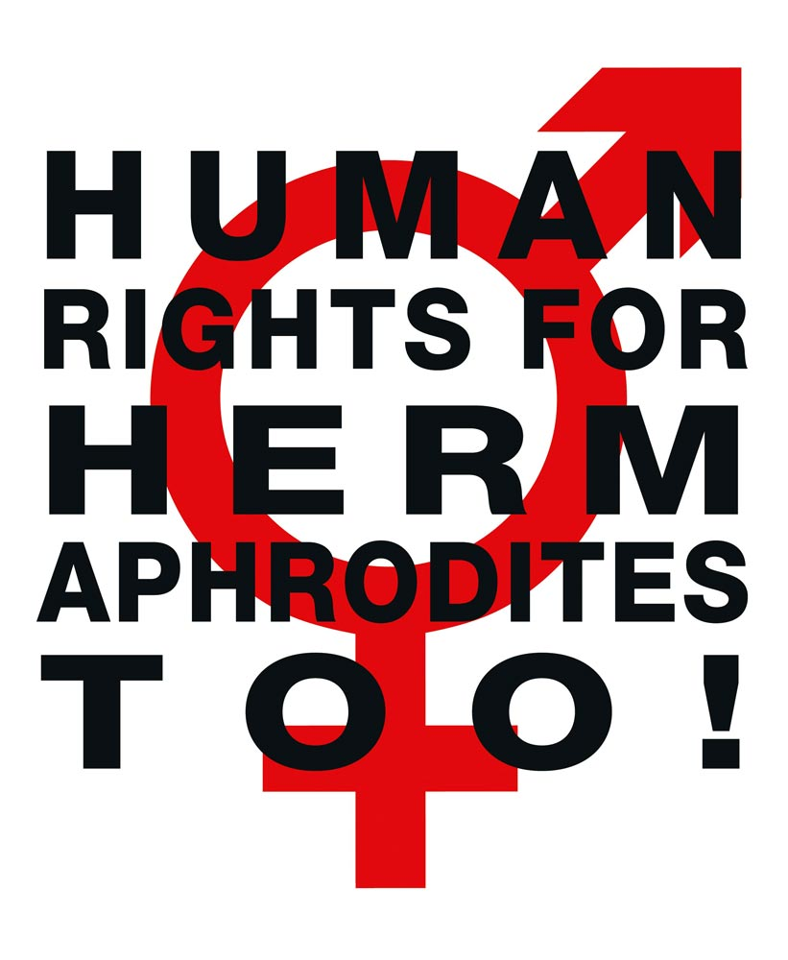

NGO Report (for LOIPR)
to the 2nd and 3rd Periodic Report of Germany on the
Convention on the Rights of Persons with Disabilities
(CRPD)
Compiled by:

StopIGM.org / Zwischengeschlecht.org (International Intersex Human Rights NGO)
Markus Bauer, Daniela Truffer
Zwischengeschlecht.org
P.O.Box 2122
CH-8031 Zurich
info_at_zwischengeschlecht.org
http://Zwischengeschlecht.org/
http://StopIGM.org/

July 2018

This NGO Report online:
http://intersex.shadowreport.org/public/2018-CRPD-LOIPR-Germany-NGO-Zwischengeschlecht-Intersex-IGM.pdf

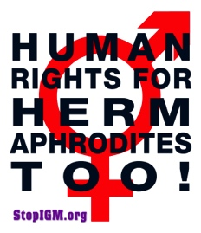
NGO Report (for LOIPR) to the 2nd and 3rd Periodic Report of Germany
on the Convention on the Rights of Persons with Disabilities (CRPD)

Table of Contents

IGM Practices in Germany (p. 14–21)

Table of Contents 3
Executive Summary 5
Suggested Questions for the List of Issues 6
2015 Concluding Observations on Intersex (CRPD/C/DEU/CO/1, paras 37-38) 7
2011 CAT Concluding Observations on Intersex (CAT/C/DEU/CO/5, para 20),
referred to by this Committee in CRPD/C/DEU/CO/1, para 38(d) 8
Introduction 9
1. Intersex, IGM and Human Rights in Germany 9
2. About the Rapporteurs 9
3. Methodology 9
A. Background: Intersex, IGM, Prejudice and the CRPD 10
1. “Inferior”, “Abnormal”, “Deformed”: Harmful Stereotypes and Prejudice 10
2. Intersex = Variations of Sex Anatomy 10
3. IGM Practices: Involuntary, unnecessary medical interventions based on prejudice 11
4. Stereotypes and Prejudice (2): Intersex is NOT THE SAME as LGBT 12
5. Stereotypes and Prejudice (3): Misrepresenting Genital Mutilation as “Health Care” 13
B. IGM in Germany: State-sponsored and pervasive, Gov fails to act 14
1. Overview: IGM practices in Germany: Pervasive and unchecked (art. 17) 14
2. IGM practices are a human rights violation,
NOT “medical treatment” or “carrying out sex reassignment surgery hastily” 15
C. Germany ignores Concluding Observations on Intersex 16
1. Recommendation (a) – Legislative and other measures to prevent IGM 16
2. Recommendation (b) – Data Collection, Redress and Compensation 17
a) Criminal Law 18
b) Civil Law 18
c) Victim’s Compensation Law (Opferentschädigungsgesetz, OEG) 19
d) Compensation Fund 19
3. Recommendations (c) + (d) – Lack of Adequate Support, Lack of Education 20
D. Conclusion: 20 Years of Endless Talk, But No Action 21
Annexe 1: Most Recent Statistics Available on IGM in Germany 22
a) IGM 3 – Sterilising Procedures: Castration / “Gonadectomy” / Hysterectomy /
Removal of “Discordant Reproductive Structures” / (Secondary) Sterilisation 22
b) IGM 2 – “Feminising Procedures”: Clitoris Amputation/“Reduction”,
“Vaginoplasty”, “Labioplasty”, Dilation 23
c) IGM 1 – “Masculinising Surgery”: Hypospadias “Repair” 25
d) Prenatal “Therapy” 25
e) IGM 4 – Other Unnecessary and Harmful Interventions and Treatments 26
Executive Summary
All typical forms of Intersex Genital Mutilation are still practised in Germany about 1,700 times annually, facilitated and paid for by the State party via the public health system. Parents and children are misinformed, kept in the dark, sworn to secrecy, kept isolated and denied appropriate support.
Germany is in breach of its obligations to (a) take effective legislative, administrative, judicial or other measures to prevent involuntary, non-urgent genital surgery and other harmful medical treatment of intersex children, (b) to ensure access to justice, redress, compensation and rehabilitation for victims, and c) to provide families with intersex children with adequate psychosocial and peer support (art. 17).
This Committee, as well as CAT and CEDAW have already considered IGM in Germany as constituting at least violation of the integrity of the person (CRPD/C/DEU/CO/1, paras 37-38), ill-treatment (CAT/C/DEU/CO/5; para 20) and a harmful practice (CEDAW/C/DEU/CO/7-8, paras 23-24). Nonetheless, to this day the German Government fails to act.
In total, UN treaty bodies CRPD, CRC, CAT, CEDAW and CCPR have so far issued 36 Concluding Observations on IGM, typically obliging State parties to enact legislation to (a) end the practice and (b) ensure redress and compensation, plus (c) access to free counselling. Also the UN Special Rapporteurs on Torture (SRT) and on Health (SRH), the UN High Commissioner for Human Rights (UNHCHR), the World Health Organisation (WHO), the Inter-American Commission on Human Rights (IACHR), the African Commission on Human and Peoples’ Rights (ACHPR) and the Council of Europe (COE) recognise IGM as a serious violation of non-derogable human rights.
Intersex people are born with Variations of Sex Anatomy, including atypical genitals, atypical sex hormone producing organs, atypical response to sex hormones, atypical genetic make-up, atypical secondary sex markers. While intersex people may face several problems, in the “developed world” the most pressing are the ongoing Intersex Genital Mutilations, which present a distinct and unique issue constituting significant human rights violations.
IGM practices include non-consensual, medically unnecessary, irreversible, cosmetic genital surgeries, and/or other harmful medical procedures that would not be considered for “normal” children, without evidence of benefit for the children concerned. Typical forms of IGM include “masculinising” and “feminising”, “corrective” genital surgery, sterilising procedures, imposition of hormones, forced genital exams, vaginal dilations, medical display, involuntary human experimentation and denial of needed health care.
IGM practices cause known lifelong severe physical and mental pain and suffering, including loss or impairment of sexual sensation, painful scarring, painful intercourse, incontinence, urethral strictures, impairment or loss of reproductive capabilities, lifelong dependency of artificial hormones, significantly elevated rates of self-harming behaviour and suicidal tendencies, lifelong mental suffering and trauma, increased sexual anxieties, and less sexual activity.
For 25 years, intersex people have denounced IGM as harmful and traumatising, as western genital mutilation, as child sexual abuse and torture, and called for remedies.
This NGO Report has been compiled by StopIGM.org, an international intersex NGO with a German constituency. It contains Suggested Questions for the LOIPR (see next page).
Suggested Questions for the List of Issues

The Rapporteurs respectfully suggest that in the LOIPR the Committee asks the German Government the following questions with respect to the civil rights of intersex people:

Intersex genital mutilation (art. 17)
- Since 2014, how many non-urgent, irreversible surgical and other procedures have been undertaken on intersex minors? Please provide detailed statistics on sterilising, feminising, and masculinising procedures, disaggregated by age groups and region (Länder).
- Does the State party plan to stop this practice? If yes, what measures does it plan to implement, and by when?
- Please indicate which criminal or civil remedies are available for intersex people who have undergone involuntary sterilisation or unnecessary and irreversible medical or surgical treatment when they were children, and whether these remedies are subject to any statute of limitations?
- Please indicate which means of rehabilitation are available for intersex people who have undergone involuntary procedures?
- Please indicate which means of psychosocial support, including peer support, are available for intersex children and their families?

2015 Concluding Observations on Intersex (CRPD/C/DEU/CO/1, paras 37-38)

Protecting the integrity of the person (art. 17)
37. The Committee is concerned about: […] (d) the lack of implementation of the 2011 recommendations of the Committee against Torture (see CAT/C/DEU/CO/5, para. 20) regarding upholding the bodily integrity of intersex children.
38. The Committee recommends that the State party take the measures, including of a legislative nature, necessary to:
[…]
(d) Implement all the recommendations of the Committee against Torture (ibid.) relevant to intersex children.

2011 CAT Concluding Observations on Intersex (CAT/C/DEU/CO/5, para 20),
referred to by this Committee in CRPD/C/DEU/CO/1, para 38(d)

Intersex people
20. The Committee takes note of the information received during the dialogue that the Ethical Council has undertaken to review the reported practices of routine surgical alterations in children born with sexual organs that are not readily categorized as male or female, also called intersex persons, with a view to evaluating and possibly changing current practice. However, the Committee remains concerned at cases where gonads have been removed and cosmetic surgeries on reproductive organs have been performed that entail lifelong hormonal medication, without effective, informed consent of the concerned individuals or their legal guardians, where neither investigation, nor measures of redress have been introduced. The Committee remains further concerned at the lack of legal provisions providing redress and compensation in such cases (arts. 2, 10, 12, 14 and 16).
The Committee recommends that the State party:
(a) Ensure the effective application of legal and medical standards following the best practices of granting informed consent to medical and surgical treatment of intersex people, including full information, orally and in writing, on the suggested treatment, its justification and alternatives;
(b) Undertake investigation of incidents of surgical and other medical treatment of intersex people without effective consent and adopt legal provisions in order to provide redress to the victims of such treatment, including adequate compensation;
(c) Educate and train medical and psychological professionals on the range of sexual, and related biological and physical, diversity; and
(d) Properly inform patients and their parents of the consequences of unnecessary surgical and other medical interventions for intersex people.
Introduction
1. Intersex, IGM and Human Rights in Germany
Germany has recently been reviewed by CAT (2011), CRPD (2015) and CEDAW (2017), all recognising IGM in Germany as constituting ill-treatment or torture, a violation of integrity and a harmful practice respectively, same as multiple UN treaty bodies including CRPD regularly denouncing IGM as a serious violation of non-derogable human rights. Nonetheless, Germany continues to deny having any “information on cases of medical or surgical treatment where the intersex person has not effectively given their consent”, and refuses to undertake effective measures, including legislation, to protect intersex children from the daily mutilations. This NGO Report demonstrates that the current harmful medical practice on intersex persons in Germany – advocated, facilitated and paid for by the State party – constitutes a serious breach of Germany’s obligations under the Convention, and the 2015 Concluding observations.
2. About the Rapporteurs
This NGO report has been prepared by the international intersex NGO StopIGM.org / Zwischengeschlecht.org:
- StopIGM.org / Zwischengeschlecht.org is an international intersex human rights NGO with a German constituency based in Switzerland, working to end IGM practices and other human rights violations perpetrated on intersex people, according to its motto, “Human Rights for Hermaphrodites, too!” According to its charter, StopIGM.org works to support persons concerned seeking redress and justice and regularly reports to UN treaty bodies, often in collaboration with local intersex advocates and NGOs.
StopIGM.org has been active in Germany since 2007, supporting intersex persons suing IGM perpetrators, publicly confronting individual perpetrators and hospitals, documenting the ongoing practice, has collaborated with members of parliament on parliamentary questions on the federal and on the Länder level, and testified before the German National Ethics Council, calling for effective remedies to end the practice, and has previously reported on IGM in Germany to CRPD, CCPR and CEDAW.
In personal capacity co-founder Daniela Truffer is also a member of the German intersex self-help group XY-Women, serving as a first contacter for 7 years, and of the German Association of Intersex People, serving as chair when it first submitted a thematic report to a UN Treaty body, leading to the first ever recommendations on intersex in 2009.
3. Methodology
This thematic NGO report is an update to the 2015 CRPD Germany NGO Report, the
2017 CEDAW Germany NGO Report and the 2018 CCPR Germany NGO Report by the same rapporteurs.
A. Background: Intersex, IGM, Prejudice and the CRPD
1. “Inferior”, “Abnormal”, “Deformed”: Harmful Stereotypes and Prejudice
Individual doctors, national and international medical bodies, public and private healthcare providers and governing State bodies have traditionally been framing and “treating” intersex variations as a form of disability in the medical definition in need to be “cured” surgically, often with racist, eugenic and suprematist undertones.
To this day, such harmful stereotypes and prejudices framing intersex as “inferior”, “deformed”, “disordered”, “degenerated” or a “bad omen” remain widespread and still inform the current harmful western medical practice, as well as other practices including infanticide and child abandonment (see below 3.).
Accordingly, the easier an intersex trait can be tested prenatally, the higher the selective (late term) abortion rates. Most intersex diagnoses are also listed as permissible for de-selection in State sponsored pre-implantation genetic diagnosis (PGD) guidelines, and e.g. in Switzerland IGM practices are paid for by the Federal Disability Insurance. And in Pakistan intersex is considered a “congenital genitalia birth defect” to be “cured” by surgery “to make them normal persons again.”
2. Intersex = Variations of Sex Anatomy
Intersex persons, in the vernacular also known as hermaphrodites, or medically as persons with “Disorders” or “Differences of Sex Development (DSD)”, are people born with Variations of Sex Anatomy, or “atypical” sex anatomies and reproductive organs, including atypical genitals, atypical sex hormone producing organs, atypical response to sex hormones, atypical genetic make-up, atypical secondary sex markers. Many intersex forms are usually detected at birth or earlier during prenatal testing, others may only become apparent at puberty or later in life.

While intersex people may face several problems, in the “developed world” the most pressing are the ongoing Intersex Genital Mutilations, which present a distinct and unique issue constituting significant human rights violations, with 1 to 2 in 1000 newborns at risk of being submitted to non-consensual “genital correction surgery”.
For more information and references, see 2015 CRPD Germany NGO Report (A 1–2, p. 6-7.)
3. IGM Practices:
Involuntary, unnecessary medical interventions based on prejudice
In “developed countries” with universal access to paediatric health care 1 to 2 in 1000 newborns are at risk of being submitted to IGM practices, i.e. non-consensual, medically unnecessary, irreversible, cosmetic genital surgeries, and/or other harmful medical treatments that would not be considered for “normal” children, practiced without evidence of benefit for the children concerned, but justified by societal and cultural prejudice, stereotypes, norms and beliefs, and often directly financed by the state via the public health system.
Typical forms of IGM include “feminising” or “masculinising”, “corrective” genital surgery, sterilising procedures, imposition of hormones (including prenatal “therapy”), forced genital exams, vaginal dilations, medical display, human experimentation, selective (late term) abortions and denial of needed health care.
IGM practices are known to cause lifelong severe physical and mental pain and suffering, including loss or impairment of sexual sensation, poorer sexual function, painful scarring, painful intercourse, incontinence, problems with passing urine (e.g. due to urethral stenosis after surgery), increased sexual anxieties, problems with desire, less sexual activity, dissatisfaction with functional and aesthetic results, lifelong trauma and mental suffering, elevated rates of self-harming behaviour and suicidal tendencies comparable to those among women who have experienced physical or (child) sexual abuse, impairment or loss of reproductive capabilities, lifelong dependency on daily doses of artificial hormones.
From countries without universal access to paediatric health care, there are reports of infanticide of intersex children, of abandonment, of expulsion, of massive bullying preventing the persons concerned from attending school (recognised by CRC as amounting to a harmful practice), and of murder.
4. Stereotypes and Prejudice (2): Intersex is NOT THE SAME as LGBT
Unfortunately, there are also other, often interrelated harmful misconceptions about intersex still prevailing in public, notably if intersex is counterfactually described as being the same as or a subset of LGBT or SOGI, e.g. if intersex and/or intersex status are represented as a sexual orientation (like gay or lesbian), and/or as a gender identity, as a subset of transgender, as the same as transsexuality.
The underlying reasons for such harmful misconceptions include lack of awareness, third party groups instrumentalising intersex as a means to an end for their own agenda, and State parties trying to deflect from criticism of involuntary intersex treatments.
Intersex persons and their organisations have spoken out clearly against instrumentalising or misrepresenting intersex issues, maintaining that IGM practices present a distinct and unique issue constituting significant human rights violations, which are different from those faced by the LGBT or SOGI community, and thus need to be adequately addressed in a separate section as specific intersex issues.
Also human rights experts are increasingly warning of the harmful conflation of intersex and LGBT.
Regrettably, these harmful misrepresentations seem to be on the rise also at the UN,
for example in recent UN press releases and Summary records misrepresenting IGM as “sex alignment surgeries” (i.e. voluntary procedures on transsexual or transgender persons), IGM survivors as “transsexual children”, and intersex NGOs as “a group of lesbians, gays, bisexuals, transgender and intersex victims of discrimination”, and again IGM survivors as “transgender children”, “transsexual children who underwent difficult treatments and surgeries”, and IGM as a form of “discrimination against transgender and intersex children” and as
“sex assignment surgery” while referring to “access to gender reassignment-related treatments”.
Particularly State parties are constantly misrepresenting intersex and IGM as sexual orientation or gender identity issues in an attempt to deflect from criticism of the serious human rights violations resulting from IGM practices, instead referring to e.g. “gender reassignment surgery” (i.e. voluntary procedures on transsexual or transgender persons) and “gender assignment surgery for children”, “a special provision on sexual orientation and gender identity”, “civil registry” and “sexual reassignment surgery” , transgender guidelines or “Gender Identity” when asked about IGM by e.g. Treaty bodies.
What’s more, LGBT organisations (including “LGBTI” organisations without actual intersex representation or advocacy) are using the ubiquitous misrepresentation of intersex = LGBT to misappropriate intersex funding, thus depriving actual intersex organisations (which mostly have no significant funding, if any) of much needed resources and public representation.
5. Stereotypes and Prejudice (3): Misrepresenting Genital Mutilation as “Health Care”
An interrelated, alarming new trend is the increasing misrepresentation of IGM as “health-care issue” instead of a serious human rights violation, and the promotion of “self-regulation” of IGM by the current perpetrators – instead of effective measures to finally end the practice (as repeatedly stipulated also by this Committee).
Even worse, Health ministries construe UN Treaty body Concluding observations falling short of explicitly recommending legislation to criminalise or adequately sanction IGM as an excuse for “self-regulation” promoting state-sponsored IGM practices to continue with impunity.
B. IGM in Germany: State-sponsored and pervasive, Gov fails to act
1. Overview: IGM practices in Germany: Pervasive and unchecked (art. 17)
In Germany (see CRPD/C/DEU/CO/1, paras 37-38; CAT/C/DEU/CO/5; para 20; CEDAW/C/DEU/CO/7-8, paras 23-24), same as in the neighbouring states of Switzerland (see CCPR/C/CHE/CO/4, paras 24-25; CRC/C/CHE/CO/2-4, paras 42-43; CAT/C/CHE/CO/7, para 20; CEDAW/C/CHE/CO/4-5, paras 38-39), France (see CRC/C/FRA/CO/5, paras 47-48; CAT/C/FRA/CO/7, paras 32–33; CEDAW/C/FRA/CO/7-8, paras 17e-f + 18e-f), Austria (see CAT/C/AUT/CO/6, paras 44-45), and in many more State parties, there are
- no effective legal or other protections in place to ensure the rights of intersex children to physical and mental integrity, autonomy and self-determination, and to prevent IGM
- no measures in place to ensure systematic data collection and monitoring of IGM
- no legal or other measures in place to ensure the accountability of IGM perpetrators
- no legal or other measures in place to ensure access to redress and justice for adult IGM survivors (see also below p. 15-17)
To this day, the German government undeviatingly refuses to “take effective legislative, administrative, judicial or other measures” to protect intersex children, but instead since 1996 continues with a perpetual cycle of denial and endless discussions, roundtables, empty promises, and yet more “careful examination” without any consequences ever.
What’s worse, this continues after the State party has already been reprimanded by CAT in 2011, by CRPD in 2015 and by CEDAW in 2017 for IGM practices, with all Committees calling for legislative measures including to ensure access to redress, and to provide adequate support.
So far, as vaguely admitted by the “Inter-Ministerial Working Group (IMAG)” (“the total number of procedures seems not to have changed significantly”), in Germany all forms of IGM practices remain widespread and ongoing, persistently advocated, prescribed and perpetrated by state funded University and Regional Children’s Clinics, and paid for by the German Public Health Insurances, as corroborated by two 2016 studies using partial data from the “Diagnosis Related Groups (DRG)” of intersex surgeries in German hospitals financed by the Public Health System, reporting on average 1,700 IGM procedures every year:
Study 1: Ulrike Klöppel: Zur Aktualität kosmetischer Operationen „uneindeutiger“ Genitalien im Kindesalter. ZtG Texte 42: https://www.gender.hu-berlin.de/de/publikationen/gender-bulletins/bulletin-texte/texte-42/kloeppel-2016_zur-aktualitaet-kosmetischer-genitaloperationen
Study 2: Anike Krämer (M.A.), Prof. Dr. Katja Sabisch, Dr. med. Jörg Woweries: Varianten der Geschlechtsentwicklung – die Vielfalt der Natur. Kinder- und Jugendarzt. 47. Jg. (2016) Nr. 5/16:
http://www.vlsp.de/files/pdf/kraemer2016.pdf
(For an overview of the 2 studies, and available data on the 1,700 IGM procedures annually, see Annexe 1, p. 21.)
Both studies, which were commissioned by the Federal Government, provide NO disaggregated regional data on procedures in individual Länder or clinics, citing “privacy concerns”.
Similarly in 2014, the State Government of Bavaria censored the actual data in the public hansard of an answer to a relevant parliamentary question on IGM statistics, claiming “data on above mentioned surgical interventions are business and trade secrets of the [mostly state controlled] clinics,” and therefore “secret” and “not allowed to be published according to art. 30 VwVfG,” further referring to “data protection.”
After 2014, no more data at all was published by the Federal Government so far – despite that since at least 1996 the German government has been regularly called upon to collect and disclose statistics on IGM practices. And CAT, CRPD and CEDAW have urged Germany to “investigate cases” and “[s]ystematically collect disaggregated data”.
At the same time, access to adequate psychosocial counselling and peer support remains sorely lacking.
2. IGM practices are a human rights violation,
NOT “medical treatment” or “carrying out sex reassignment surgery hastily”
Germany is a particularly cautionary example of a State party trying to deflect from the serious violations of non-derogable human rights constituted by involuntary, non-urgent genital surgery and other treatment on intersex children including partial clitoris amputations, sterilising procedures, imposition of hormones, “blind” prenatal “therapy” and selective abortion, by constantly misrepresenting intersex and IGM as sexual orientation, gender identity or “health” issues in an attempt to deflect from criticism, for example by persistently trivialising IGM as “medical treatment” and/or “carrying out sex reassignment surgery hastily” (i.e. putting involuntary surgery on intersex children on a level with voluntary surgery for trans people).
See also above “Harmful Stereotypes and Prejudice”, particularly “Intersex is NOT THE SAME as LGBT” (p. 11-12) and “Misrepresenting Genital Mutilation as ‘Health Care’” (p. 12)
C. Germany ignores Concluding Observations on Intersex
1. Recommendation (a) – Legislative and other measures to prevent IGM
(a) Ensure the effective application of legal and medical standards following the best practices of granting informed consent to medical and surgical treatment of intersex people, including full information, orally and in writing, on the suggested treatment, its justification and alternatives;
On the side of “medical standards”, in 2015 federal self-regulation body German Medical Association (GMA) (“Bundesärztekammer (BÄK)”) issued a “Statement on DSD” , and in 2016 the Association of the Scientific Medical Societies in Germany (AWMF) (“Arbeitsgemeinschaft der Wissenschaftlichen Medizinischen Fachgesellschaften”) coordinating the national programme of medical guidelines issued a guideline “174/001: Variants of Sex Development”, which both in principle recommend to postpone irreversible surgery, but both contain loopholes and advocate for “exceptions”, and both are NOT legally binding.
On the side of “legal standards”, meanwhile the Government admits, “the total number of interventions does not appear to have changed significantly, even if it is partly stated that the ‘senseless to criminal operations’ are a thing of the past” and “discusses” the “Necessity of prohibition standards”, and further admits that the current anti-sterilisation legislation is ineffective to adaequately protect intersex children, arguing: “Parents should not only not be able to consent to sterilisations for their child, but also not to interventions that have a (optical) sex-adaptive effect.”
Since 1996 the German government has been regularly called upon to undertake legislation to stop IGM practices – last in 2017 when CEDAW obliged Germany (CEDAW/C/DEU/CO/7-8, paras 23-24) to:
“(d) Adopt clear legislative provisions explicitly prohibiting the performance of unnecessary surgical or other medical treatment on intersex children until they reach an age at which they can provide their free, prior and informed consent; […]”
And the Coalition Agreement 2018-21 of the current Government explicitly promises: “We will make it clear by law that […] medical interventions on [intersex] children are only permissible in cases that cannot be postponed and in order to avert danger to life.”
Nonetheless, to this day the German government undeviatingly refuses to “take effective legislative, administrative, judicial or other measures” to protect intersex children, but instead continues with a perpetual cycle of denial and endless discussions, roundtables, and yet more studies without any actual consequences ever – the current Government same as the one before, and so on and on ...
Tellingly, in the most recent publication the Department of Justice (BMJV) on the one hand argues legislation against IGM practice would be unnecessary, claiming IGM would already fall under the prohibition according to § 226a StGB (Female Genital Mutilation), §§ 223 ff. StGB (bodily harm) and to some extent § 1631c BGB (prohibition of sterilisation), but on the other hand at the same time claims legal prohibition would be potentially harmful, “not in the best interest of the child” and “not helpful” for “parents in a difficult psychological decision situation”, as “counselling seems more necessary than prohibitions”.
2. Recommendation (b) – Data Collection, Redress and Compensation
(b) Undertake investigation of incidents of surgical and other medical treatment of intersex people without effective consent and adopt legal provisions in order to provide redress to the victims of such treatment, including adequate compensation;
The statutes of limitation prevent survivors of early childhood IGM practices to call a court because persons concerned often do not find out about their medical history until much later in life, which in combination with severe trauma caused by IGM practices often proves to amount to a severe obstacle. This is well-known to and publicly admitted by the Government at least regarding Civil Law, referring to “claims” of intersex advocates for “prolongation of limitation periods for asserting civil claims under medical malpractice law”.
Accordingly, in 2017 CEDAW obliged Germany (CEDAW/C/DEU/CO/7-8, paras 23-24) to:
“(e) Ensure the effective access to justice, including by amending the statute of limitations, of intersex persons who have undergone unnecessary surgical or other medical treatment without their free, prior and informed consent; and consider the proposal of the German Ethics Council to establish a State compensation fund.”
As the following updated sections document, the lack of access to justice, redress and compensation for survivors of IGM practices is well known and near total.
In addition, as highlighted above (p. 14), effective after 2014 the Government stopped publishing any data on IGM practices, despite being obliged to collect and publish disaggregated data by Treaty bodies.

a) Criminal Law
No survivor of IGM practices ever succeeded in filing criminal charges.
In case of average early surgeries “in the first two years of life”, all statutes of limitations have long passed before survivors come of age.
To this day, persons concerned and their organisations in vain call for a legal review of the statutes of limitations in cases of IGM practices, referring to current and recent legal reviews regarding prolongation or suspension of the statutes of limitation in cases of child sexual abuse (§§ 176 ff. StGB), and female genital mutilation (§ 226a StGB).
In 2014, also the 24th Conference of Ministers for Women’s Issues and Equality (GFMK) explicitly called for a “legal ban of medically unnecessary surgical and pharmacological [...] interventions on intersex minors,” explicitly referring to the need of intersex children for similar protection against sterilisation (§ 1631c BGB) and female genital mutilation (§ 226a StGB) that other children and girls already enjoy.
b) Civil Law
No survivor of childhood IGM practices ever succeeded in filing civil charges.
Only 3 survivors of IGM practices so far succeeded in filing civil charges – all of them only for surgeries they were submitted to as adults of 18 years or older. The first case in Cologne 2007-2009 resulted in a surgeon being sentenced to pay 100’000 Euros damages. Two more cases filed 2011 in Nuremberg and 2012 in Munich are currently (slowly) under way, with the Nuremberg case currently in the second instance (OLG) without anything happening for more than 2 years, after a first verdict sentencing the Erlangen University Clinic to pay damages.
All other survivors of IGM practices attempting to sue so far were prevented by the statutes of limitations.
Already in 2009 during an intersex hearing of the State Parliament of Hamburg, specialised local lawyer Dr. Oliver Tolmein stated: “Interestingly, a great many [intersex] persons come to our lawyer’s office wanting to sue their doctors for damages [however, so far all were prevented by the statutes of limitations]”.

c) Victim’s Compensation Law (Opferentschädigungsgesetz, OEG)
The Victims Compensation Law (OEG) was introduced with the stated intent “to create a financial compensation in cases of the state failing its mission to prevent crimes”.
So far, no survivor of IGM practices succeeded in winning any compensation, with the courts consistently denying compensation to IGM victims, including by explicitly stating that for the plaintiff to be eligible for compensation, “there would have to be laws [against IGM] in place. However, there aren’t.” Another case, originally initiated in 2009 (!), has currently been resting in the second instance (Social Court Hamburg) for 35 months without any development.
d) Compensation Fund
A longstanding demand is a compensation fund for IGM survivors unable to pursue legal avenues, for example due to the statutes of limitations. In 2012 the German Ethics Council recommended to establish a compensation fund. And in 2017 CEDAW explicitly obliged Germany (CEDAW/C/DEU/CO/7-8, paras 23-24) to “consider the proposal of the German Ethics Council to establish a State compensation fund”.
This all is well-known to and publicly admitted by the Government confirming in 2016, “Other claims touch on the question of the establishment of a compensation fund for people who have had sex-assigning surgeries in the past”.
However, to this day the Government refuses to undertake any actual steps, again ...

3. Recommendations (c) + (d) – Lack of Adequate Support, Lack of Education
(c) Educate and train medical and psychological professionals on the range of sexual, and related biological and physical, diversity; and
(d) Properly inform patients and their parents of the consequences of unnecessary surgical and other medical interventions for intersex people.
Similarly, in 2017 CEDAW obliged Germany (CEDAW/C/DEU/CO/7-8, paras 23-24) to:
“(d) […] provide the families of intersex children with adequate counselling and support; and ensure that the German Medical Association provides information to medical professionals on the legal prohibition of unnecessary surgical or other medical interventions for intersex children;”
The lack of adequate support for intersex children and their families – including access to peer support – as well as the lack of human rights-based education and training for medical professionals have been long-standing criticisms of intersex advocates.
However, once more the Government continues to refuse to undertake any actual steps.
D. Conclusion: 20 Years of Endless Talk, But No Action
At least since 1996 the German government has been regularly called upon to
- undertake legislation to prohibit IGM practices
- guarantee access to redress for IGM survivors
- ensure adequate support for intersex children and their families
- systematically collect disaggregated data,
including by its own Conference of Ministers for Women’s Issues and Equality (GFMK).
And UN Treaty bodies CAT, CRPD and CEDAW have all urged Germany inter alia to “adopt legal provisions in order to provide redress to the victims of such treatment”, to “[s]ystematically collect disaggregated data” and to “provide families with intersex children with adequate counselling and support”.
Nonetheless, to this day the German government undeviatingly refuses to take any effective legislative or other action to protect intersex children, but, as documented above, instead continues with a perpetual cycle of denial and endless discussions, roundtables, “careful examination” and yet more studies – but without any actual consequences ever – the current Government same as the one before, and so on and on ...
Or in the words of a German IGM survivor on occasion the most recent review of Germany by CEDAW (2017):
“For more than 20 years, all the government does is talk and talk and talk. As intersex persons and IGM survivors we finally want to see actions, including on prohibition under criminal law, access to redress and justice, and abolition of statutes of limitations.”
We therefore would like to respectfully ask the Committee to raise Intersex Genital Mutilation with Germany in the List of Issues (LOIPR) under art. 17 “Protecting the integrity of the person” (see Suggested questions, p. 6).
Annexe 1: Most Recent Statistics Available on IGM in Germany
In Germany all forms of IGM practices remain widespread and ongoing, persistently advocated, prescribed and perpetrated by state funded University and Regional Children’s Clinics, and paid for by the German Public Health Insurances, as corroborated by two 2016 studies using partial data from the “Diagnosis Related Groups (DRG)” of intersex surgeries in German hospitals financed by the Public Health System, and reporting on average 1,700 IGM procedures every year. At the same time, access to adequate psychosocial counselling and peer support remains sorely lacking.
Study 1: Ulrike Klöppel (2016): Zur Aktualität kosmetischer Operationen „uneindeutiger“ Genitalien im Kindesalter. ZtG Texte 42: https://www.gender.hu-berlin.de/de/publikationen/gender-bulletins/bulletin-texte/texte-42/kloeppel-2016_zur-aktualitaet-kosmetischer-genitaloperationen
Study 2: Anike Krämer (M.A.), Prof. Dr. Katja Sabisch, Dr. med. Jörg Woweries (2016): Varianten der Geschlechtsentwicklung – die Vielfalt der Natur. Kinder- und Jugendarzt. 47. Jg. (2016) Nr. 5/16:
http://www.vlsp.de/files/pdf/kraemer2016.pdf
Both studies, which were commissioned by the Federal Government, provide NO disaggregated regional data on procedures in individual Länder or clinics, citing “privacy concerns”.
After 2014, no more data on IGM at all has been published by the Federal Government so far – despite that since at least 1996 the German government has been regularly called upon to collect and disclose statistics on IGM practices, and CAT, CRPD and CEDAW have urged Germany to “investigate cases” and “[s]ystematically collect disaggregated data”.
The following sections summarise key findings on the most frequent forms of IGM practices as documented in the mentioned two 2016 studies:
a) IGM 3 – Sterilising Procedures:
Castration / “Gonadectomy” / Hysterectomy /
Removal of “Discordant Reproductive Structures” / (Secondary) Sterilisation
Study 1 documents ongoing gonadectomies on children 0-9 and 10-19 years with a limited selection of “intersex diagnoses” 2005-14, averaging at almost 4 procedures annually. On intersex persons raised as girls, gonadectomies were more frequent (58:25). In girls and boys Q99.1 “46, XX true hermaphrodite” was the most frequent diagnosis.
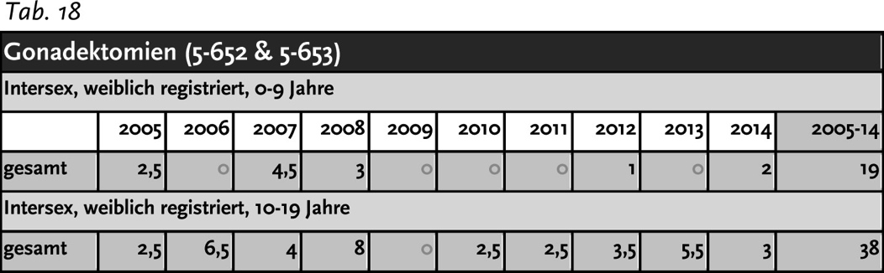
Figure 1: Intersex Gonadectomies on Females by Age Group, p. 52(48)

b) IGM 2 – “Feminising Procedures”: Clitoris Amputation/“Reduction”,
“Vaginoplasty”, “Labioplasty”, Dilation
According to Study 1, “feminizing surgeries” on intersex children 0-9 years were rising, with the five-year-average increasing from 70 to 79 procedures per year:
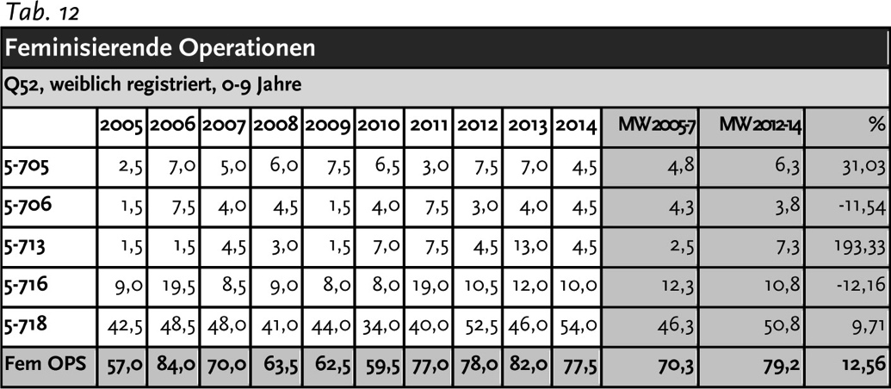
Figure 2: “Feminising” IGM Surgeries on children 0-9 years, p. 42(38)
Study 1 documents 164 cases of “clitoral surgery” on intersex children 0-9 years. After 2008, when for the first – and still last – time an IGM surgeon was sentenced in the last instance to pay damages for a non-consensual procedure on an adult person, “clitoral surgery” decreased in the five-year-average from 20 to 11 procedures per year …
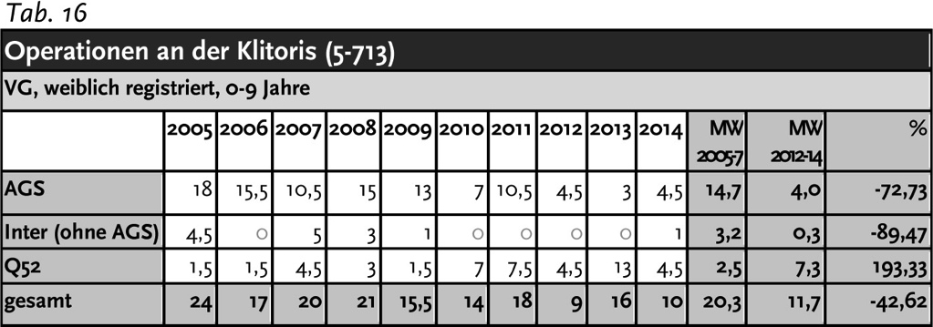
Figure 3: “Clitoral Surgery” on intersex children 0-9 years, p. 48(44)

… however with the notable exception of the age group < 1 year, where the numbers not only stayed steady (at around 5–10 surgeries per year)…
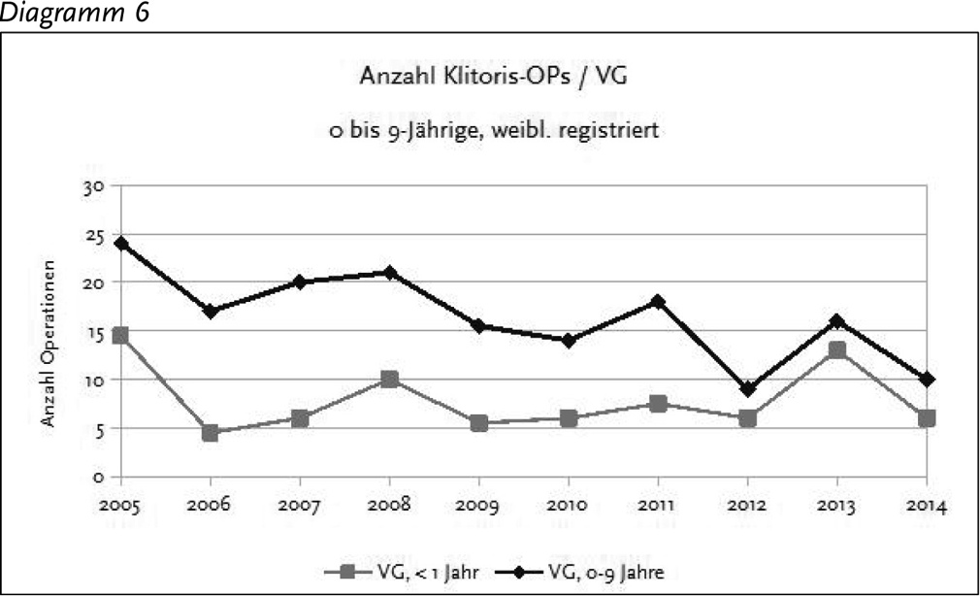
Figure 4: “Clitoral Surgery” 0-9 years vs. <1 year, p. 49(45)
… but after 2011, after the questionable “Opinion on the Situation of Intersex People” of the German National Ethics Council, according to Study 2, procedures on <1 year olds became most frequent in young children (at around 8–13 surgeries every year), surpassing procedures on girls 1-5 years (at around 4–7 surgeries per year), additionally suggesting rising numbers in early school age, allegedly with the “consent” of the children concerned:
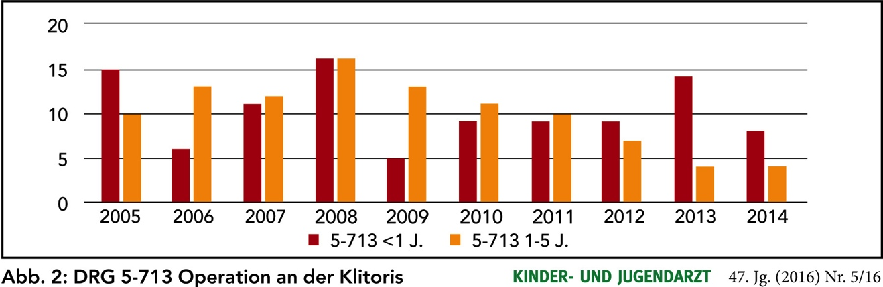
Figure 5: “Clitoral Surgery” 1-5 years vs. <1 year, p. 320

c) IGM 1 – “Masculinising Surgery”: Hypospadias “Repair”
According to Study 2, Q54 “Hypospadias” remains the most frequent IGM practice by far, with over 1’400 procedures every year on children 0-9, even when discarding procedures of the “First degree (Q54.0)” and counting only the second and third degree (Q54.1-3). In addition, Q55 “Other congenital malformations of male genital organs” shows the biggest increase in procedures. In average, there are 1600 masculinising procedures annually:
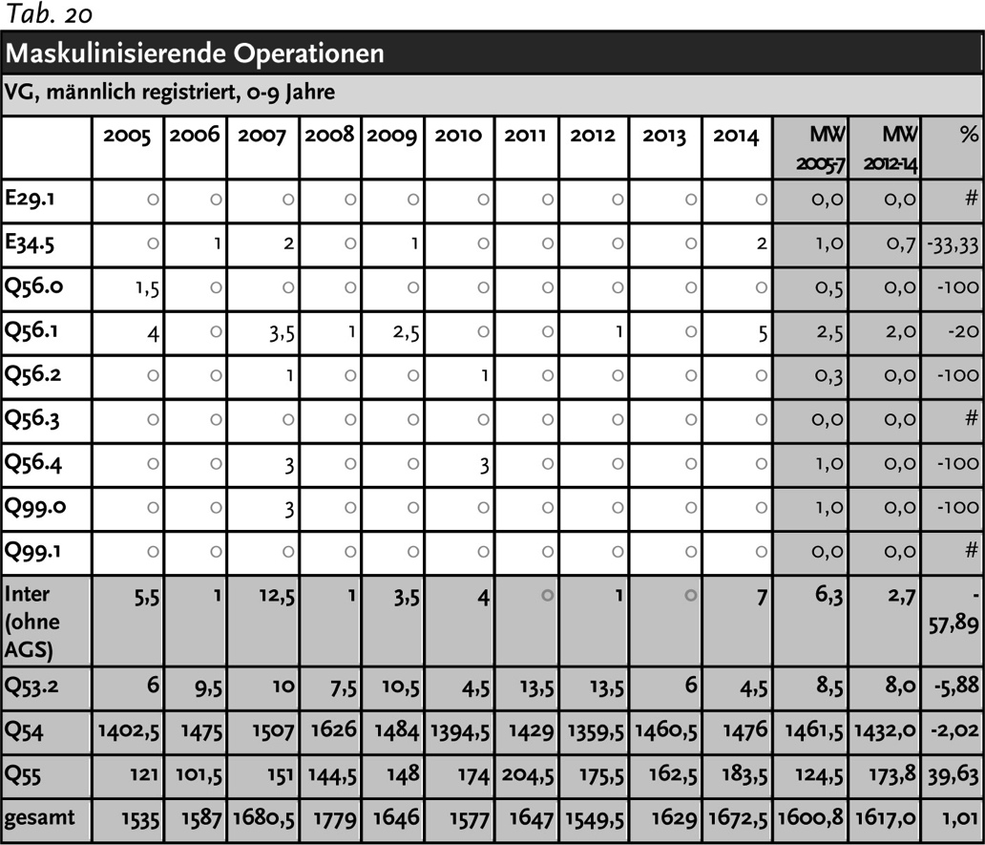
Figure 6: “Masculinising” IGM Surgeries on children 0-9 years, p. 55(51)

d) Prenatal “Therapy”
Also prenatal “Therapy” with Dexamethasone is still advocated and practiced in Germany, for example in the official guideline “AWMF 174/013” “S1-Leitlinie – Stellungnahme zur pränatalen Therapie des Adrenogenitalen Syndroms mit 21-Hydroxylase-Defekt (AGS) in Deutschland”, despite openly admitting that the “therapy” is “no evidence based protocol” (p. 3) and “experimental” (p. 6).

e) IGM 4 – Other Unnecessary and Harmful Interventions and Treatments
Other frequent harmful treatments include (as detailed in the 2014 CRC NGO Report):
- Involuntary Medical and Scientific Human Experimentation (p. 74)
- Forced Excessive Genital Exams, Medical Display, (Genital) Photography (p. 73)
- Misinformation and Directive Counselling for Parents (p. 70)
- Systematic Lies and Imposition of “Code of Silence” on Children (p. 72)
- Imposition of Hormones (p. 73)
- Forced Mastectomy (p. 70)
- Denial of Needed Health Care (p. 75)
- Selective (Late Term) Abortion (p. 76)
- Preimplantation Genetic Diagnosis (PGD) to Eliminate Intersex Fetuses (p. 76)

http://Zwischengeschlecht.org/ English homepage: http://stop.genitalmutilation.org
http://zwischengeschlecht.org/post/Statuten
http://intersex.shadowreport.org/
http://intersex.shadowreport.org/public/2015-CRPD-LoI-Germany_NGO-Report_Zwischengeschlecht_Intersex-IGM.pdf
http://intersex.shadowreport.org/public/2017-CEDAW-Germany-NGO-Zwischengeschlecht-Intersex-IGM.pdf
http://intersex.shadowreport.org/public/2018-CCPR-LOIPR-Germany-NGO-Zwischengeschlecht-Intersex-IGM.pdf
2014 CRC NGO Report, p. 52, 69, 84, http://intersex.shadowreport.org/public/2014-CRC-Swiss-NGO-Zwischengeschlecht-Intersex-IGM_v2.pdf
In the WHO “World Atlas of Birth Defects (2nd Edition)”, many intersex diagnoses are listed, including “indeterminate sex” and “hypospadias”: http://web.archive.org/web/20160305152127/http://prenatal.tv/lecturas/world%20atlas%20of%20birth%20defects.pdf
“The Racist Roots of Intersex Genital Mutilations” http://stop.genitalmutilation.org/post/Racist-Roots-of-Intersex-Genital-Mutilations-IGM
For 500 years of “scientific” prejudice in a nutshell, see 2016 CEDAW France NGO Report, p. 7, http://intersex.shadowreport.org/public/2016-CEDAW-France-NGO-Zwischengeschlecht-Intersex-IGM.pdf
For stats and references, see “Selective Intersex Abortions: XXY 74%, Indeterminate Sex 47%, Hypospadias 2%”, http://stop.genitalmutilation.org/post/Selective-Intersex-Abortions-Hypospadias-Intersex-XXY
For example in the UK, see http://guide.hfea.gov.uk/pgd/
See 2014 CRC Switzerland NGO Report, p. 76, http://intersex.shadowreport.org/public/2014-CRC-Swiss-NGO-Zwischengeschlecht-Intersex-IGM_v2.pdf
Pakistani doctors in “The Nation”, see http://stop.genitalmutilation.org/post/Pakistan-Intersex-children-birth-defects-patents-offered-surgery-to-make-them-normal-again Original source: https://www.thenews.com.pk/print/287739-100-infants-with-birth-defects-rehabilitated
The currently still official medical terminology “Disorders of Sex Development” is strongly refused by persons concerned. See 2014 CRC NGO Report, p. 12 “Terminology”.
http://intersex.shadowreport.org/public/2015-CRPD-LoI-Germany_NGO-Report_Zwischengeschlecht_Intersex-IGM.doc
For references and general information, see “What are Intersex Genital Mutilations (IGM)?”, 2016 CEDAW NGO Report France, p. 45–51, http://intersex.shadowreport.org/public/2016-CEDAW-France-NGO-Zwischengeschlecht-Intersex-IGM.pdf
See “IGM Practices – Non-Consensual, Unnecessary Medical Interventions ”, ibid., p. 38–47
For example in South Africa, see 2016 CRC South Africa NGO Report, p. 12, http://intersex.shadowreport.org/public/2016-CRC-ZA-NGO-Zwischengeschlecht-Intersex-IGM.pdf For South Africa, see also https://mg.co.za/article/2018-01-24-00-intersex-babies-killed-at-birth-because-theyre-bad-omens For example in Uganda, Kenya, Rwanda, see "Baseline Survey on intersex realities in East Africa – Specific focus on Uganda, Kenya, and Rwanda" by SIPD Uganda, relevant excerpts and source: http://stop.genitalmutilation.org/post/Africa-Intersex-Survey-Documents-Intersex-Genital-Mutilation-Infanticide-Abandonment-Expulsion-Uganda-Kenya-Rwanda ; for Uganda, see also 2015 CRC Briefing, slide 46, http://intersex.shadowreport.org/public/Zwischengeschlecht_2015-CRC-Briefing_Intersex-IGM_web.pdf For Kenya, see also http://www.bbc.com/news/world-africa-39780214
For example in Uganda, Kenya, Rwanda, see "Baseline Survey on intersex realities in East Africa – Specific focus on Uganda, Kenya, and Rwanda" by SIPD Uganda, relevant excerpts and source: http://stop.genitalmutilation.org/post/Africa-Intersex-Survey-Documents-Intersex-Genital-Mutilation-Infanticide-Abandonment-Expulsion-Uganda-Kenya-Rwanda For example in China, see 2015 Hong Kong, China NGO Report, p. 15, http://intersex.shadowreport.org/public/2015-CAT-Hong-Kong-China-NGO-BBKCI-Intersex.pdf
For example in Uganda, Kenya, Rwanda, see "Baseline Survey on intersex realities in East Africa – Specific focus on Uganda, Kenya, and Rwanda" by SIPD Uganda, relevant excerpts and source: http://stop.genitalmutilation.org/post/Africa-Intersex-Survey-Documents-Intersex-Genital-Mutilation-Infanticide-Abandonment-Expulsion-Uganda-Kenya-Rwanda
For example in Nepal (CRC/C/NPL/CO/3-5, paras 41–42), based on local testimonies, see http://stop.genitalmutilation.org/post/Denial-of-Needed-Health-Care-Intersex-in-Nepal-Pt-3
For example in Kenya, see https://76crimes.com/2015/12/23/intersex-in-kenya-held-captive-beaten-hacked-dead/
For references, see 2016 CEDAW France NGO Report, p. 45. http://intersex.shadowreport.org/public/2016-CEDAW-France-NGO-Zwischengeschlecht-Intersex-IGM.pdf
For example ACHPR Commissioner Lawrence Murugu Mute (Kenya), see http://stop.genitalmutilation.org/post/ACHPR-African-Commissioner-warns-Stop-conflating-intersex-and-LGBT
CAT60 Argentina, http://stop.genitalmutilation.org/post/UN-Press-Release-calls-IGM-survivors-transsexual-children-CATArgentina-UNCAT60
CRC77 Spain, http://stop.genitalmutilation.org/post/UN-Press-Release-mentions-genital-mutilation-of-intersex-children
CRC76 Denmark, http://stop.genitalmutilation.org/post/UN-Press-Release-calls-IGM-survivors-transsexual-children-CRC-Denmark-UNCRC67
CAT/C/DNK/QPR/8, para 32
CRC73 New Zealand, http://stop.genitalmutilation.org/post/NZ-to-be-Questioned-over-Intersex-Genital-Mutilations-by-UN-Committee-on-the-Rights-of-the-Child
CCPR120 Switzerland, http://stop.genitalmutilation.org/post/Pinkwashing-of-Intersex-Genital-Mutilations-at-the-UN-CCPR120
CAT56 Austria, http://stop.genitalmutilation.org/post/Geneva-UN-Committee-against-Torture-questions-Austria-over-Intersex-Genital-Mutilations
CAT60 Argentina, http://stop.genitalmutilation.org/post/CAT60-Argentina-to-be-Questioned-on-Intersex-Genital-Mutilation-by-UN-Committee-against-Torture
CRPD18 UK, http://stop.genitalmutilation.org/post/UK-Questioned-over-Intersex-Genital-Mutilations-by-UN-Committee-on-the-Rights-of-Persons-with-Disabilities-CRPD
For example in Scotland (UK), LGBT organisations have so far collected at least £ 135,000.– public intersex funding, while actual intersex organisations received ZERO public funding, see 2017 CRPD UK NGO Report, p. 14, http://intersex.shadowreport.org/public/2017-CRPD-UK-NGO-Coalition-Intersex-IGM.pdf Typically, during the interactive dialogue with CRPD, the UK delegation nonetheless tried to sell this glaring misappropriation as “supporting intersex people”, but fortunately got called out on this by the Committee, see transcript (Session 2, 10:53h + 11:47h), http://stop.genitalmutilation.org/post/UK-Questioned-over-Intersex-Genital-Mutilations-by-UN-Committee-on-the-Rights-of-Persons-with-Disabilities-CRPD
See e.g. “Instrumentalizing intersex: ‘The fact that LGBTs in particular embrace intersex is due to an excess of projection’ - Georg Klauda (2002)”, http://stop.genitalmutilation.org/post/Instrumentalizing-Intersex-Georg-Klauda-2002
For example Amnesty (2017), see http://stop.genitalmutilation.org/post/Amnesty-Report-fails-Intersex-Children-and-IGM-Survivors
For example FRA (2015), see Presentation OHCHR Expert Meeting (2015), slide 8, http://stop.genitalmutilation.org/public/S3_Zwischengeschlecht_UN-Expert-Meeting-2015_web.pdf
For example CEDAW (2017), see, http://stop.genitalmutilation.org/post/Major-Setback-for-Intersex-Human-Rights-at-the-UN
See e.g. Ministry of Health Chile (2016), http://stop.genitalmutilation.org/post/Circular-7-step-back-for-intersex-human-rights-in-Chile
See http://stop.genitalmutilation.org/post/IAD-2016-Soon-20-UN-Reprimands-for-Intersex-Genital-Mutilations
See 2016 CRPD Germany NGO Report, p. 18-20, http://intersex.shadowreport.org/public/2015-CRPD-LoI-Germany_NGO-Report_Zwischengeschlecht_Intersex-IGM.pdf
BMFSFJ (ed.): „Situation von trans- und intersexuellen Menschen im Fokus“. Sachstandsinformation, p. 18: https://www.bmfsfj.de/blob/112092/46d6be33eb8f2b5d2ee81488da03029c/situation-von-tans--und-intersexuellen-menschen-im-fokus-data.pdf
17/3884 [leaked uncensored version of answer to original question no. 3, p. 1 – in the official answer, the relevant original question no. 3 was secretly omitted, see p. 2] http://blog.zwischengeschlecht.info/public/Bayern_2014_Anfrage_17-3884_Intersex_IGM_Zensur_web.pdf
2015 CRPD NGO Report for Germany (p. 17), http://intersex.shadowreport.org/public/2015-CRPD-LoI-Germany_NGO-Report_Zwischengeschlecht_Intersex-IGM.pdf
CEDAW66 Germany, section on intersex in the 7th and 8th Periodic State report, paras 200-205 (on Recommendation 62)
https://www.bundesaerztekammer.de/fileadmin/user_upload/downloads/pdf-Ordner/Stellungnahmen/BAeK-Stn_DSD.pdf
https://www.awmf.org/uploads/tx_szleitlinien/174-001l_S2k_Geschlechtsentwicklung-Varianten_2016-08_01.pdf
Interministerial Working Group (2016), "Focus on the situation of trans- and intersexual people". Status information of the BMFSFJ. Accompanying material to the Interministerial Working Group on Inter- & Transsexuality - Volume 5, Berlin, p. 18, https://www.bmfsfj.de/blob/112092/f199e9c4b77f89d0a5aa825228384e08/imag-band-5-situation-von-trans-und-intersexuellen-menschen-data.pdf
https://www.buzzfeed.com/de/julianeloeffler/groko-operationsverbot-intergeschlechtliche-kinder?utm_term=.wkljqeaB5#.pjL4wk8dP
http://intersex.shadowreport.org/public/2015-CRPD-LoI-Germany_NGO-Report_Zwischengeschlecht_Intersex-IGM.pdf
Ibid.
BMFSFJ (ed.): „Situation von trans- und intersexuellen Menschen im Fokus“. Sachstandsinformation, p. 20-22: https://www.bmfsfj.de/blob/112092/46d6be33eb8f2b5d2ee81488da03029c/situation-von-tans--und-intersexuellen-menschen-im-fokus-data.pdf
Globally, no survivor of early surgeries ever managed to have their case heard in court. All relevant court cases (3 in Germany, 1 in the USA) were either about surgery of adults, or initiated by foster parents.
Interministerial Working Group (2016), "Focus on the situation of trans- and intersexual people". Status information of the BMFSFJ. Accompanying material to the Interministerial Working Group on Inter- & Transsexuality - Volume 5, Berlin, p. 17, https://www.bmfsfj.de/blob/112092/f199e9c4b77f89d0a5aa825228384e08/imag-band-5-situation-von-trans-und-intersexuellen-menschen-data.pdf
E.g. Staatsanwaltschaft Hamburg, Az. 7200 Js 63/10 and LKA Hamburg, Az. LKA 533a/1K/0203909/200
2015 CRPD Germany NGO Report, p. 52-54 https://www.gleichstellungsministerkonferenz.de/documents/beschluesse_23_gfmk_05092013_2_1510227451.pdf
OLG Köln 03.09.2008, Az. 5 U 51/08 http://www.justiz.nrw.de/nrwe/olgs/koeln/j2008/5_U_51_08beschluss20080903.html
LG Köln 12.08.2009, Az. 25 O 179/07 http://www.justiz.nrw.de/nrwe/lgs/koeln/lg_koeln/j2009/25_O_179_07schlussurteil20090812.html
LG Nürnberg-Fürth, Az. 4 O 7000/11. 1st day in court was 26.02.2015.
LG München, Az. 9 O 27981/12.
OLG Nürnberg, Az. 5 U 53/16.
Sentence LG Nürnberg-Fürth, 17.12.2015, Az. 4 O 7000/11.
Wortprotokoll, at 11 http://kastrationsspital.ch/public/19_10_HH_Wortpr_Intersex.pdf
Franziska Brachthäuser, Theresa Richarz (2014): Zwischen Norm und Geschlecht – Erste Entwürfe möglicher nationaler Entschädigungs- und Schadensersatzansprüche intersexueller Menschen gegen die Bundesrepublik Deutschland, Humboldt Law Clinic Menschenrechte (HLCMR) Working Paper Nr. 5, at 22–24 (= 19–21 according to pagination) http://hlcmr.de/wp-content/uploads/2015/01/Working_Paper_Nr.5.pdf
For 4 cases, see 2015 CRPD Germany NGO Report, p. 21-22, http://intersex.shadowreport.org/public/2015-CRPD-LoI-Germany_NGO-Report_Zwischengeschlecht_Intersex-IGM.pdf
Ibid., see Case 2, SG Bayreuth, 01.08.2012, Az. S 4 VG 5/11 (unpublished); see also relevant quote in Nürnberger Nachrichten (04.11.2013) https://web.archive.org/web/20131114044728/http://www.nordbayern.de/nuernberger-nachrichten/region-bayern/schmerzliche-suche-nach-dem-eigenen-geschlecht-1.3257295
Ibid., see Case 4, SG Hamburg, Az. S 12 VE 46/14.
Stellungnahme „Intersexualität“, 14. Februar 2012 (BT – Drs. 17/9088), S. 176
Interministerial Working Group (2016), "Focus on the situation of trans- and intersexual people". Status information of the BMFSFJ. Accompanying material to the Interministerial Working Group on Inter- & Transsexuality - Volume 5, Berlin, p. 17, https://www.bmfsfj.de/blob/112092/f199e9c4b77f89d0a5aa825228384e08/imag-band-5-situation-von-trans-und-intersexuellen-menschen-data.pdf
See 2015 CRPD Germany NGO Report (p. 20-22), http://intersex.shadowreport.org/public/2015-CRPD-LoI-Germany_NGO-Report_Zwischengeschlecht_Intersex-IGM.pdf
StopIGM.org / OII Germany: JointNGO Oral Statement CEDAW66 Germany, 20.02.2017, delivered by Claudia Kasper, http://stop.genitalmutilation.org/post/CEDAW66-NGO-Briefing-on-Intersex-Genital-Mutilations-in-Germany
For general information, see 2016 CRC NGO Report UK, p. 43-44, 63: http://intersex.shadowreport.org/public/2016-CRC-UK-NGO-Zwischengeschlecht-Intersex-IGM_v2.pdf
Ulrike Klöppel: Zur Aktualität kosmetischer Operationen „uneindeutiger“ Genitalien im Kindesalter.: https://www.gender.hu-berlin.de/de/publikationen/gender-bulletins/bulletin-texte/texte-42/kloeppel-2016_zur-aktualitaet-kosmetischer-genitaloperationen
For general information, see 2016 CRC NGO Report UK, p. 44-45, 62: http://intersex.shadowreport.org/public/2016-CRC-UK-NGO-Zwischengeschlecht-Intersex-IGM_v2.pdf
For general information, see 2016 CRC NGO Report UK, p. 45, 61. http://intersex.shadowreport.org/public/2016-CRC-UK-NGO-Zwischengeschlecht-Intersex-IGM_v2.pdf
For general information, see 2014 CRC NGO Report Switzerland, p.75-76. http://intersex.shadowreport.org/public/2014-CRC-Swiss-NGO-Zwischengeschlecht-Intersex-IGM_v2.pdf
http://www.awmf.org/uploads/tx_szleitlinien/174-013l_S1_Adrenogenitales_Syndrom_mit_21_Hydroxylaxe_Defekt_AGS_2015-verlaengert.pdf
http://intersex.shadowreport.org/public/2014-CRC-Swiss-NGO-Zwischengeschlecht-Intersex-IGM_v2.pdf

